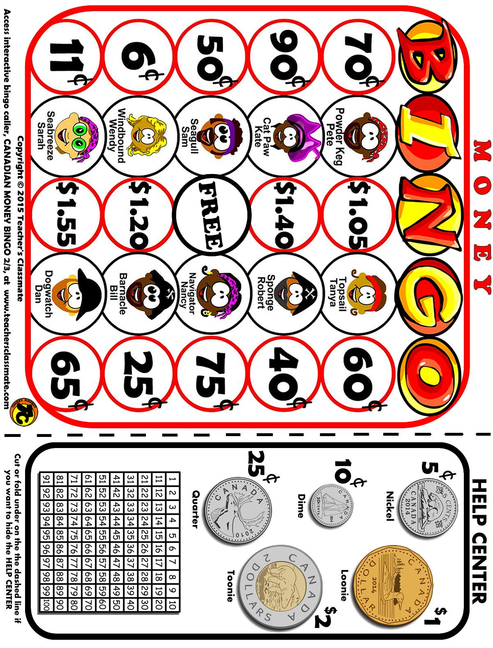
Copyright © 2015 Teacher's Classmate
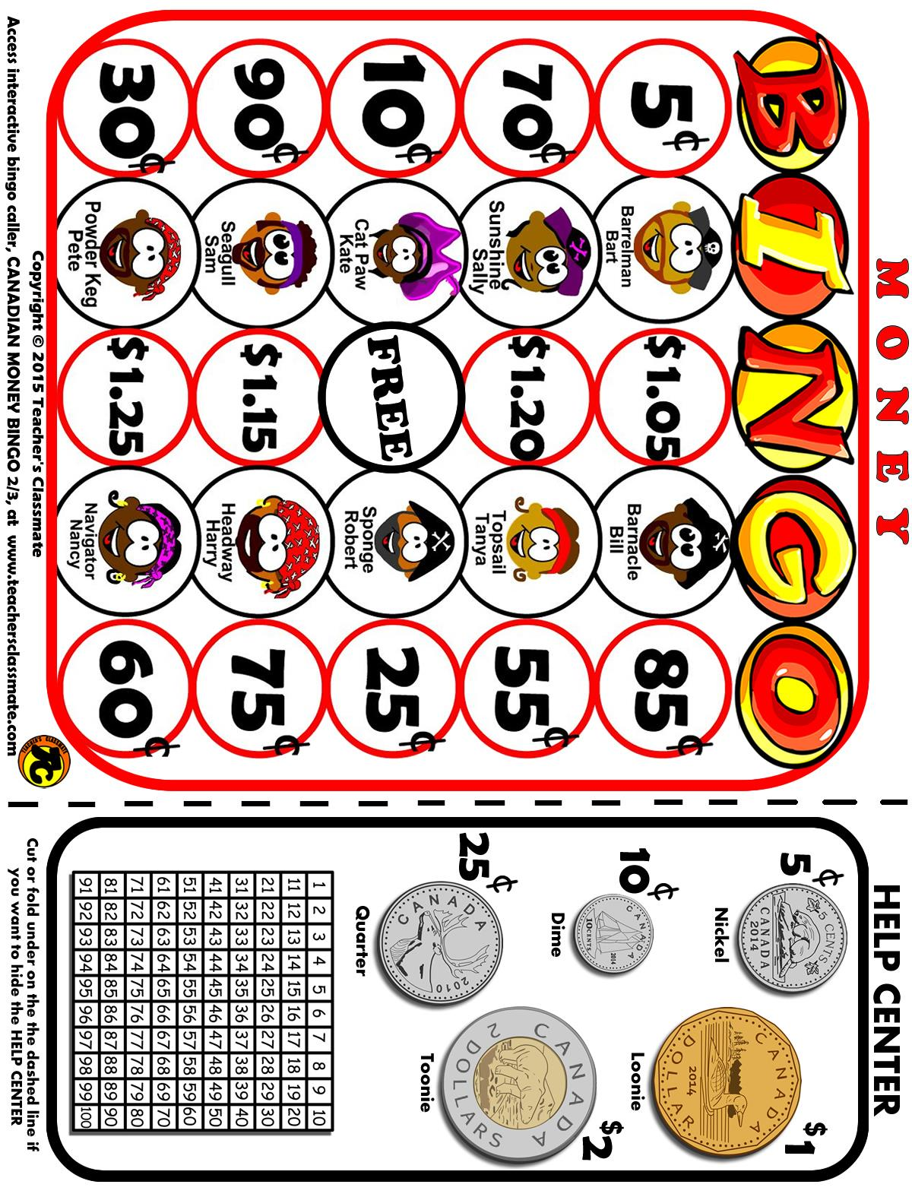
Copyright © 2015 Teacher's Classmate
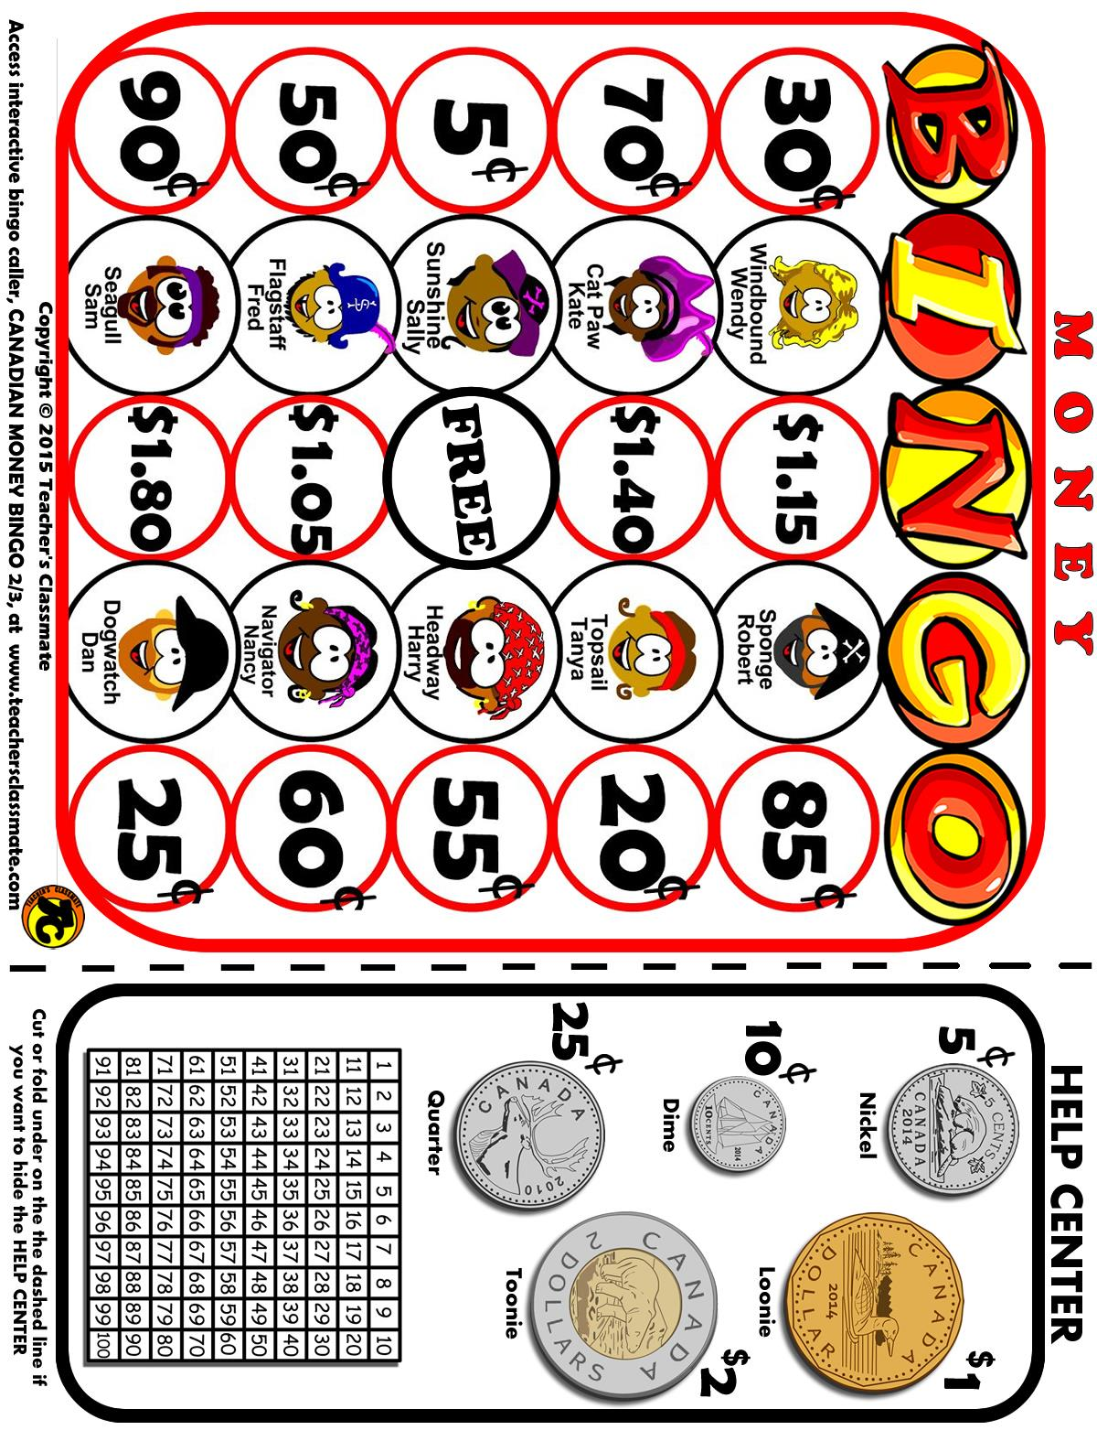
Copyright © 2015 Teacher's Classmate
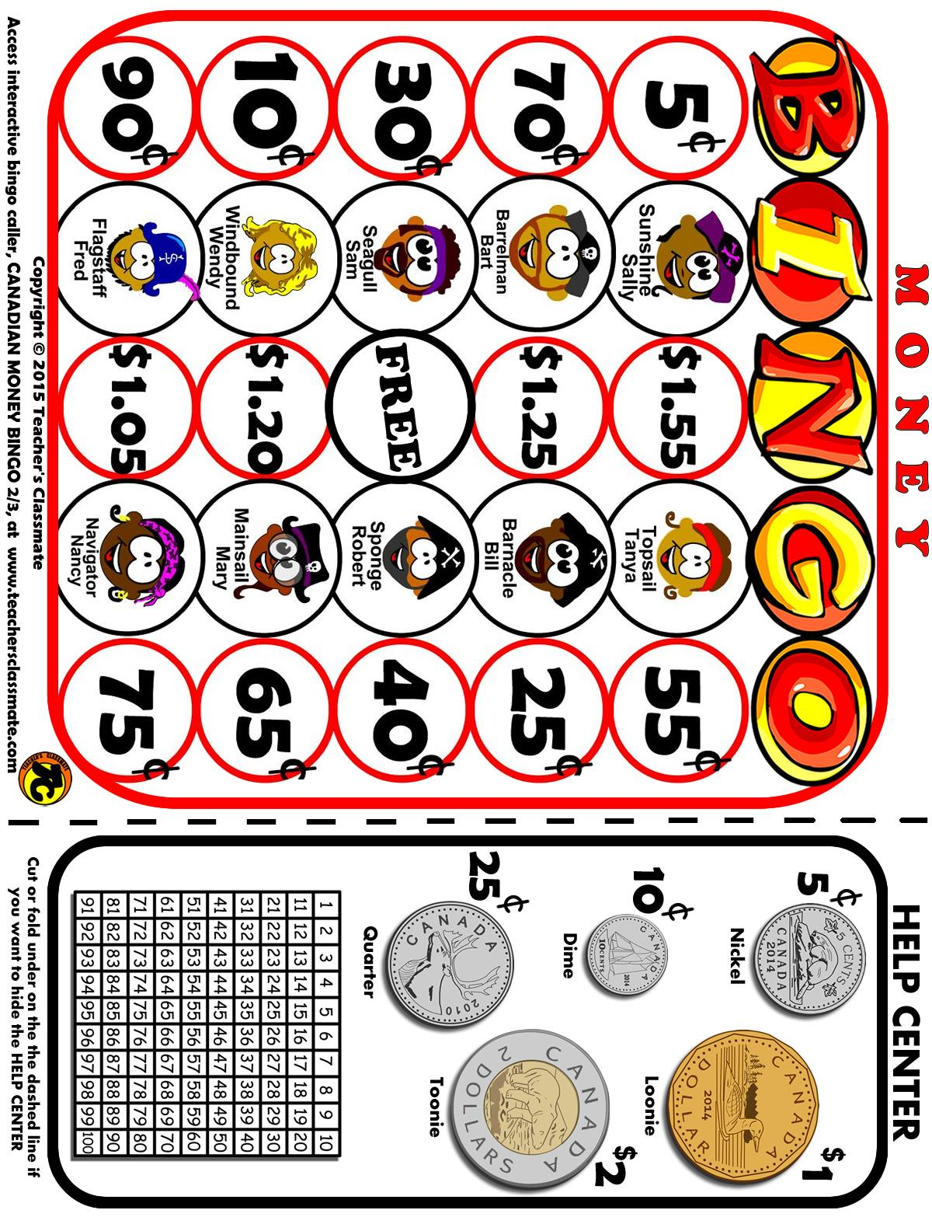
Copyright © 2015 Teacher's Classmate
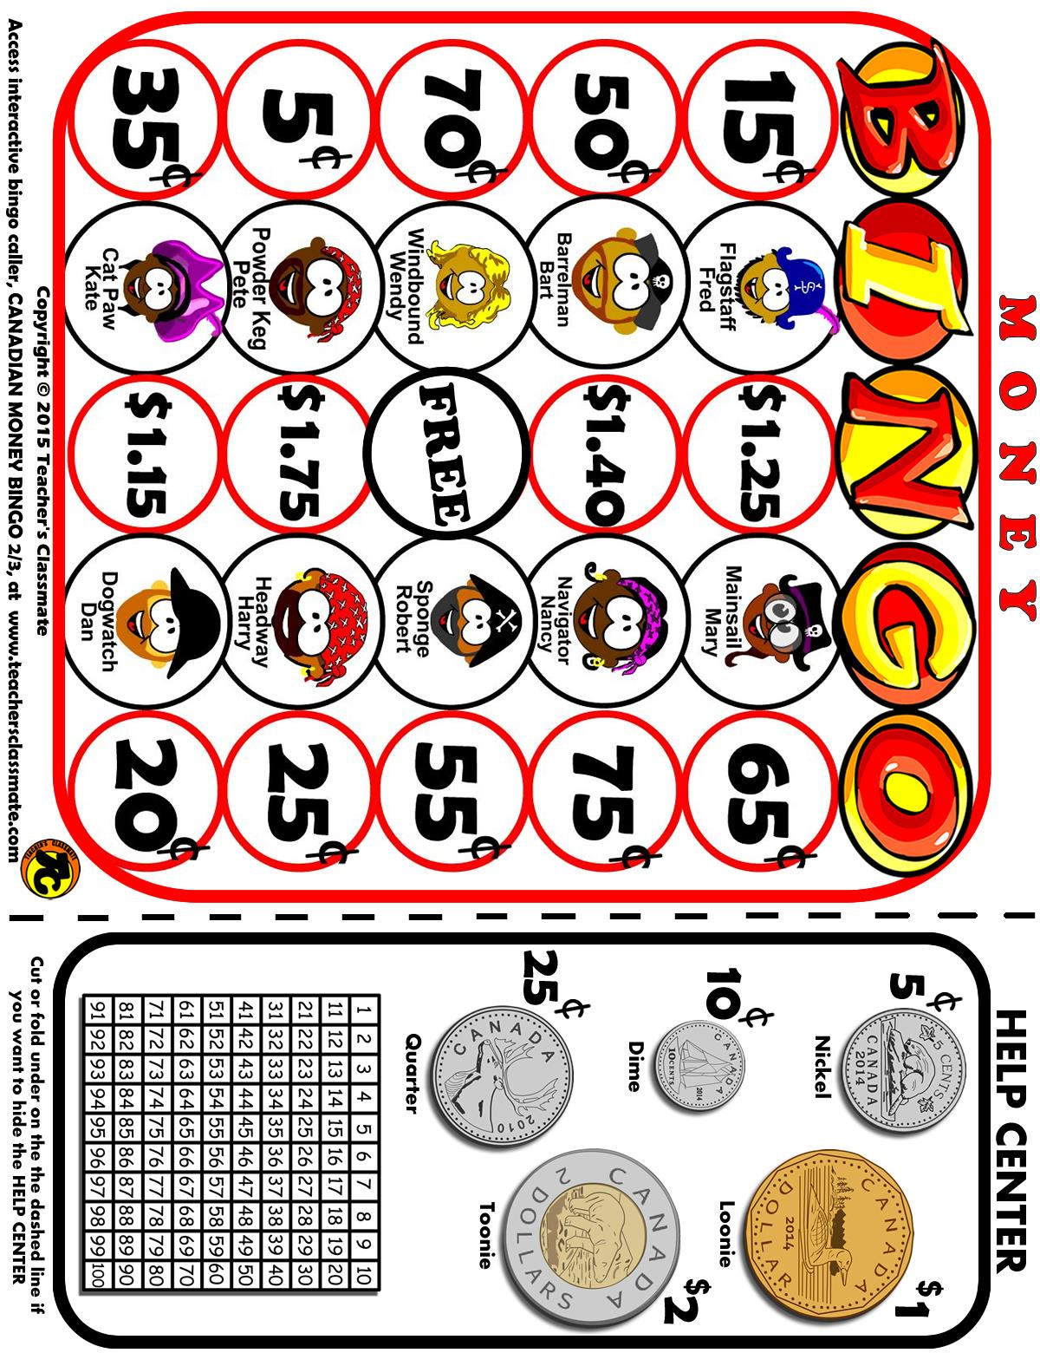
Copyright © 2015 Teacher's Classmate
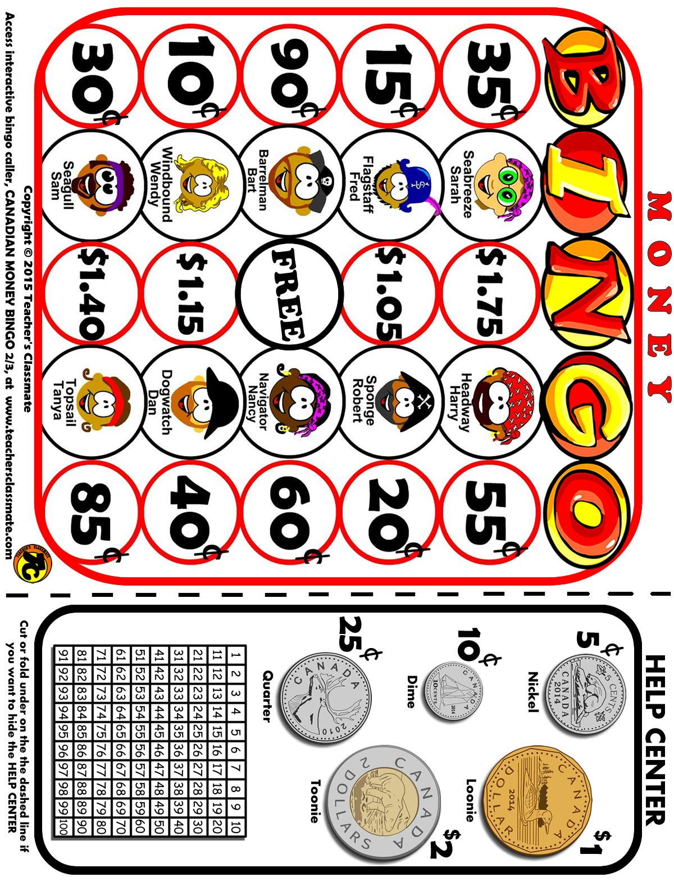
Copyright © 2015 Teacher's Classmate
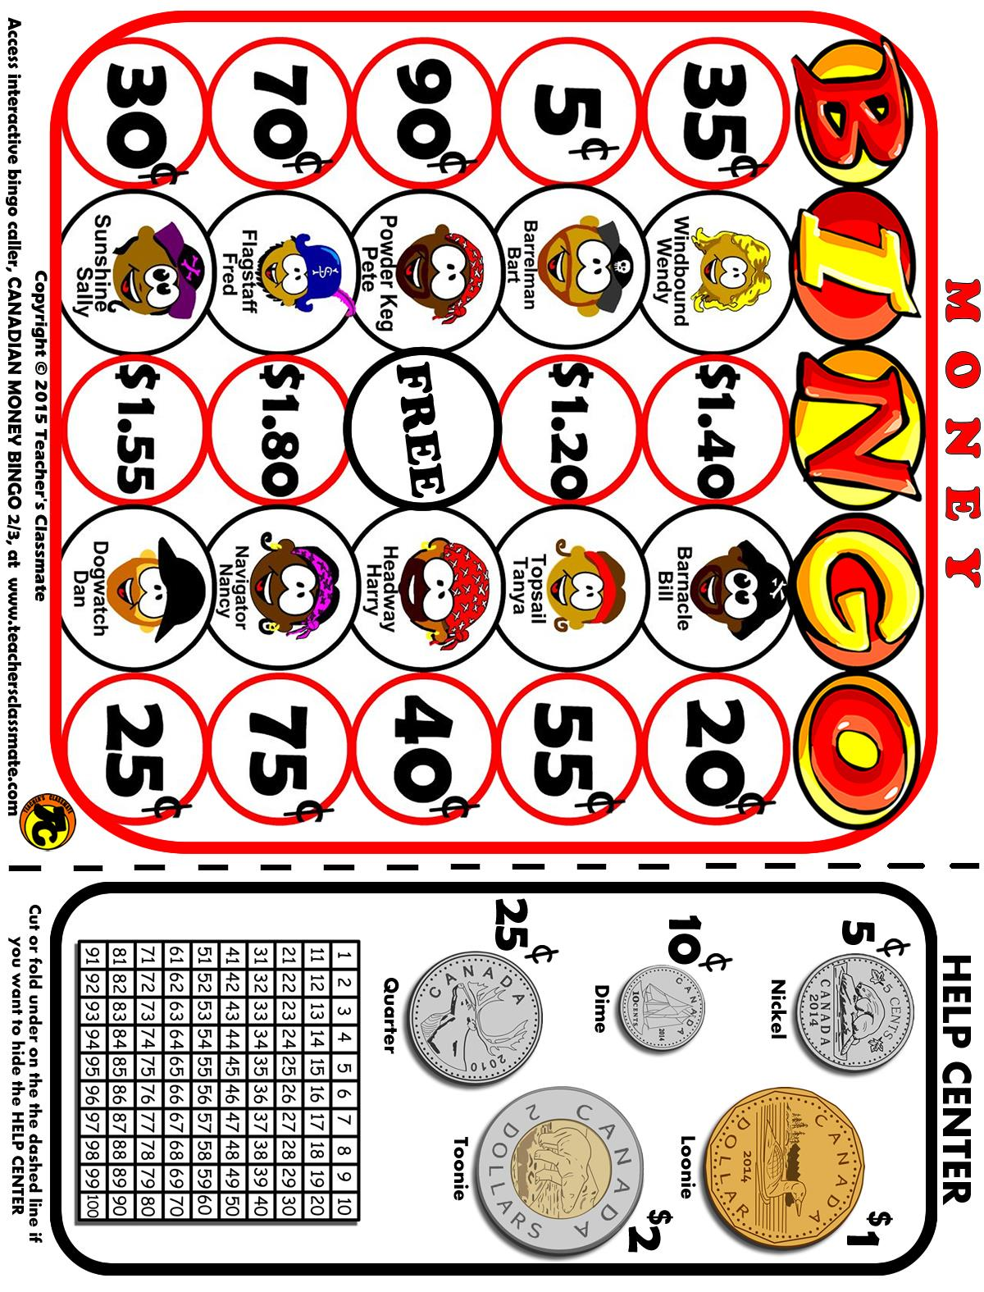
Copyright © 2015 Teacher's Classmate
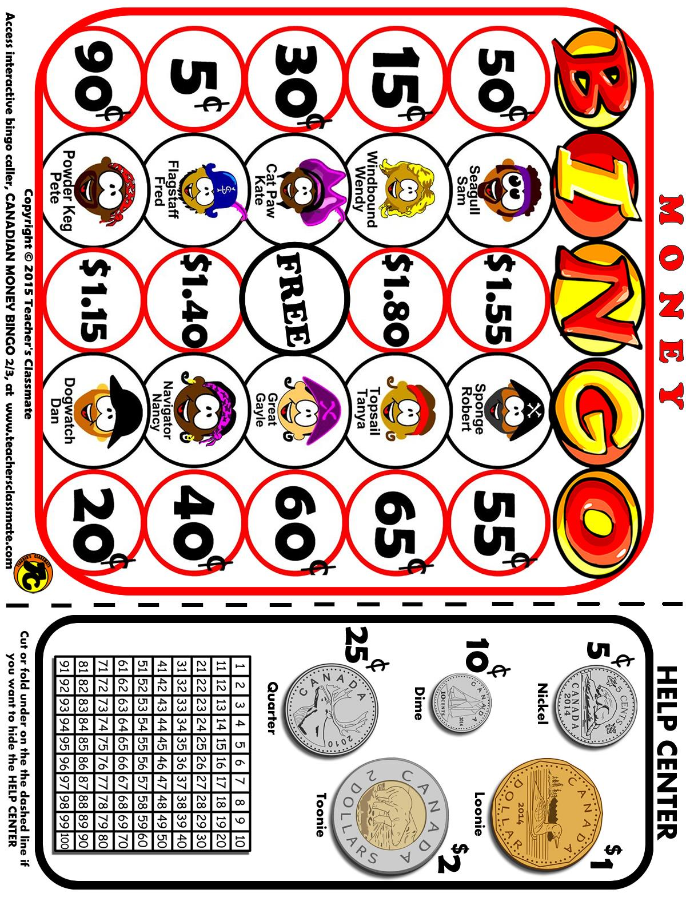
Copyright © 2015 Teacher's Classmate
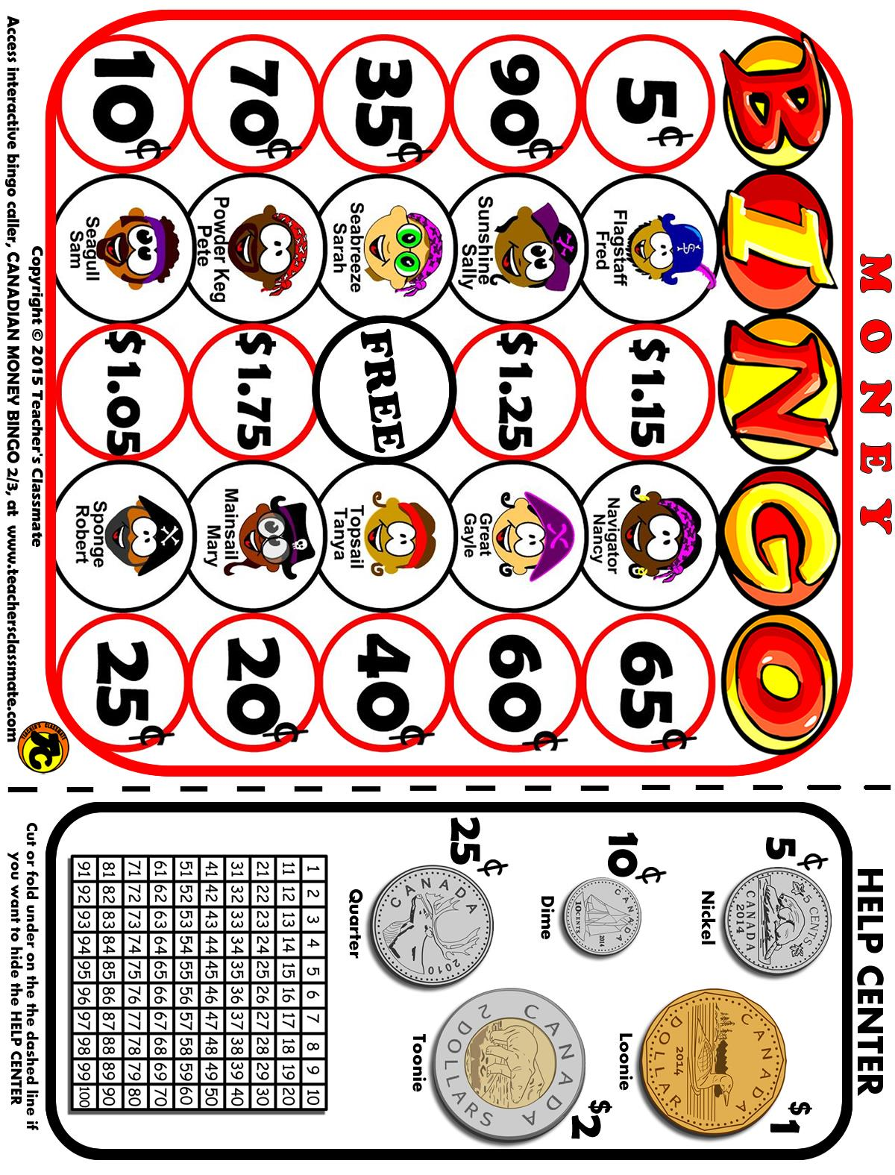
Copyright © 2015 Teacher's Classmate
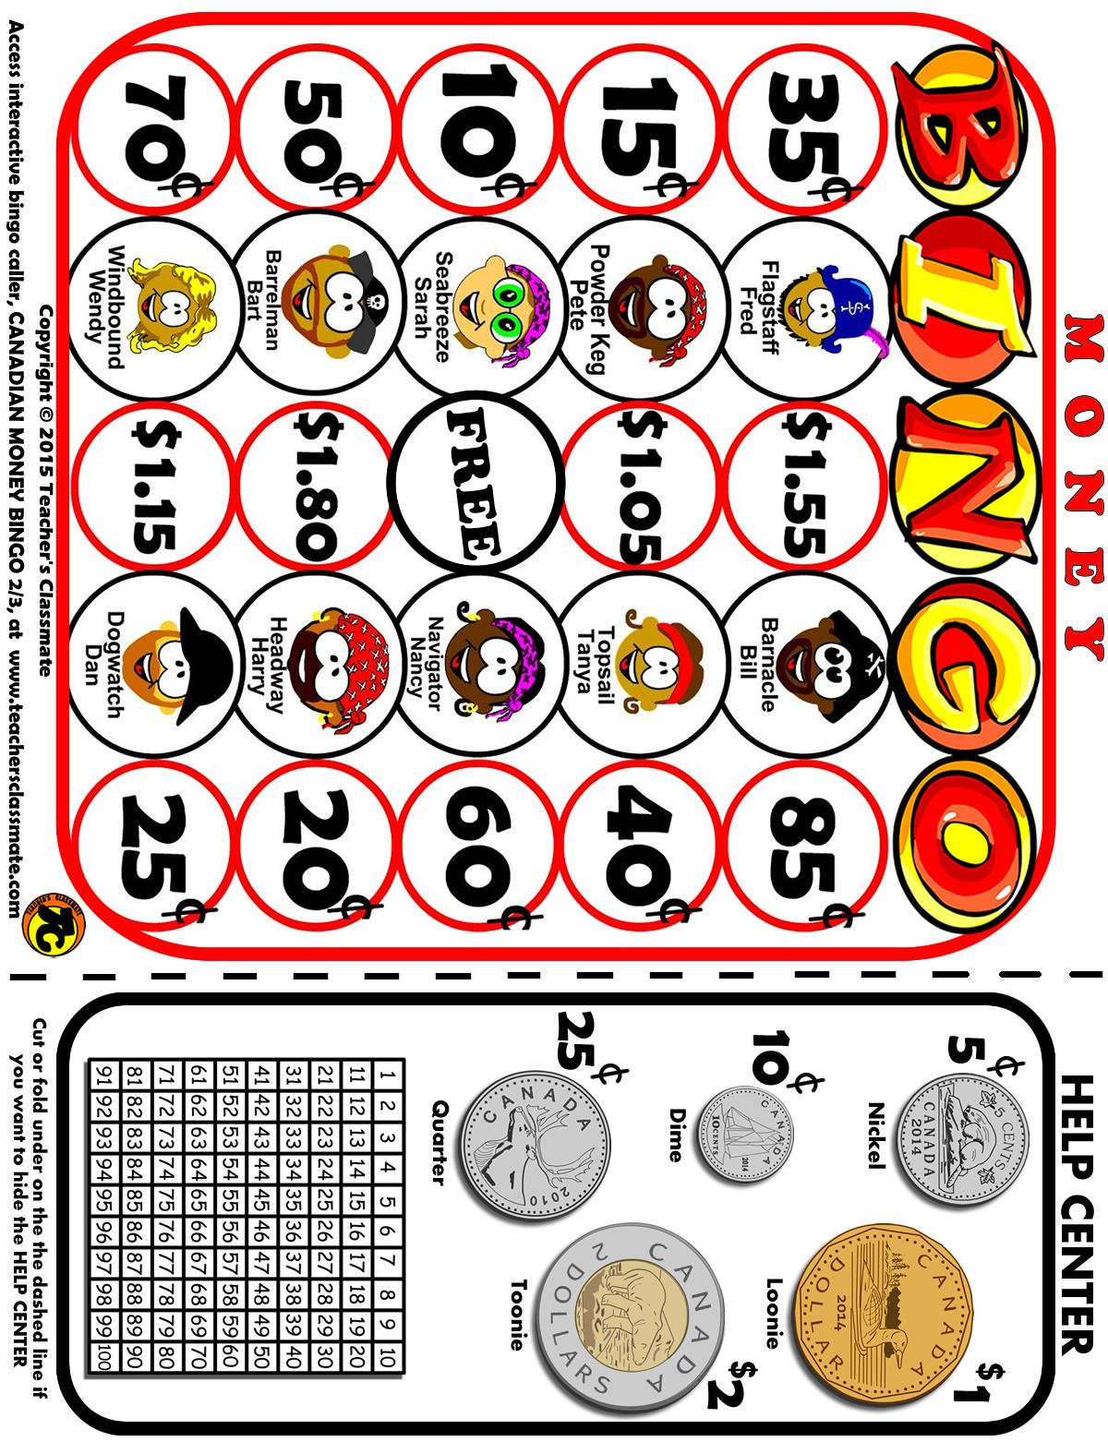
Copyright © 2015 Teacher's Classmate
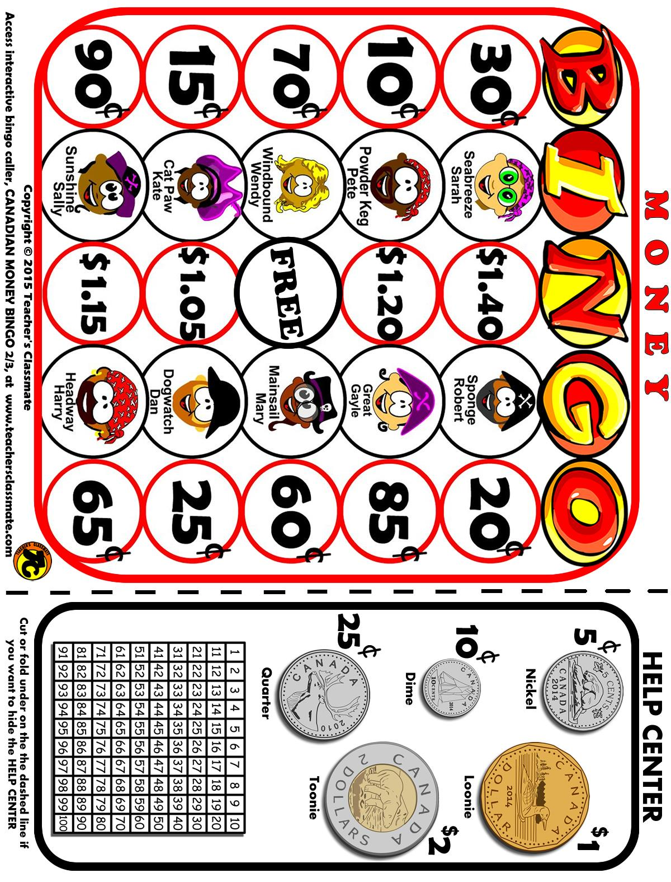
Copyright © 2015 Teacher's Classmate
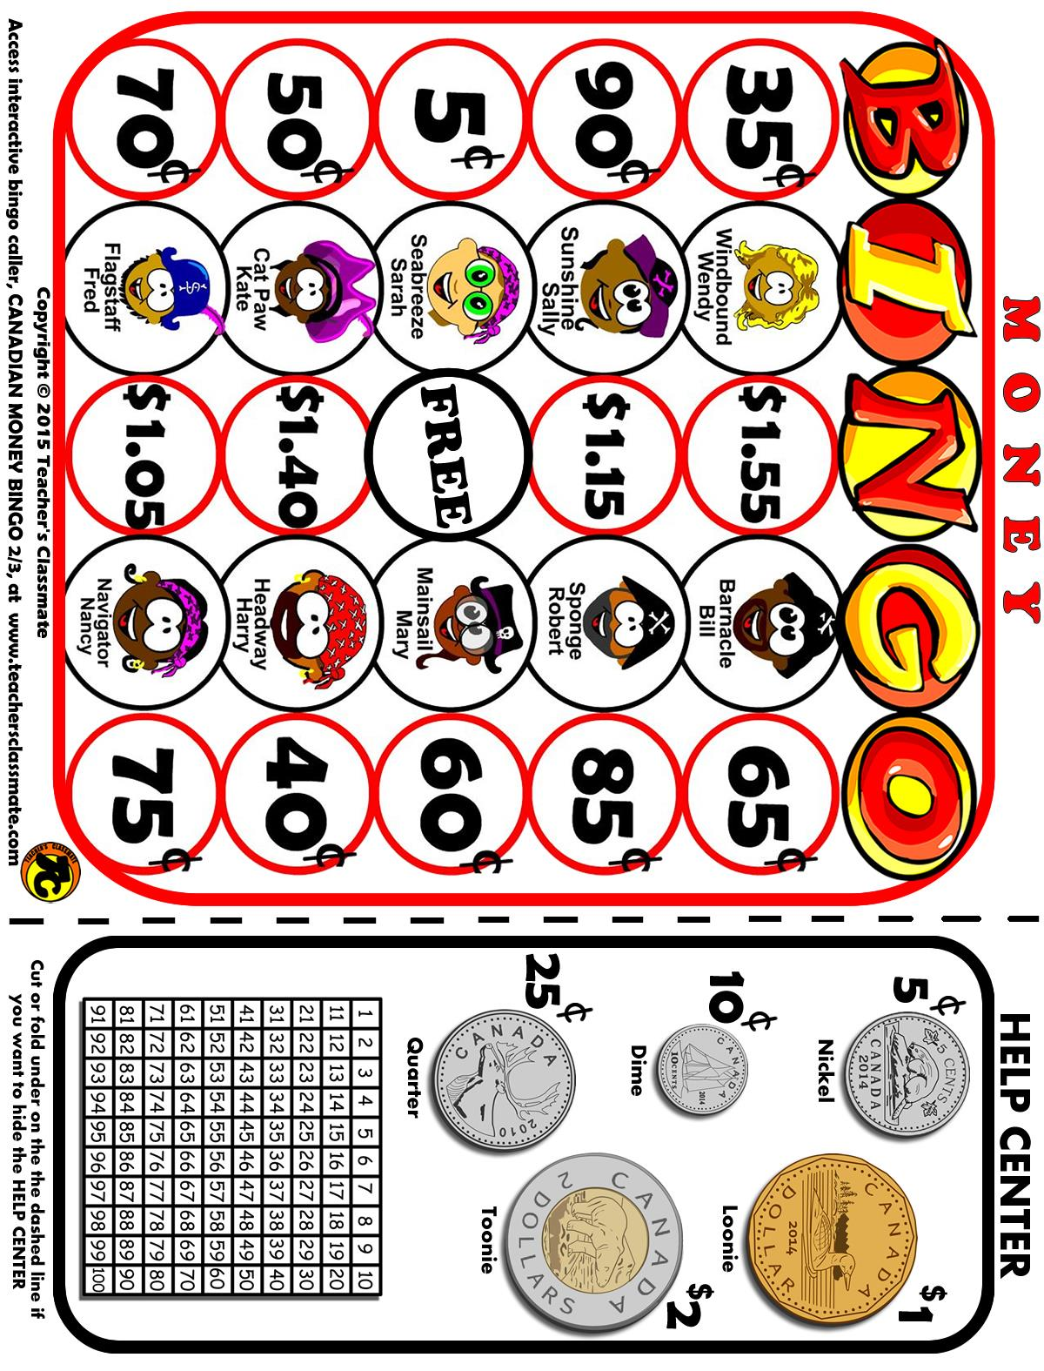
Copyright © 2015 Teacher's Classmate
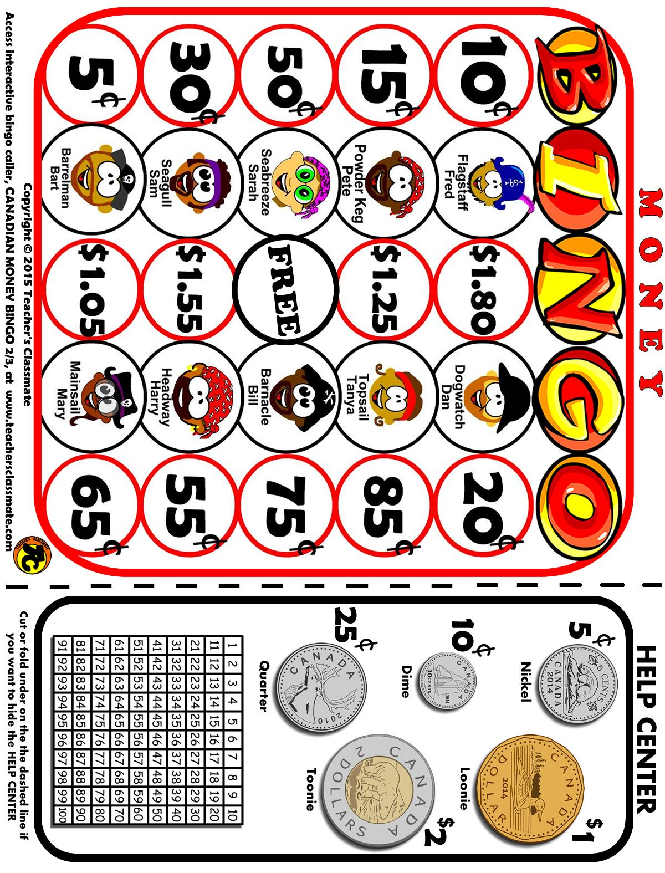
Copyright © 2015 Teacher's Classmate
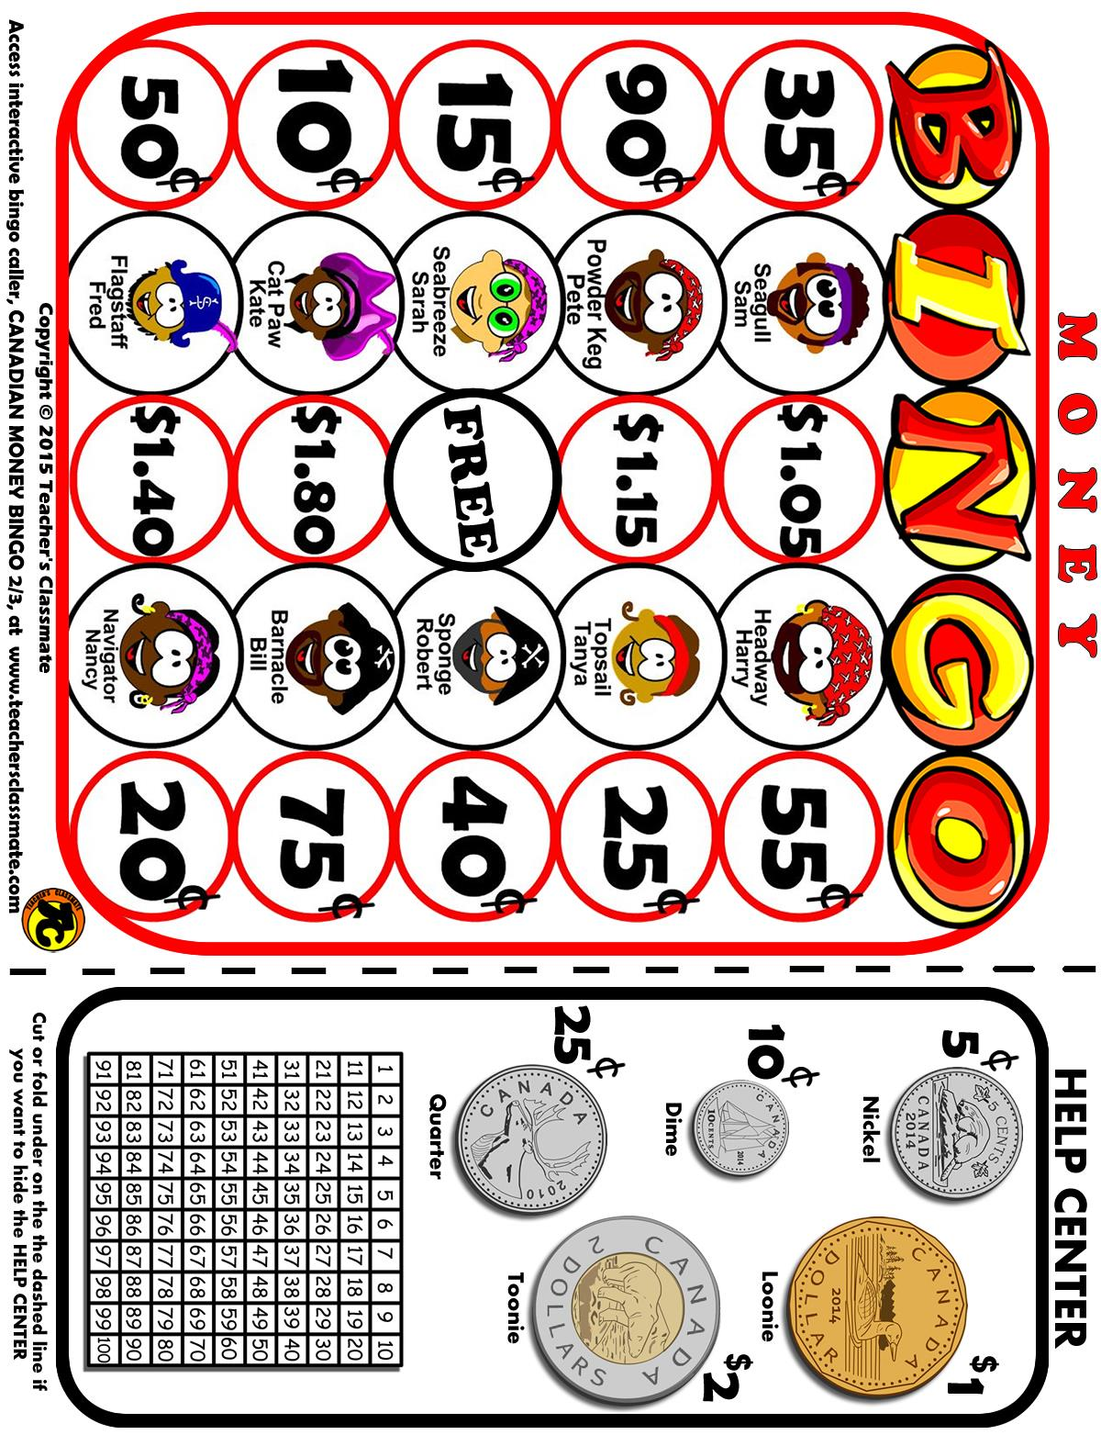
Copyright © 2015 Teacher's Classmate
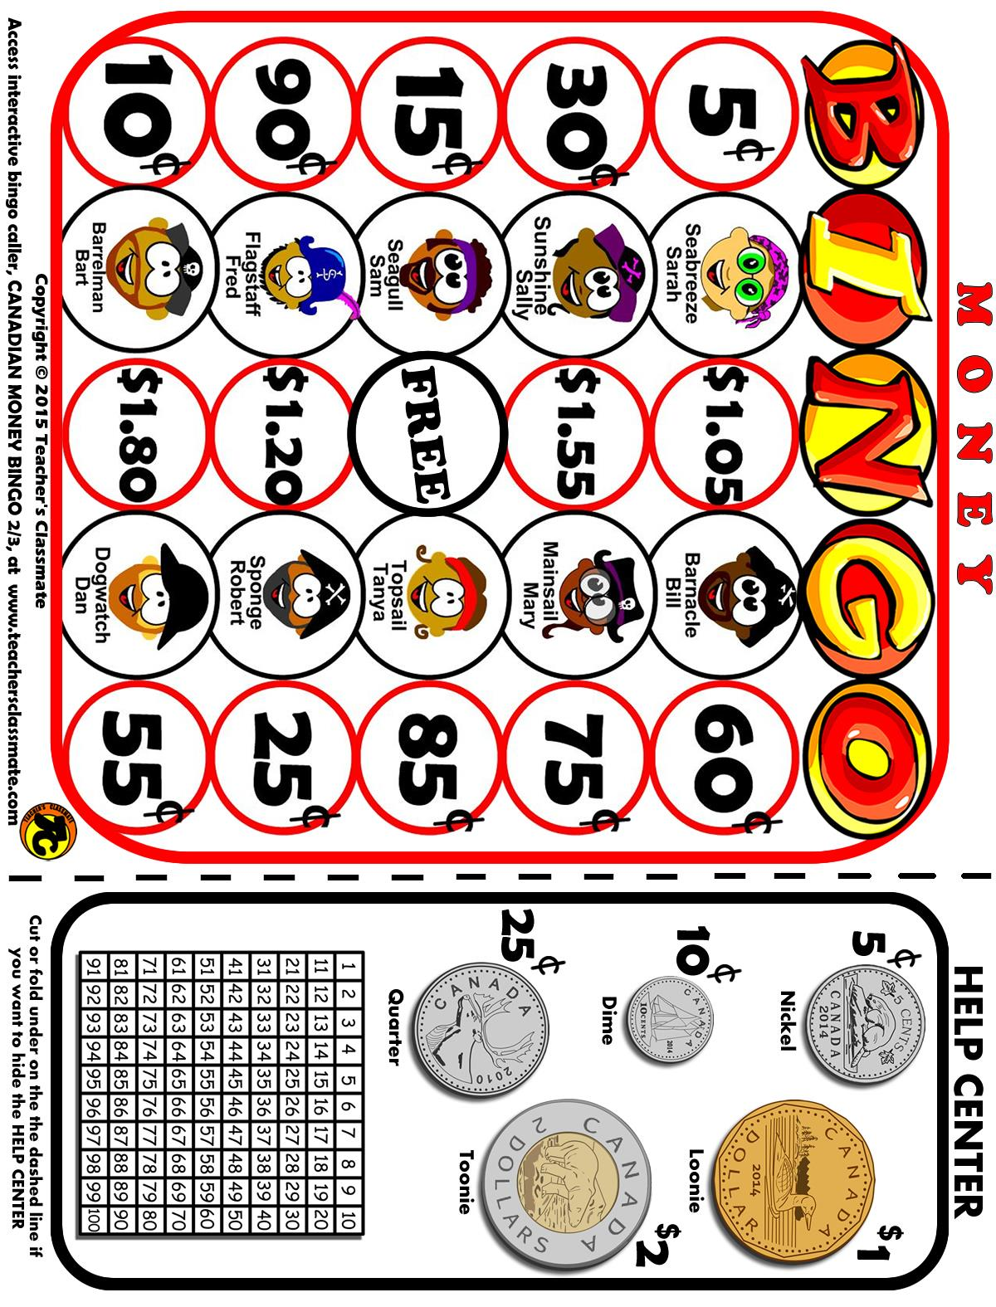
Copyright © 2015 Teacher's Classmate
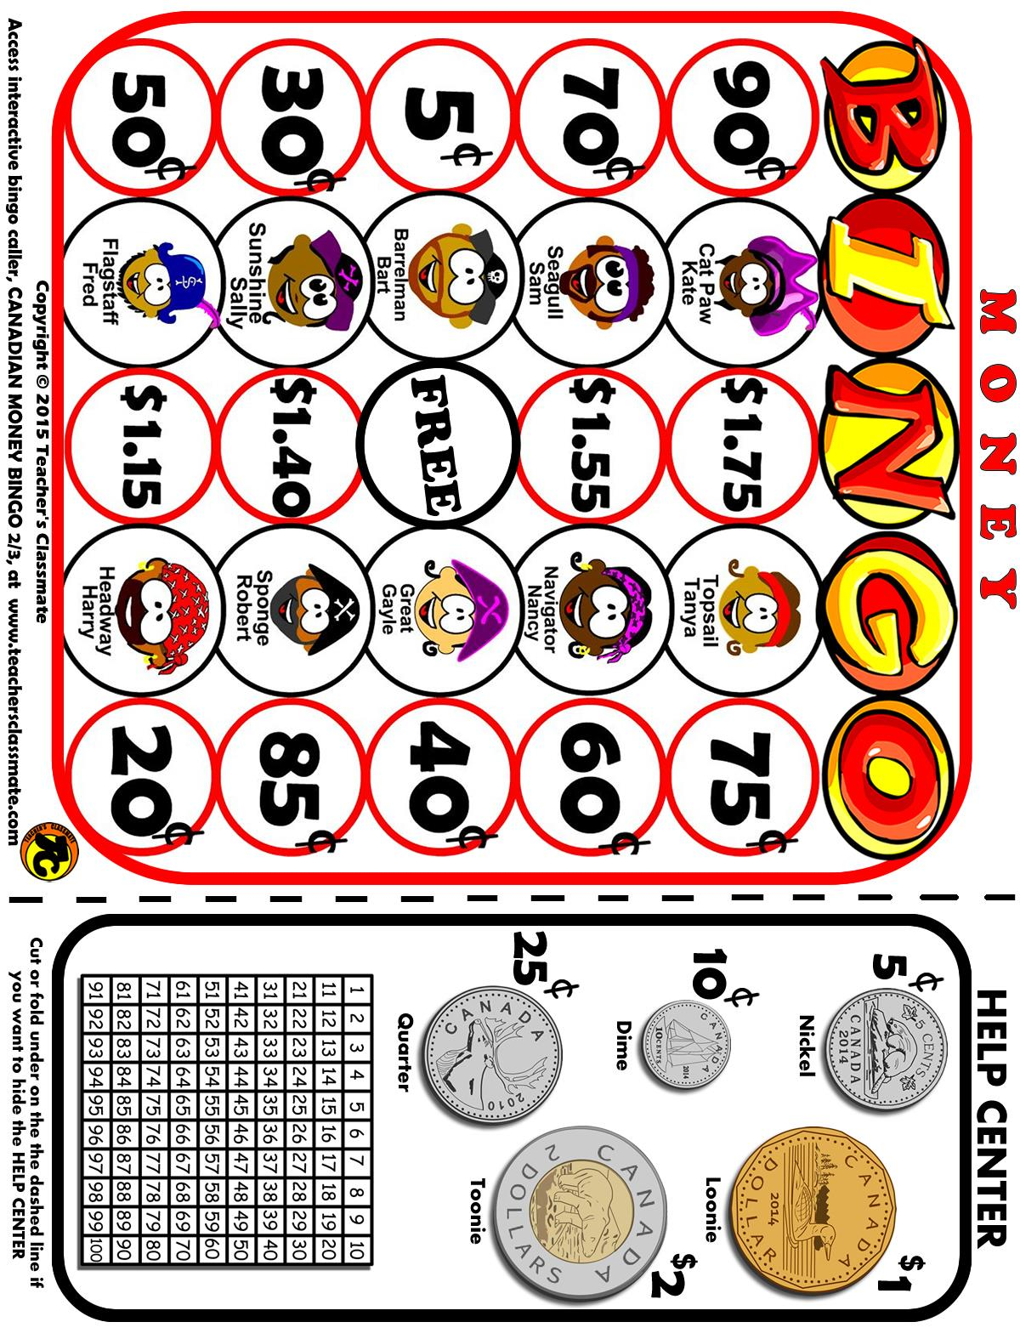
Copyright © 2015 Teacher's Classmate
