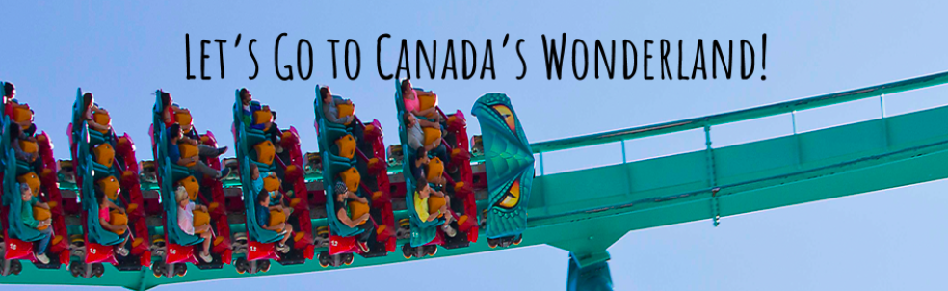
We are all finally going on a class trip to Canada’s Wonderland!

CLICK ON THE LINKS BELOW:

THE FLY
https://www.youtube.com/watch?v=BtNOspvqDPA&list=PLSOlmvL4MTAohtUcKPSW2269i0BrKc1UD&index=4&t=3s

WHITEWATER CANYON
https://www.youtube.com/watch?v=1LB_XB3br4s&list=PLSOlmvL4MTAohtUcKPSW2269i0BrKc1UD&index=2&t=17s

SWING OF THE CENTURY
https://www.youtube.com/watch?v=V3yLtM5bnHs&list=PLSOlmvL4MTAohtUcKPSW2269i0BrKc1UD&index=4

PLANET SNOOPY
https://www.youtube.com/watch?v=HBsvj5fnWDI

KLOCKWERKS
https://www.youtube.com/watch?v=cecCU8rD4Ik&list=PLSOlmvL4MTAohtUcKPSW2269i0BrKc1UD&index=5

Select 1 ride and give me 6 descriptive sentences

Ride Name: ______________________

1)__________________________________________________________________________________________________________________________________________________________________________________
☐ Step #1 of OPP ☐ Step #2 of OPP ☐ Step #3 of OPP

2)__________________________________________________________________________________________________________________________________________________________________________________
☐ Step #1 of OPP ☐ Step #2 of OPP ☐ Step #3 of OPP

3)__________________________________________________________________________________________________________________________________________________________________________________
 ☐ Step #1 of OPP ☐ Step #2 of OPP ☐ Step #3 of OPP

4)__________________________________________________________________________________________________________________________________________________________________________________
 ☐ Step #1 of OPP ☐ Step #2 of OPP ☐ Step #3 of OPP

5)__________________________________________________________________________________________________________________________________________________________________________________
☐ Step #1 of OPP ☐ Step #2 of OPP ☐ Step #3 of OPP

6)__________________________________________________________________________________________________________________________________________________________________________________
☐ Step #1 of OPP ☐ Step #2 of OPP ☐ Step #3 of OPP

