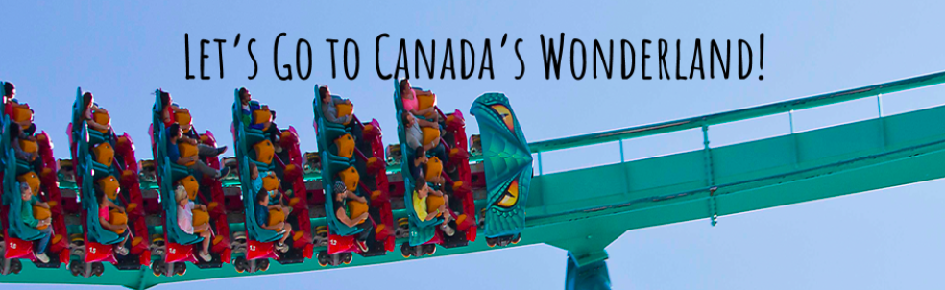
We are all finally going on a class trip to Canada’s Wonderland!
CLICK ON THE LINKS BELOW:
LEVIATHAN
https://www.youtube.com/watch?v=lBmwckH1SxI&list=PLSOlmvL4MTArWMkLN7OAasxGleEGyAP52&index=10&t=0s

SLINGSHOT
https://www.youtube.com/watch?v=9BnhLqioMZc&list=PLSOlmvL4MTAo6XT0P7Q0kLG8ywoz6yiEN&index=8

YUKON STRIKER
https://www.youtube.com/watch?v=3PghLRu0rB4&list=PLSOlmvL4MTArWMkLN7OAasxGleEGyAP52&index=2&t=35s

BEHEMOTH
https://www.youtube.com/watch?v=X1CFr8FDnTg&list=PLSOlmvL4MTArWMkLN7OAasxGleEGyAP52&index=3

GHOSTER COASTER
https://www.youtube.com/watch?v=_eDqUIkS_CE&list=PLSOlmvL4MTArWMkLN7OAasxGleEGyAP52&index=2

Select 1 ride and give me 6 descriptive sentences

Ride Name: ______________________

1)__________________________________________________________________________________________________________________________________________________________________________________
☐ Step #1 of OPP ☐ Step #2 of OPP ☐ Step #3 of OPP

2)__________________________________________________________________________________________________________________________________________________________________________________
☐ Step #1 of OPP ☐ Step #2 of OPP ☐ Step #3 of OPP

3)__________________________________________________________________________________________________________________________________________________________________________________
 ☐ Step #1 of OPP ☐ Step #2 of OPP ☐ Step #3 of OPP

4)__________________________________________________________________________________________________________________________________________________________________________________
 ☐ Step #1 of OPP ☐ Step #2 of OPP ☐ Step #3 of OPP

5)__________________________________________________________________________________________________________________________________________________________________________________
☐ Step #1 of OPP ☐ Step #2 of OPP ☐ Step #3 of OPP

6)__________________________________________________________________________________________________________________________________________________________________________________
☐ Step #1 of OPP ☐ Step #2 of OPP ☐ Step #3 of OPP

