We are all finally going on a class trip to Canada’s Wonderland!

Describe what you already know about this amusement park in a paragraph below:

⃝ I indented the paragraph (5 finger spaces)
⃝ I have a topic sentence introducing the focus in a general way.
____________________________________________________________________________________________________________________________________________

⃝ I have added 3-5 sentences that support the paragraph’s focus.
⃝ I used transition words (First, Second, Third, Next, Then, Last,)
_____________________________________________________________________________________________________________________________________________________________________________________________________________________________________________________________________________________________________________________________________________________________________________________________________________________________________________________________________________________________________________________________________________

⃝ I have a closing sentence to finish off my paragraph. This closing sentence restates the focus and might tease the reader to read onto the next paragraph. (Now you know, In conclusion, In Summary,…Read on to learn all about ___________.
____________________________________________________________________________________________________________________________________________
⃝ I (or my proofreading partner) edited my work using “O.P.P.”

The fastest route to Canada’s Wonderland from our school is 29 kilometers (km). Our bus leaves Sir John A. Macdonald P.S. at 8:45 am to go to Canada’s Wonderland. Some students needed to go to the bathroom along the way, so the bus only drove 7 km to the closest Walmart to use their restrooms. The bus drove another 4 km until the bus stopped at a gas station to fill up on gas. How many kilometers are left to drive to Canada’s Wonderland?
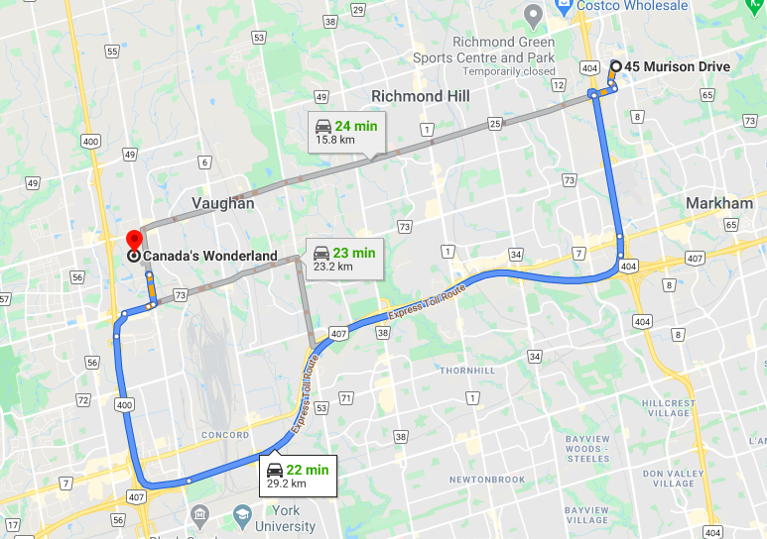
PICTURES | NUMBERS | WORDS

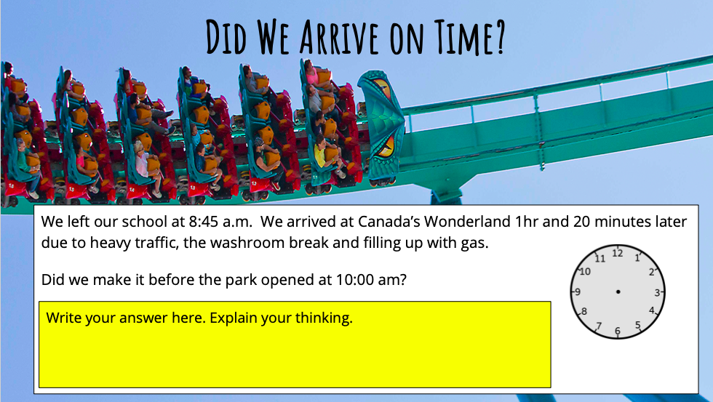

CLICK ON THE LINKS BELOW:
THE FLY
https://www.youtube.com/watch?v=BtNOspvqDPA&list=PLSOlmvL4MTAohtUcKPSW2269i0BrKc1UD&index=4&t=3s

WHITEWATER CANYON
https://www.youtube.com/watch?v=1LB_XB3br4s&list=PLSOlmvL4MTAohtUcKPSW2269i0BrKc1UD&index=2&t=17s

SWING OF THE CENTURY
https://www.youtube.com/watch?v=V3yLtM5bnHs&list=PLSOlmvL4MTAohtUcKPSW2269i0BrKc1UD&index=4

PLANET SNOOPY
https://www.youtube.com/watch?v=HBsvj5fnWDI

KLOCKWERKS
https://www.youtube.com/watch?v=cecCU8rD4Ik&list=PLSOlmvL4MTAohtUcKPSW2269i0BrKc1UD&index=5

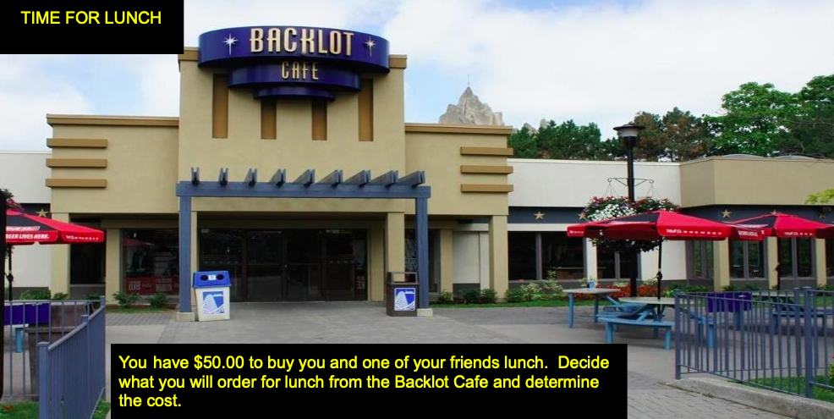
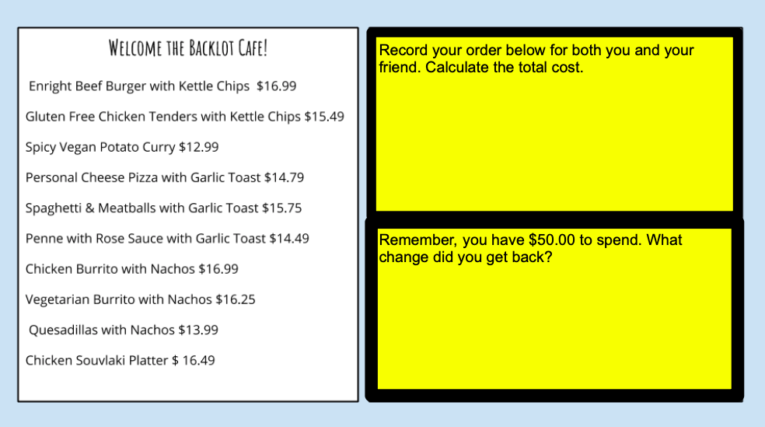

CLICK ON THE LINKS BELOW:
LEVIATHAN
https://www.youtube.com/watch?v=lBmwckH1SxI&list=PLSOlmvL4MTArWMkLN7OAasxGleEGyAP52&index=10&t=0s

SLINGSHOT
https://www.youtube.com/watch?v=9BnhLqioMZc&list=PLSOlmvL4MTAo6XT0P7Q0kLG8ywoz6yiEN&index=8

YUKON STRIKER
https://www.youtube.com/watch?v=3PghLRu0rB4&list=PLSOlmvL4MTArWMkLN7OAasxGleEGyAP52&index=2&t=35s

BEHEMOTH
https://www.youtube.com/watch?v=X1CFr8FDnTg&list=PLSOlmvL4MTArWMkLN7OAasxGleEGyAP52&index=3

GHOSTER COASTER
https://www.youtube.com/watch?v=_eDqUIkS_CE&list=PLSOlmvL4MTArWMkLN7OAasxGleEGyAP52&index=2

IN YOUR OPINION, WHAT WAS THE BEST RIDE AT CANADA’S WONDERLAND?

COMPLETE A REVIEW PARAGRAPH
https://jonathandrooker.weebly.com/reviewpersuasive.html

REVIEW WRITING BRAINSTORMING
☐  COMPOUND SENTENCE | OPINION: | REASON:
☐ | EXAMPLE:  1)  2)  3)

☐  COMPOUND SENTENCE | OPINION: | REASON:
☐ | EXAMPLE:  1)  2)  3)

☐  COMPOUND SENTENCE | OPINION: | REASON:
☐ | EXAMPLE:  1)  2)  3)

☐  COMPOUND SENTENCE | OPINION: | REASON:
☐ | EXAMPLE:  1)  2)  3)

☐  COMPOUND SENTENCE | OPINION: | REASON:
☐ | EXAMPLE:  1)  2)  3)

☐  COMPOUND SENTENCE | OPINION: | REASON:
☐ | EXAMPLE:  1)  2)  3)

REVIEW PARAGRAPH WRITING
⃝ I indented the paragraph (5 finger spaces)
⃝ I state what is being reviewed.
_______________________________________________________________________________________________________________________________________________________________________________

⃝ I stated my opinions (Like/Pro/Advantage or Dislike/Con/Disadvantage) and reasons in compound sentences
⃝ I repeated the “Opinion-Reason-Example” process _____ times.
⃝ I used transition words (For example, Another example is, Lastly)
______________________________________________________________________________________________________________________________________________________________________________________________________________________________________________________________________________________________________________________________________________________________________________________________________________________________________________________________________________________________________________________________________________________________________________________________________________________________________________________
_________________________________________________________________________________________________________

⃝ I have a closing sentence stating my overall opinion.
⃝I have given what I have reviewed a score out of 5 _____________ s.
_______________________________________________________________________________________________________________________________________________________________________________
⃝ I edited my work using my “O.P.P.” checklist after every sentence.

