The following art/writing task will review the use of captions and labelling alongside the following drawing tips:
1) Pencil first! (Use a sharp pencil!)
2) Trace your pencil outline and texture with a black pen to make it pop!
3) Consider and select your colours and values.
(Light values require space between hatch lines. Dark values require hatch lines close to one another)
4) When hatching, use a consistent direction (unless texture is needed)

Instructions
1)Add all of the elements of your dream house using pencil first!
2)Record a number next to important details and record its meaning in the key provided below. (Don’t forget to use your spelling strategies).
3)Go through steps 2-4 listed above

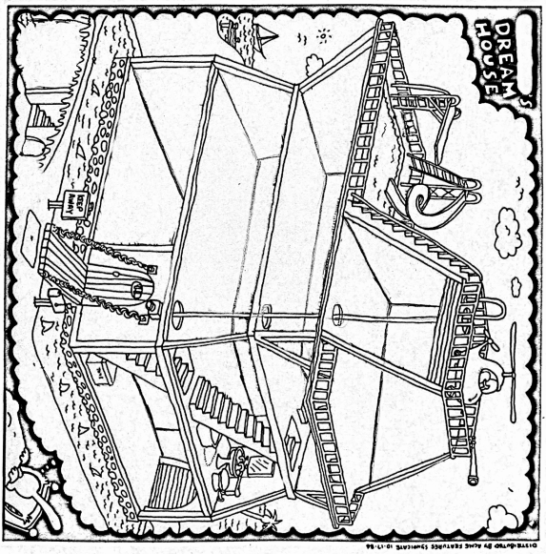

KEY

NUMBER | MEANING
1
2
3
4
5
6
7
8
9
10
11
12
13
14
15
16
17
18
19
20
21
22
23
24
25

