FREE FALL WRITING
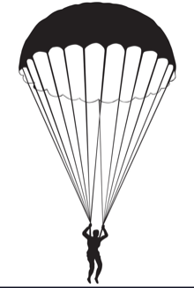
Record the title (don’t forget capitals!) of the prompt provided below. Write as much as you can about that topic until you are uninspired. Then select a topic of your own choosing. Write and center a new title and repeat the process beneath it. You will have 30 minutes altogether to free fall write!

Use the following post writing reflection questions to analyze your work:

Did you apply “Our Proofreading Plan” to your work after completion? Yes or No
Were you able to continuously with few pauses? Yes or No
Were you inspired by the initial writing prompt? Yes or No
Is the energy even throughout all of your writing pieces? Yes or No
Did your writing run out of energy in spots? Yes or No
Did you use juicy adjectives (words that describe nouns)? Yes or No
Did you use adverbs (words that describe verbs (action words))? Yes or No
Did you use your senses? Yes or No
Did you include dialogue? Yes or No
Did you include similes/metaphors? Yes or No
Did you have a balance between telling and showing? Yes or No
Is there something within this exercise that you would want to polish and publish in the future? Yes or No

_____________________

_________________________________________________________________________________________________________________________________________________________________________________________________________________________________________________________________________________________________________________________________________________________________________________
_________________________________________________________________________________________________________________________________________________________________________________________________________________________________________________________________________________________________________________________________________________________________________________
_________________________________________________________________________________________________________________________________________________________________________________________________________________________________________________________________________________________________________________________________________________________________________________
_________________________________________________________________________________________________________________________________________________________________________________________________________________________________________________________________________________________________________________________________________________________________________________
_________________________________________________________________________________________________________________________________________________________________________________________________________________________________________________________________________________________________________________________________________________________________________________
_________________________________________________________________________________________________________________________________________________________________________________________________________________________________________________________________________________________________________________________________________________________________________________
_________________________________________________________________________________________________________________________________________________________________________________________________________________________________________________________________________________________________________________________________________________________________________________
_____________________________________________________________________________________________________________________________________________________________________________________________________________

