Regular polygons: All sides and all angles are the same measurement.
Irregular polygons: Remember all it takes is one side or one angle to be different and you will have an irregular polygon
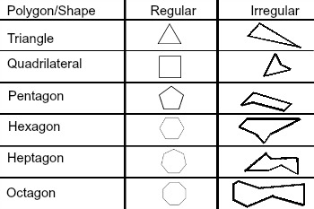

When labeling a shape, use the following rules:
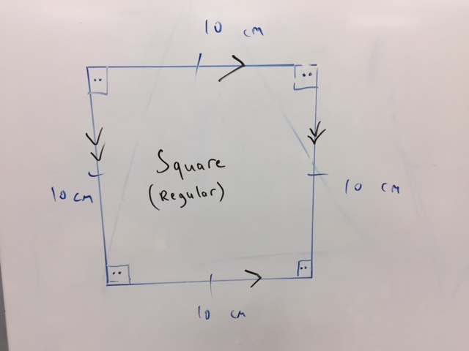
- Put an arc in any inside angles
- If two or more angles are the same measure, place the same symbol inside the arc
- Measure all sides and record the length outside of the shape
- Use a notch symbol on any sides that are the same length
- Put the chevron symbol to show any parallel sides
- Record the name of the shape and identify if it is regular or irregular inside the shape

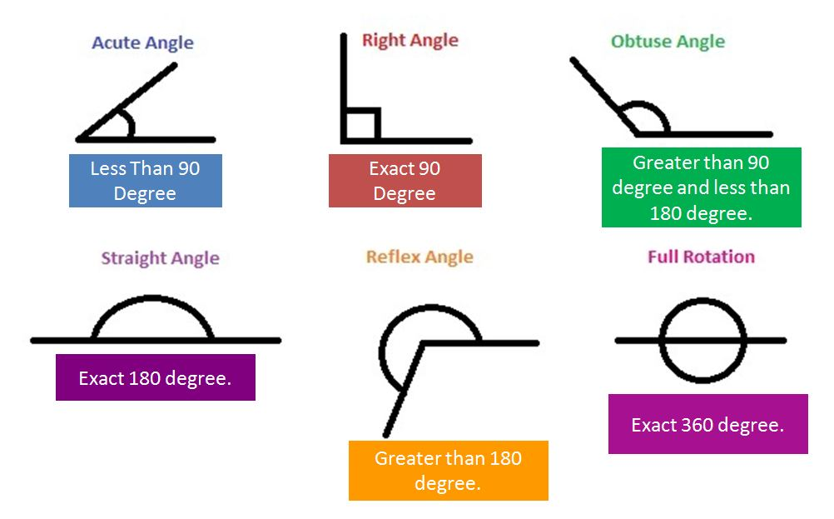
Name Tricks
Triangle | 3 | 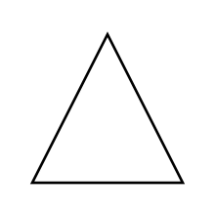
Quadrilateral | 4 | 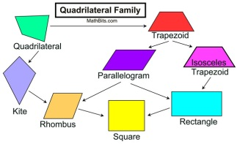
Pentagon | 5 | 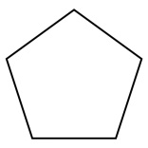 | 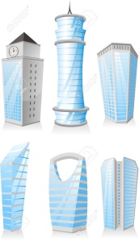
Hexagon | 6 | 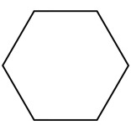 | “Hex”=Spell  6 devil/witch
Heptagon | 7 | 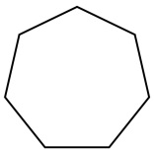 | Hept = Sept (7 in French)
Octogon | 8 | 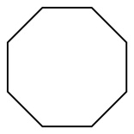
Nonogon | 9 | 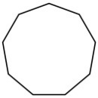 | Nonagon (Starts with N for nine)
Decagon | 10 | 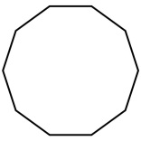 | Deca/Deka is greek for 10

Types of Triangles
