GRADE 3 HERITAGE AND IDENTITY
1780-1850
ARTIFACT TASK
https://www.drooker.ca/communities-1780-1850.html

STEP 1: SELECT 1 ARTIFACT

☑ Checkers Board Game
☑ Pin the Tail on the Donkey Game
☑ Jacob’s Ladder Game
☑ Sled/Toboggan
☑ Rounders Bat
☑ Hoop and Stick Game
☑ Ball and Cup Toy
☑ Corn Husk Doll
☑ Kazoo
☑ Spinning Top
☑ Butter Churn
☑ Maple Syrup
☑ Conestoga Wagon
☑ Macadamized Road
☑ Corduroy Road
☑ Steam Engine Locomotive
☑ Grist Mill
☑ Saw Mill
☑ The “3 Sisters” Planting strategy/plants
☑ Sod House, Shanty/Log House, Frame House, “Big House”
☑ Pemmican
☑ Food Preservation: Drying, Salting, Smoking, Pickling of food
☑ Dug Out Canoe
☑ Lock Waterway System
☑ Cornbread/Cornbread Pan
☑ Mallet
☑ Wool Carder
☑ Candle Snuffer
☑ Rattle
☑ Slate Board
☑ Quill Pen
☑ Propose Your Own:______________________________________________________________________

STEP 2: Design the artifact! You need not go to any expense. Feel free to draw a picture of your artifact or design a model out of plasticine (Provided) or make a model out of Lego or papier mache or... If you’d like to actually explore the artifact and make it from scratch (e.g. butter, etc.) you’re welcome to as well!

STEP 3: Research your artifact and take notes!

Remember:
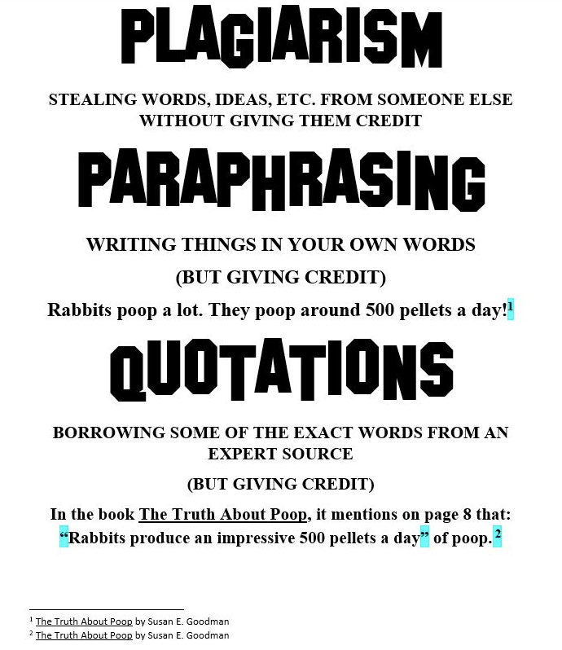
Remember: https://www.perplexity.ai is the ultimate tool. It will aggregate information into a summary with sources (essentially doing the work for you). If the information it provides you is too challenging, you might want to copy the information and paste it into https://chat.openai.com/ and use the “Explain like I’m 5 years old (“ELI5”) strategy”. If it’s still too challenging to understand, ask AI to provide you a summary as if you’re 5 years old while also incorporating analogies.

Other research tools are available here: (https://www.drooker.ca/educational-links.html)

Ensure you conduct sufficient research to answer the following guiding questions:

☐Who was the artifact used by?

☐What was the artifact used for?

☐What was the artifact made of?

☐Why is this artifact important?

STEP 4: Using your research and notes, explain the item’s importance in a concise paragraph.

STEP 5: Once steps 1 to 4 are complete, students in the class will be halved. One half will conduct a “gallery walk” or “museum visit” with the other half presenting as artifact experts. We will then change roles and repeat the process You’re welcome to get dressed up and perform your research in role (costumes, makeup, props, etc. are welcome!)

PARAGRAPH WRITING
⃝ A descriptive paragraph describes something.
⃝ A narrative paragraph tells a story.
⃝ A persuasive paragraph discusses an opinion.
⃝ An explanatory paragraph explains something.

THE OVERALL TOPIC IS: _________________________________________________________________
THE FOCUS OF MY PARAGRAPH IS: ______________________________________________________
⃝ I indented the paragraph (5 finger spaces)
⃝ I have a topic sentence introducing the focus in a general way.
_________________________________________________________________________________________________________________________________

⃝ I have added 3-5 sentences that support the paragraph’s focus.
⃝ I used transition words (First, Second, Third, Next, Then, Last,)
_____________________________________________________________________________________________________________________________________________________________________________________________________________________________________________________________________________________________________________________________________________________________________________________________________________________________________________________________________________________________________________________________________________________________________________________________________________________________________________________________________________________________________________________________________________________________________________________________________________________________________________________________________________________________________________________________________________________________________________________________________________________________

⃝ I have a closing sentence to finish off my paragraph. This closing sentence restates the focus and might tease the reader to read onto the next paragraph. (Now you know, In conclusion, In Summary,…Read on to learn all about ___________.
____________________________________________________________________________________________________________________________________________________________________________
⃝ I (or my proofreading partner) edited my work using “O.P.P.”

PRESENTATION EVALUATION

NAME/DATE/PURPOSE: _________________________________________________

STRONG
1) I made eye contact with the audience most of the time.
2) My voice was loud enough for everyone to hear
3) My voice level went up and down to emphasize meaning most of the time. I articulated clearly most of the time. The audience was able to understand every word.
4) I spoke at a good pace that kept the audience interested but without racing through my speech.
5) I avoided using “filler” words between my ideas (e.g., and…um…you know...like)
6) I used gestures to enhance the meaning of my words.
7) I knew my speech well enough so that I could just glance at my notes.
8) If I used visual aids or props, they helped make things clearer.
PART-WAY THERE
1) I made eye contact with the audience some of the time. I made eye contact with a few people.
2) My voice was loud enough for the audience to hear part of the time. I was quiet at times
3) My voice level went up and down to emphasize meaning some of the time. I articulated clearly some of the time but mumbled at other times.
4) I spoke at a fairly good pace but there were times when I spoke too quickly.
5) I sometimes used “filler” words between my ideas (e.g., and…um…you know...like)
6) My gestures may have been a little stiff or unnatural.
7) I had to read my notes for some or most of my presentation.
8) If I used visual aids, they may not have added much to make things clearer.
JUST BEGINNING
1) I had a hard time making eye contact with the audience. I mostly looked up, away, or down.
2) My voice was too quiet for everyone to hear me.
3) I spoke in a monotone and mumbled.
4) I raced or dragged through my presentation.
5) I used a lot of “filler” words between my ideas (e.g., and…um…you know...like)
6) My gestures and movement seemed stiff or unnatural, or I moved around so much it distracted the audience.
7) I had to read my notes for most or all of my presentation.
8) If I used visual aids, they were confusing or distracting.
GRADE/FEEDBACK:
