GRADE 3 DATA
MATH UNIT PLANNER
https://www.drooker.ca/dataprobability.html
UNIT AT A GLANCE
SUBJECT: | Math
GRADE: | 3
TIMELINE: | TBD
APPROXIMATE DATES: | TBD
PURPOSE: | Data handling allows children to make sense of information, to identify patterns and trends and to predict and plan for the future. This unit will assist students in data handling in a manner which will assist their nascent critical thinking skills. It will also expose students to real world situations which can be assisted and governed by data collection. Specifically, students will use collected data to influence public safety protocol.  In general, students in Grade 3:  -describe and compare data presented in charts, tables, graphs, and other graphic organizers (e.g., tally charts, Venn diagrams);  -describe the shape of the data (the distribution of the data) in graphs;  -interpret and make conclusions from information presented in charts, tables, and graphs;  -understand how data can be used to prove or disprove a statement.
LESSON 1: Sorting Data (3 + 4)
LESSON 2: Sorting Data Carrol Diagrams (6)
LESSON 3: Sorting Data Venn Diagrams (7 + 8)
LESSON 4: Sorting Data Tree Diagrams (9 + 10)
LESSON 5: Reading Tree Diagrams (11)
LESSON 6: Tally Marks and Frequency Tables (12 + 13)
LESSON 7: Mean (14 + 15)
LESSON 8: Mode/Mean and Mode (16 + 17)
LESSON 9: Collecting Data Quantitative (18)
LESSON 10: Discrete or Continuous Data (19)
LESSON 11: Horizontal Pictograph (20 + 21)
LESSON 12: Creating a Horizontal Pictogram (22)
LESSON 13 : Vertical Pictographs (23 + 24)
LESSON 14 : Creating a Vertical Pictogram (25)
LESSON 15 : Vertical Bar Graphs (26 + 27)
LESSON 16 : Drawing Bar Graphs (28 + 29)
LESSON 17 : Creating Scale (30 + 31)
LESSON 18 : Collecting Data Qualitative/Bar Graph/ (32 + 33, 34 + 35)
LESSON 19 : Collecting Data Quantitative/Bar Graph/ (36 + 37, 38 + 39)
LESSON 20 : Circle Graph (40)
LESSON 21 : Interpreting Line Graph (41)
LESSON 22 : Interpreting Double Bar Graphs (42)
LESSON 23 : Examing Scale/Applying Data Collection to Real World Scenarios (43+ 44 and Stop Sign Intersection Graphing Organizer)
LESSON 24 : Summative Task

MINISTRY EXPECTATIONS
OVERALL | SPECIFIC
GRADE 3  -manage, analyse, and use data to make convincing arguments and informed decisions, in various contexts drawn from real life | GRADE 3  -sort sets of data about people or things according to two and three attributes, using tables and logic diagrams, including Venn, Carroll, and tree diagrams, as appropriate  -collect data through observations, experiments, and interviews to answer questions of interest that focus on qualitative and quantitative data, and organize the data using frequency tables  -display sets of data, using many-to-one correspondence, in pictographs and bar graphs with proper sources, titles, and labels, and appropriate scales  -determine the mean and identify the mode(s), if any, for various data sets involving whole numbers, and explain what each of these measures indicates about the data  -analyse different data sets presented in various ways, including in frequency tables and in graphs with different scales, by asking and answering questions about the data and drawing conclusions, then make convincing arguments and informed decisions
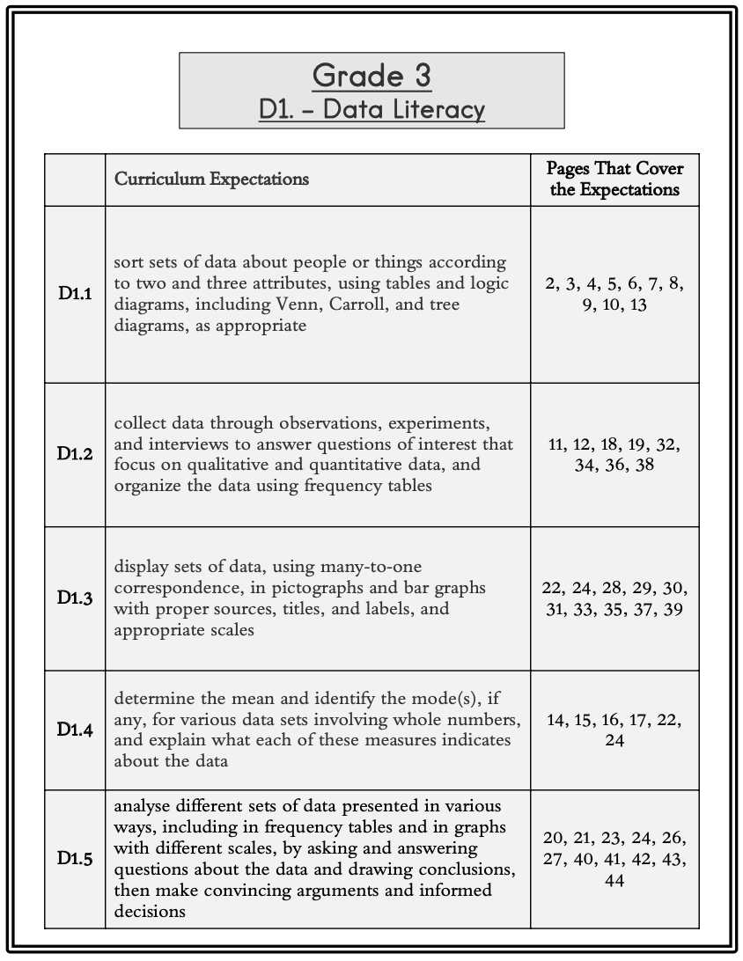

ACHIEVEMENT CHART
KNOWLEDGE/  UNDERSTANDING  *Knowledge of Data Management | Able to sort and classify objects about people or things according to two or three attributes, using tables and logic diagrams, including Venn, Carroll and Tree diagrams  Able to describe the sorting rule that was used.  Identify the mean and mode (s) for various data sets presented in concrete graphs, pictographs, line plots, bar graphs, and tables  Collect data through observations, experiments, and interviews to answer questions of interest that focus on qualitative and quantitative data and organize the data using frequency tables
THINKING  *Creative/critical thinking processes are used to form an answer in their words | Understands that people survey to learn information and that pictographs show information  Able to explain what the mean and mode indicates about the data collected  Able to analyze different sets of data by asking and answering different questions about the data
COMMUNICATION  *Clear expression and logical organization of an answer  *Use of conventions (spelling, grammar, punctuation) | Shows mathematical thinking and understanding in an organized way using charts, graphs, tally marks, numbers and words  Display sets of data using many to one correspondence in pictographs and bar graphs with proper sources, titles, labels and appropriate scales
APPLICATON  *Transfers ideas from text into other texts and/or world outside | Able to develop a survey question, and able to describe what was learned from the data  Able to analyze data presented in various ways, including in frequency tables and in graphs with different scales and draw conclusions and make convincing arguments and informed decisions about the data as it applies to real world situations

PRIOR LEARNING
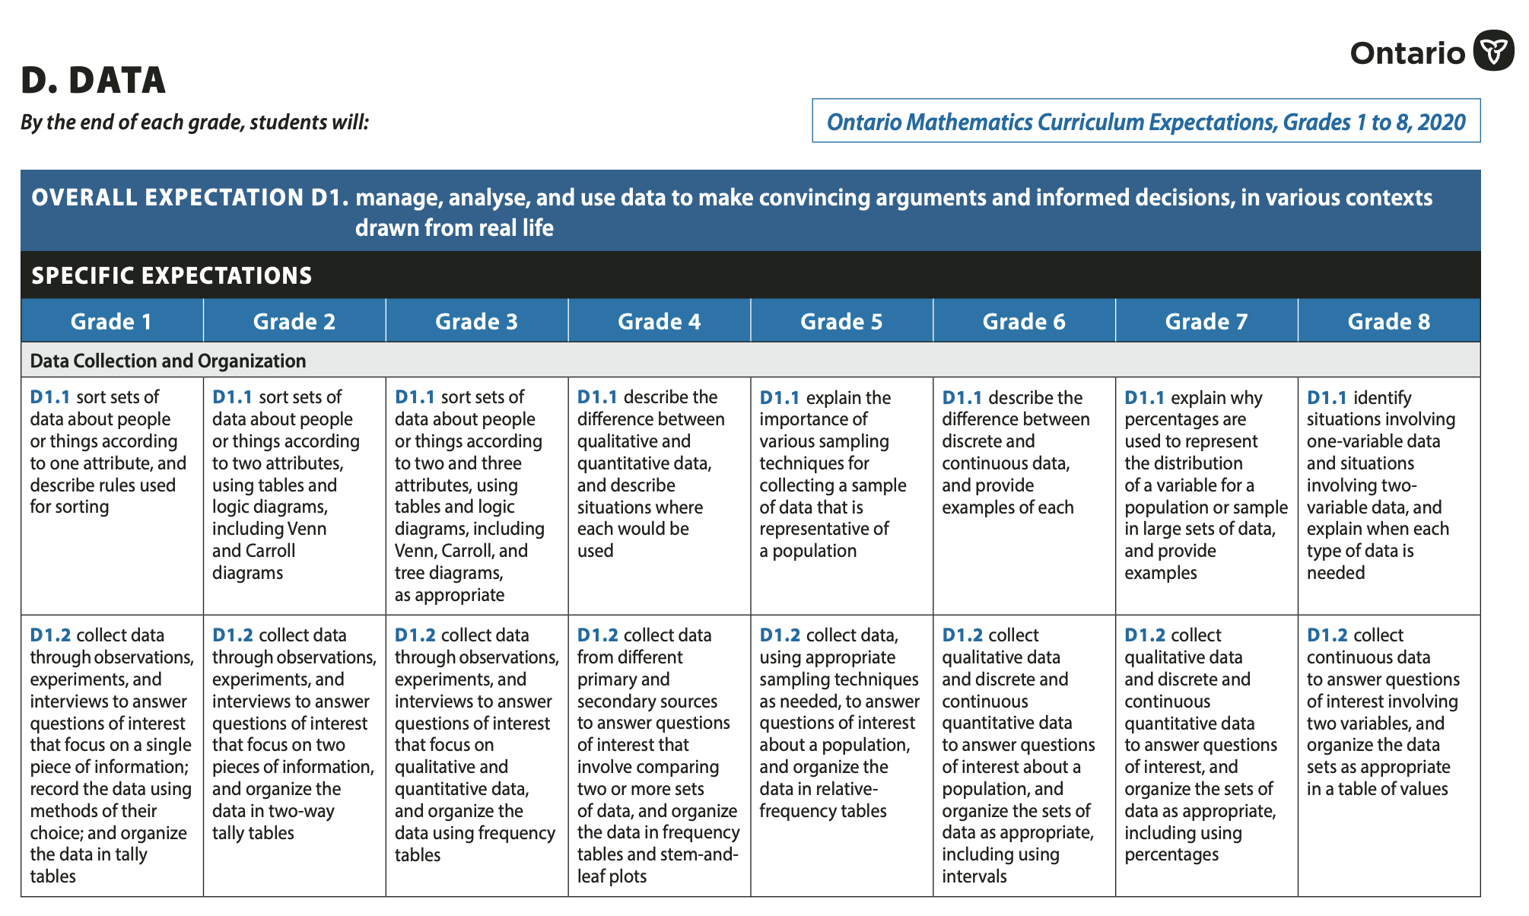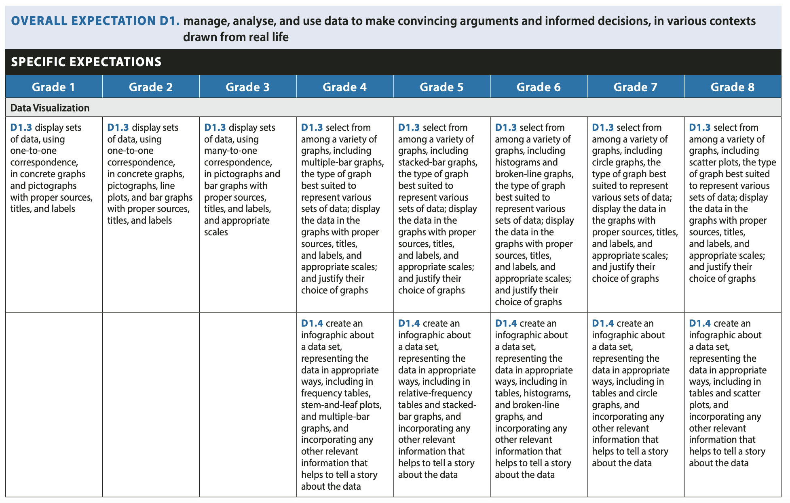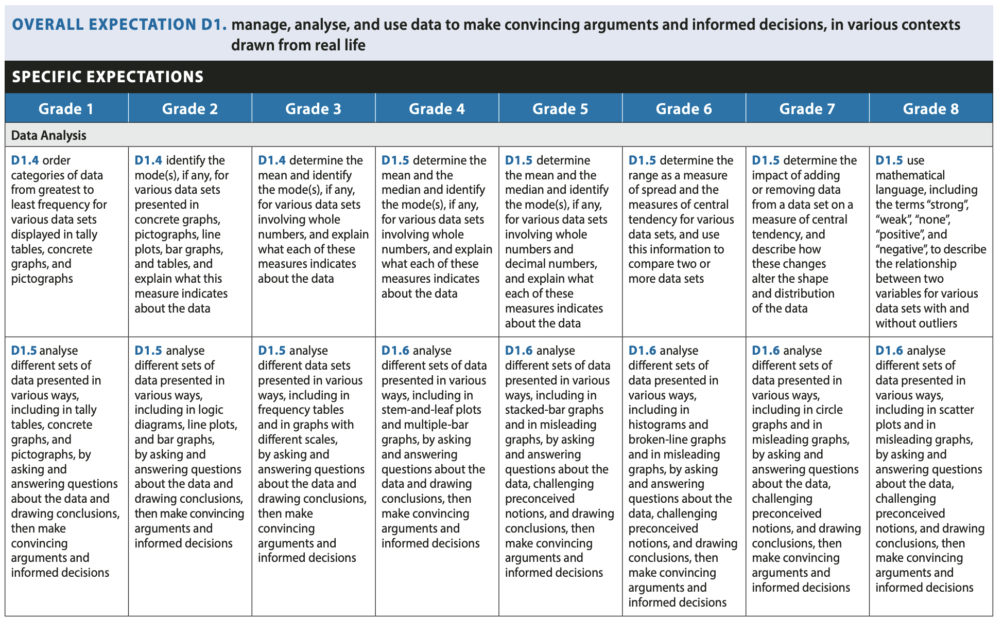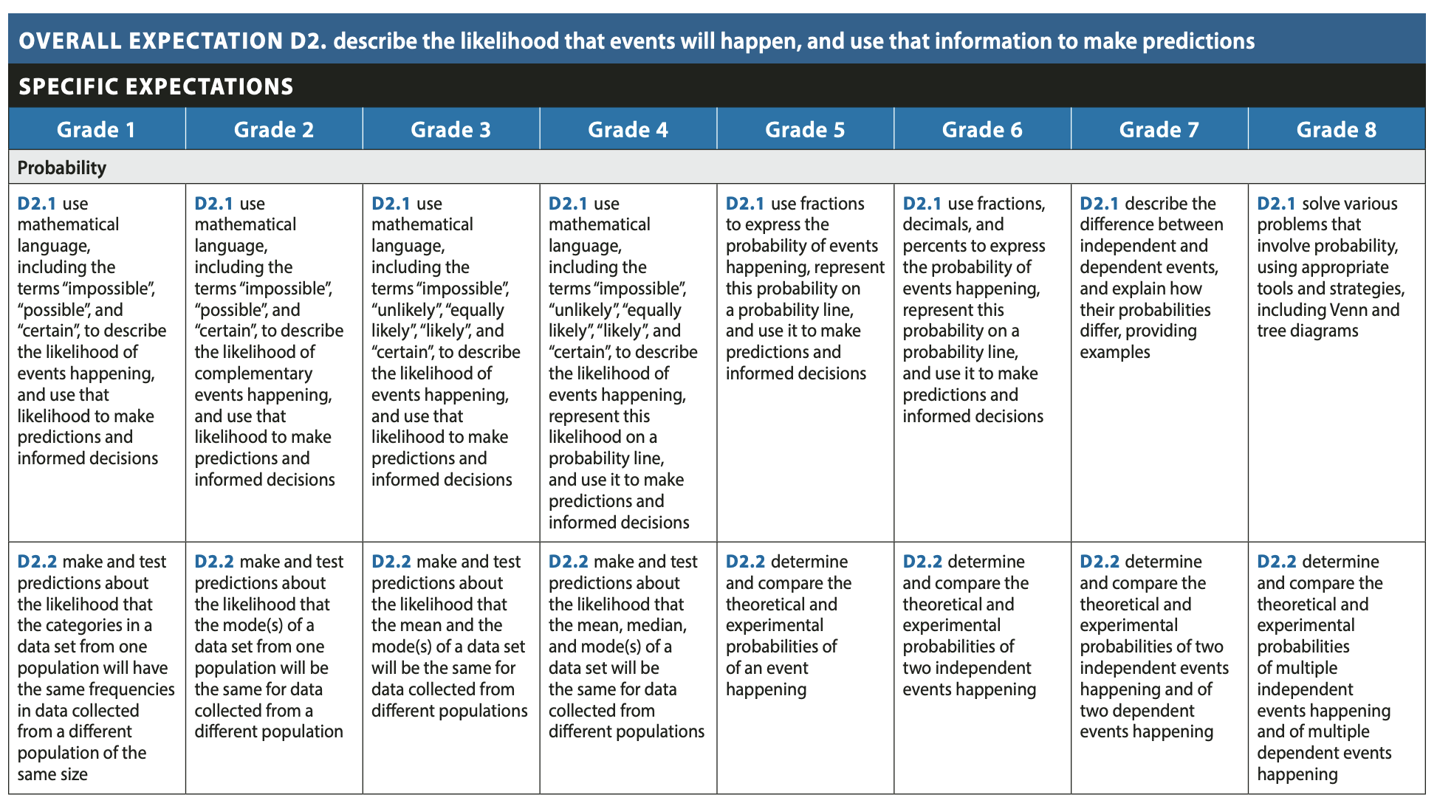

GUIDING QUESTIONS
(Throughout the Unit)
Students in Grade 3 benefit from the following instructional strategies:

-posing questions that require students to examine and describe information in graphs and other graphic organizers (e.g., tally charts, Venn diagrams);
-asking students to compare (e.g., more, less, equal, most, fewest) the number of items in different categories of a graph;
-providing opportunities for students to pose questions about information presented in a graph (e.g., “What question could you ask a classmate about this graph?”);
-posing questions that encourage students to interpret and make conclusions from information presented in charts, tables, and graphs, for example, “Why does the graph show that most students wore a coat today?” “What does the chart tell us about the number of children in most families?”;
-discussing what a specific graph shows and does not show, for example, by asking them, “What does the graph tell us about our favourite animals? What does the graph not tell us?”;
-discussing the shape of the data (the distribution of the data) in graphs (e.g., “Most of the data are at the high end”);
-having students find and discuss the mode (i.e., the value that occurs most often) in a set of data;
-having students judge whether certain statements about information in a graph are correct or incorrect (e.g., “Is this statement true or false? Most students chose milk as their favourite drink.”).

LEARNING GOALS
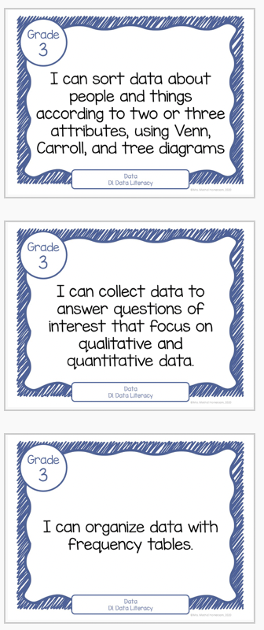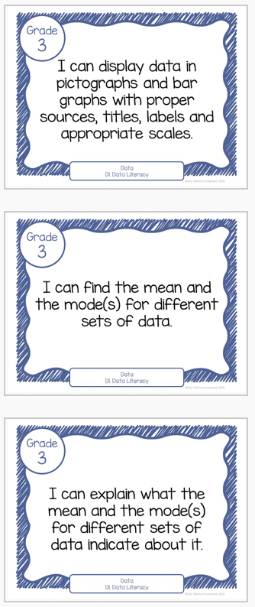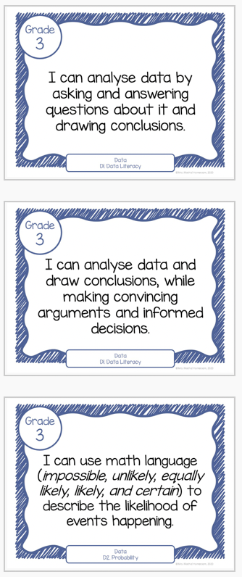
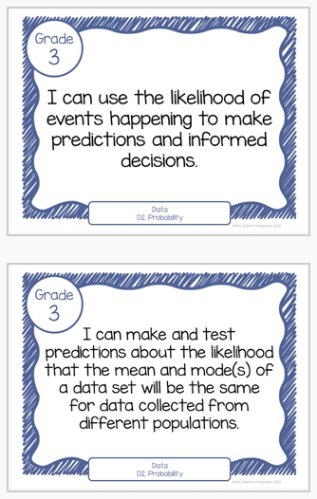

SUCCESS CRITERIA
~ understands that data can be collected, organized, and displayed in a variety of ways.
~ collects and organizes data from a variety of sources.
~ organizes and displays data in charts and graphs.
~ creates a meaningful survey question, collects data from peers, and transfers the data into a labelled graph.
~ uses data to create a labelled graph.
~ understands that each piece of data collected in a survey will need one count on a graph.
~ asks questions to clarify understanding of the concept.
~ communicates mathematical thinking (orally, visually and in writing) using mathematical vocabulary, in a variety of representations.
~ uses feedback from teacher and peers to improve the clarity of math explanations.
~ uses a variety of methods when representing thinking.
~ checks the reasonableness of solution.
~ asks questions about data displayed in graphs.
~ makes relevant statements about data displayed in bar graphs.
~ asks and answers questions about data collected from the class.
~ reads and interprets bar graphs and charts.
~ uses comparative mathematical language when describing the data in a graph (e.g., more, most, least).
~ uses the information displayed in a graph to draw conclusions.
~ asks relevant questions when reading data in graphs and tables.
~ uses a variety of methods when representing thinking.
~ proves and justifies solutions.
~ checks the reasonableness of his solution.
~ predicts and investigates the frequency that an event will occur.
~ conducts simple probability experiments.
~ using mathematical language, ~ predicts the frequency of a specific outcome in a probability investigation.
~ understands what makes a game fair or unfair.
~ compares predictions to the results of an experiment.
~ uses appropriate math vocabulary when communicating understanding in math posters and journals.
~ uses a variety of methods when representing thinking.
~ proves and justifies his solutions.
~ checks the reasonableness of solutions.
~ sorts sets of data about people or things according to two and three attributes, using tables and logic diagrams, including Venn, Carroll, and tree diagrams, as appropriate
~ collect data through observations, experiments, and interviews to answer questions of interest that focus on qualitative and quantitative data, and organize the data using frequency tables
~ display sets of data, using many-to-one correspondence, in pictographs and bar graphs with proper sources, titles, and labels, and appropriate scales
~determine the mean and identify the mode(s), if any, for various data sets involving whole numbers, and explain what each of these measures indicates about the data
~analyses different data sets presented in various ways, including in frequency tables and in graphs with different scales, by asking and answering questions about the data and drawing conclusions, then make convincing arguments and informed decisions
~uses mathematical language, including the terms “impossible”, “unlikely”, “equally likely”, “likely”, and “certain”, to describe the likelihood of events happening, and use that likelihood to make predictions and informed decisions
~makes and tests predictions about the likelihood that the mean and the mode(s) of a data set will be the same for data collected from different populations

ENDURING UNDERSTANDINGS
(What students should know after unit completion)
Beyond consolidating their data management skills, students will parlay their nascent data management skills into a school/neighborhood safety campaign and will gain greater insight into data driven policy making from Markham Mayor Frank Scarpitti.

ACCOMODATIONS
Please refer to appendix of accommodations accompanying this unit plan. https://education.alberta.ca/media/525534/ipp6.pdf

Partner/peer helper
Ongoing feedback
Computer/ Internet
Additional time
Technology for organization
Scribe/handout
Alternatives to writing (charts, tables or graphic organizers)
Specialized tools and materials
Alternate assignment
Oral test
IEPs for other modifications
Modified note/handout
Other
Dictionaries
List of important vocabulary
Verbal demonstration
Reword the instructions
Reinforcing effort and providing recognition
Taped material
Anchor activities
Literature circles
Learning contracts
Small-group instruction
Group investigation
Independent study
4MAT
Varied questioning strategies
Compacting
Varied journal prompts

PEDAGOGICAL WEBSITES/RESOURCES
A Guide to Effective Instruction in Mathematics, Kindergarten to Grade 3
Data Management and Probability
https://thelearningexchange.ca/wp-content/uploads/2017/01/Data-Management-and-Probability-K-3.pdf

https://nces.ed.gov/nceskids/createagraph/

https://www.drooker.ca/dataprobability.html

https://www.drooker.ca/math-toolkit.html

https://www.drooker.ca/numeracy-block.html

http://www.amathsdictionaryforkids.com/MathsChartsPDFs/Data%20and%20Statistics.pdf

http://www.amathsdictionaryforkids.com/qr/qr.html

ASSESSMENT STRATEGIES | ASSESSMENT DEVICES | TECHNOLOGY
Conference  Classroom Presentation  Interview  Questions/Answers  Exhibition/Demonstration  Learning Log  Observation  Performance Task  Quiz, Test, Examination  Select Response  Self-Assessment  Peer Assessment  Conference  Portfolio  Response Journal | Checklist  Rubric  Rating Scale  Anecdotal Notes  Journal  Pictures  Audio Recording | Laptop/LCD Projector  Document Camera  Classroom Laptops  Classroom Tablets  Laptop/Tablet Cart
MULTIPLE INTELLIGENCES | DIFFERENTIATED INSTRUCTIONS  (INSTRUCTIONAL INTELLIGENCES)  http://goo.gl/11rwT9 | BLOOM’S TAXONOMY VERBS
Visual Spatial  Bodily Kinesthetic  Musical  Interpersonal  Intrapersonal  Linguistic  Logical-mathematical  Natural  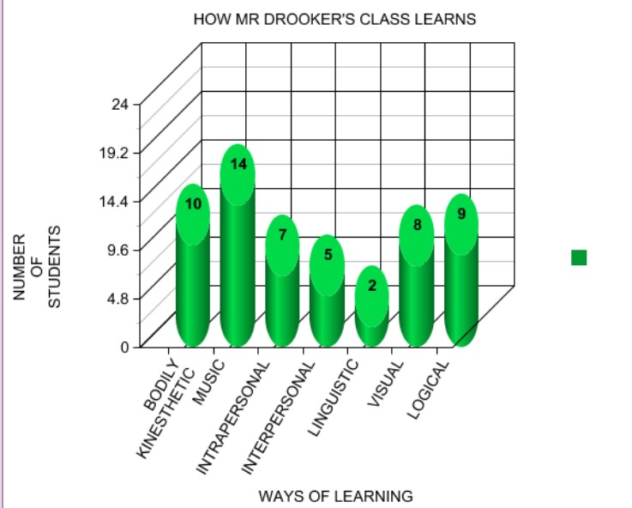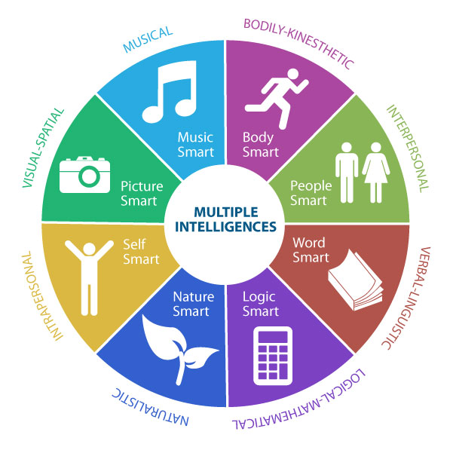 | Think/Pair/Share  Placemat  PMI: Positive/Minus/Interesting  EBS: Examine Both Sides  Fishbone  Venn Diagrams  Numbered Heads  Value Lines/Walkabout  Cooperative Learning  Inside/Outside Circles  Four Corners  Three Step Interview  Graffiti  Team Games Tournament  Concept Attainment  Six Thinking Hats  Discussion  Peer Practice  Cloze  Demonstrations  Flash Cards  Guided Exploration  Guided Reading  Guided Writing  Making Words  Read Along  Shared Read  Independent read  Word wall  Word menu  Work book  Reading Response  Brainstorming  Classifying  Concept Clarification  Estimating  Problem Solving  Writing to learn  Choral reading  Chanting  Games | Knowledge: Count, Define, Describe, Draw, Find, Identify, Label, List, Match, Name, Quote, Recall, Recite, Sequence, Tell, Write  Comprehension: Conclude, Demonstrate, Discuss, Explain, Generalize, Identify, Illustrate, Interpret, Paraphrase, Predict, Report, Restate, Review, Summarize, Tell  Application (Doing after being shown how): Apply, Change, Choose, Compute, Dramatize, Interview, Prepare, Produce, Role-play, Select, Show, Transfer, Use  Analysis (Consider the parts separately): Analyze, Characterize, Classify, Compare, Contrast, Debate, Deduce, Diagram, Differentiate, Discriminate, Distinguish, Examine, Outline, Relate, Research, Separate  Synthesis (Create, Design, Invent): Compose, Construct, Create, Design, Develop, Integrate, Invent, Make, Organize, Perform, Plan, Produce, Propose, Rewrite  Evaluation (Judge, Critically Appraise): Appraise, Argue, Assess, Choose, Conclude, Critic, Decide, Evaluate, Judge, Justify, Predict, Prioritize, Prove, Rank, Rate, Select

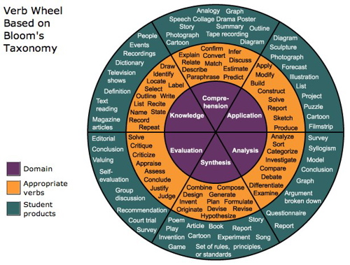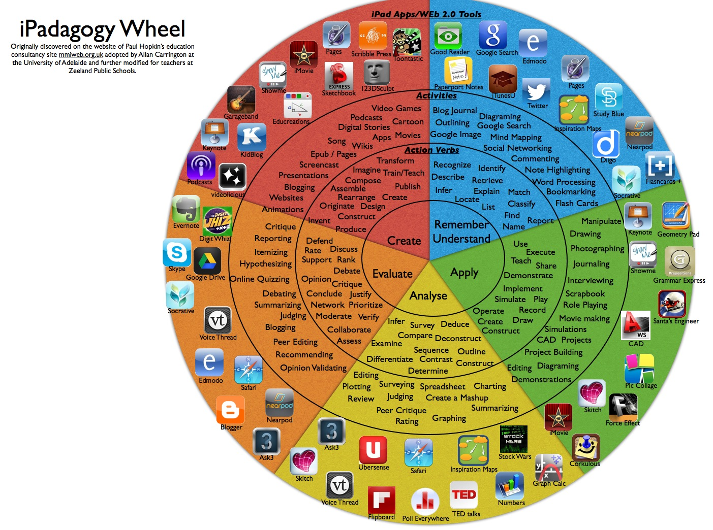

GRADE 3 DATA OVERALL EXPECTATION RUBRIC
LEVEL 1 | LEVEL 2 | LEVEL 3 | LEVEL 4
With limited effectiveness, you manage, analyse, and use data to make convincing arguments and informed decisions, in various contexts drawn from real life | With some effectiveness, you manage, analyse, and use data to make convincing arguments and informed decisions, in various contexts drawn from real life | With considerable effectiveness, you manage, analyse, and use data to make convincing arguments and informed decisions, in various contexts drawn from real life | With a high degree of effectiveness, you manage, analyse, and use data to make convincing arguments and informed decisions, in various contexts drawn from real life
With limited effectiveness, you describe the likelihood that events will happen, and use that information to make predictions | With some effectiveness, you describe the likelihood that events will happen, and use that information to make predictions | With considerable effectiveness, you describe the likelihood that events will happen, and use that information to make predictions | With a high degree of effectiveness, you describe the likelihood that events will happen, and use that information to make predictions
STRENGTHS (HIGHLIGHTED):
~ understands that data can be collected, organized, and displayed in a variety of ways.
~ collects and organizes data from a variety of sources.
~ organizes and displays data in charts and graphs.
~ creates a meaningful survey question, collects data from peers, and transfers the data into a labelled graph.
~ uses data to create a labelled graph.
~ understands that each piece of data collected in a survey will need one count on a graph.
~ asks questions to clarify understanding of the concept.
~ communicates mathematical thinking (orally, visually and in writing) using mathematical vocabulary, in a variety of representations.
~ uses feedback from teacher and peers to improve the clarity of math explanations.
~ uses a variety of methods when representing thinking.
~ checks the reasonableness of solution.
~ asks questions about data displayed in graphs.
~ makes relevant statements about data displayed in bar graphs.
~ asks and answers questions about data collected from the class.
~ reads and interprets bar graphs and charts.
~ uses comparative mathematical language when describing the data in a graph (e.g., more, most, least).
~ uses the information displayed in a graph to draw conclusions.
~ asks relevant questions when reading data in graphs and tables.
~ uses a variety of methods when representing thinking.
~ proves and justifies solutions.
~ checks the reasonableness of his solution.
~ predicts and investigates the frequency that an event will occur.
~ conducts simple probability experiments.
~ using mathematical language, ~ predicts the frequency of a specific outcome in a probability investigation.
~ understands what makes a game fair or unfair.
~ compares predictions to the results of an experiment.
~ uses appropriate math vocabulary when communicating understanding in math posters and journals.
~ uses a variety of methods when representing thinking.
~ proves and justifies his solutions.
~ checks the reasonableness of solutions.
~ sorts sets of data about people or things according to two and three attributes, using tables and logic diagrams, including Venn, Carroll, and tree diagrams, as appropriate
~ collect data through observations, experiments, and interviews to answer questions of interest that focus on qualitative and quantitative data, and organize the data using frequency tables
~ display sets of data, using many-to-one correspondence, in pictographs and bar graphs with proper sources, titles, and labels, and appropriate scales
~determine the mean and identify the mode(s), if any, for various data sets involving whole numbers, and explain what each of these measures indicates about the data
~analyses different data sets presented in various ways, including in frequency tables and in graphs with different scales, by asking and answering questions about the data and drawing conclusions, then make convincing arguments and informed decisions
~uses mathematical language, including the terms “impossible”, “unlikely”, “equally likely”, “likely”, and “certain”, to describe the likelihood of events happening, and use that likelihood to make predictions and informed decisions
~makes and tests predictions about the likelihood that the mean and the mode(s) of a data set will be the same for data collected from different populations

NEXT STEPS (HIGHLIGHTED):

~Asking questions to explain his/her thinking when he/she has had to collect data (e.g., ‘what kind of ice cream his/her friends will want at a party’) will help him/her reflect on the strategies he/she used to get his/her answer.
~Helping to see the connection between real life situations and his/her ability to effectively organize data (e.g., making a tally for a preferred activity) will help him/her to apply his/her understanding in different contexts.
~He/She would benefit from reading and discussing graphs and tables found in newspapers or on websites.
~In order for him/her to use graphing in a real-life context, he/she could keep track of the weather in a week or a month and graph the results to see the trend.
~Asking questions to explain his/her thinking when he/she is reading graph will help him/her reflect on the strategies he/she uses.
~He/She would benefit from reading and discussing graphs found in the newspaper or on a website.
~In order to support the development of his/her mathematical vocabulary, he/she can describe graphs and explain how they support decision making and learning.
~At home, he/she is encouraged to share his/her conclusions about his/her data management project.
~In future science and social studies units, he/she will have further opportunities to interpret graphs.
~He/She will have opportunities to collect and interpret data when planning future activities in the classroom (e.g., organizing a class party).
~At school, he/she will be involved in activities that require him/her to read and represent data, such as collecting information for student council activities.
~To further improve his/her problem-solving skills, he/she needs to identify what the problem is, the information he/she has and needs to find out, and the strategies he/she will use in order to deepen his/her mathematical thinking around graphing.
~He/She will be given opportunities to communicate his/her mathematical thinking orally, visually and in writing in order to develop his/her mathematical vocabulary.
~He/She will be given opportunities to use his/her learning about how his/her thinking is represented in future strands of math in order to make connections about how we show our thinking to solve problems.
~He/She is encouraged to spend time building up the automaticity of his/her skills for this unit on www.mathletics.ca, www.ixl.com, etc.
~He/She is encouraged to conduct probability experiments at home (e.g., tossing coins, rolling dice).
~Asking questions to explain his/her thinking when he/she has made a predication will help him/her reflect on the strategies he/she used.
~Helping him/her to see the connection between real life situations and the need for predictions about everyday events (e.g., weather) will help him/her to apply his/her understanding in different contexts.
~He/She would benefit from discussions at home about what makes a game fair or unfair.
~At school, he/she will be involved in activities that require him/her to describe the outcome of events happening, such as discussing completion of tasks or competitive games.
~He/She will be given opportunities to communicate his/her mathematical thinking orally, visually and in writing in order to develop his/her mathematical vocabulary.
~With his/her math partners, he/she will have further opportunities to discuss the strategies he/she uses when solving problems.
OVERALL:

LESSON PLAN #

LESSON #
LESSON TITLE:
TIME ALLOTTED:
LEARNING TARGET:
SUCCESS CRITERIA:
CURRICULUM EXPECTATIONS:
INSTRUCTIONAL APPROACHES: | Modeled  Shared  Guided  Independent
INSTRUCTIONAL STRATEGIES:  http://goo.gl/11rwT9 | Think/Pair/Share  Placemat  PMI: Positive/Minus/Interesting  EBS: Examine Both Sides  Fishbone  Venn Diagrams  Numbered Heads  Value Lines/Walkabout  Cooperative Learning  Inside/Outside Circles  Four Corners  Three Step Interview  Graffiti  Team Games Tournament  Concept Attainment  Six Thinking Hats  Discussion  Peer Practice  Cloze  Demonstrations  Flash Cards  Guided Exploration  Guided Reading  Guided Writing  Making Words  Read Along  Shared Read  Independent read  Word wall  Word menu  Work book  Reading Response  Brainstorming  Classifying  Concept Clarification  Estimating  Problem Solving  Writing to learn  Choral reading  Chanting  Games
GROUPINGS: | Whole Class  Small Groups  Pairs  Individuals
ASSESSMENT CHECKPOINT:  ☐Diagnostic (Assessment of Previous Learning):  ☐Formative (Assessment for/as Learning):  Assessment FOR learning is the use of a task or an activity for the purpose of determining student progress during a unit or block of instruction. Teachers are now afforded the chance to adjust classroom instruction based upon the needs of the students. Similarly, students are provided valuable feedback on their own learning.  Assessment AS learning is the use of a task or an activity to allow students the opportunity to use assessment to further their own learning. Self and peer assessments allow students to reflect on their own learning and identify areas of strength and need. These tasks offer students the chance to set their own personal goals and advocate for their own learning.  ☐Summative (Assessment of Learning):  Assessment OF learning is the use of a task or an activity to measure, record and report on a student's level of achievement in regards to specific learning expectations. These are often known as summative assessments. | Test/quiz  Homework check  Assignment  Project  Presentation  Culminating task  Summative  Rubrics  Self-evaluation  Peer-evaluation  Application  Observation  Participation  Response/Reflection  Critique  Sketchbook/Hournal  Conferencing  Verbal feedback  Other:  Test  Conference  Product  Performance  Other:
 | 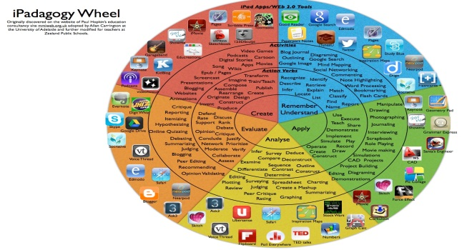
LEARNING SKILLS | Organization  Independent Work  Collaboration  Responsibility  Initiative  Self-Regulation
ACCOMODATIONS/MODIFICATIONS | https://education.alberta.ca/media/525534/ipp6.pdf  Partner/peer helper  Ongoing feedback  Computer/ Internet  Additional time  Technology for organization  Scribe/handout  Alternatives to writing (charts, tables or graphic organizers)  Specialized tools and materials  Alternate assignment  Oral test  IEPs for other modifications  Modified note/handout  Other  Dictionaries  List of important vocabulary  Verbal demonstration  Reword the instructions  Reinforcing effort and providing recognition  Taped material  Anchor activities  Literature circles  Learning contracts  Small-group instruction  Group investigation  Independent study  4MAT  Varied questioning strategies  Compacting  Varied journal prompts
COMPREHENSIVE MATH PROGRAM | MINI LESSONS: Where for a short time, the whole group or small group works together to increase fluency with mental math strategies. They’re building an understanding of connections and relationships between numbers:  Is there something about this concept that I must help students to name?  Are there connections that I need to draw attention to?  PUZZLES: Playing games and solving puzzles is another type of experience that builds understanding and computational skills:  What games and puzzles will build a deeper understanding of the math?  What game and puzzles support connections to other math content?  MEANINGFUL PROBLEMS: Meaningful problems are designed to support students in reaching specific mathematical goals while developing flexibility of ideas and strategies:  What scenarios will engage students in the math?  How can I help students investigate math content?  PURPOSEFUL PRACTICE  What will be meaningful practice?  Problems are often explored using a 3-part lesson structure:  - Setting the Context/Activating Students’ thinking  - Investigation Stage  - Consolidating the Learning
RESOURCES
BEFORE/ACTION:
(Mental Set/”Hook”)
DURING/MINDS ON:  (Model, Demonstrate, Guided Practice, Check for Understanding, Independent Practice) | Re-voice  Paraphrase  Agree or Disagree? Why?  Prompt for Participation  Wait Time
AFTER/CONSOLIDATION:
REFLECTION/NOTES:

