GROWTH AND CHANGE
IN ANIMALS

ANIMAL INVESTIGATION

Name: _______________

INSTRUCTIONS
1)Select one animal from one of the following 4 vertebrate groups (fish, amphibians, reptiles, and birds).
My selected animal: __________________________________
2)You will be finding similarities and differences between your chosen animal and yourself (a mammal). Using the organizer below, research and record your animal’s habitat (food, water, shelter and space). Do the same for yourself…after all, you are an expert on yourself!

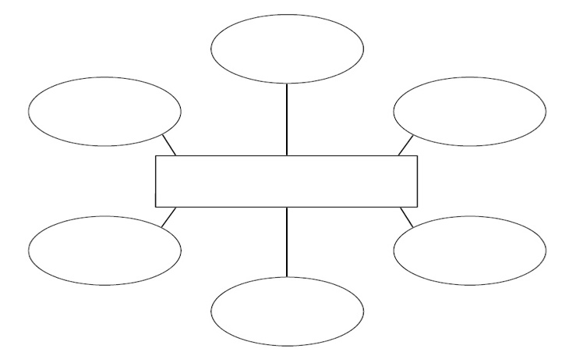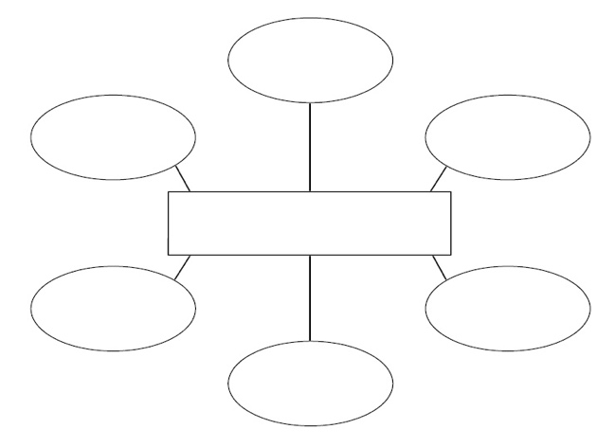

3)Now, design your animal and your habitat within a halved shoebox diorama. Make sure you show off physical characteristics of your animal and yourself and all features of both habitats (food, water, shelter, space).
4)Using your research, answer the following questions using the words in the question to start your answer.

CHOSEN ANIMAL:__________________________
Where does your animal get water from?
____________________________________________________________________________________________________________
What does it eat?
____________________________________________________________________________________________________________
Is it an omnivore, carnivore, or herbivore?
____________________________________________________________________________________________________________
Does your animal lay eggs or give birth to live babies?
____________________________________________________________________________________________________________

What does your animal use to breathe?
____________________________________________________________________________________________________________
Describe the physical characteristics of your animal’s skin, size, hair, limbs, etc:
________________________________________________________________________________________________________________________________________________________________________________________________________________________
Identify 3 ways in which your animal can be harmful to humans:
________________________________________________________________________________________________________________________________________________________________________________________________________________________
Identify 3 ways in which your animal can be helpful to humans:
________________________________________________________________________________________________________________________________________________________________________________________________________________________
Describe an adaptation of your animal towards its environment, predator, etc.:
________________________________________________________________________________________________________________________________________________________________________________________________________________________

YOU
Where do you get water from?
____________________________________________________________________________________________________________
What do you eat?
____________________________________________________________________________________________________________
Are you an omnivore, carnivore, or herbivore?
____________________________________________________________________________________________________________
Describe the physical characteristics of yourself (skin, size, hair, limbs, etc.):
________________________________________________________________________________________________________________________________________________
Identify 3 ways in which we as humans are harmful to your animal:
________________________________________________________________________________________________________________________________________________________________________________________________________________________
Identify 3 ways we as humans can help the survival of your animal:
________________________________________________________________________________________________________________________________________________________________________________________________________________________

Describe a personal adaptation towards your environment, predator, etc.:
________________________________________________________________________________________________________________________________________________________________________________________________________________________
5)Lastly, using the Venn diagram maker available here:
http://tiny.cc/vennd
to compare key identifying features of a mammal to your chosen animal’s vertebrate category.

https://jonathandrooker.weebly.com/animal-growth-and-change.html

