Level 4 Paragraph (Shared Write)
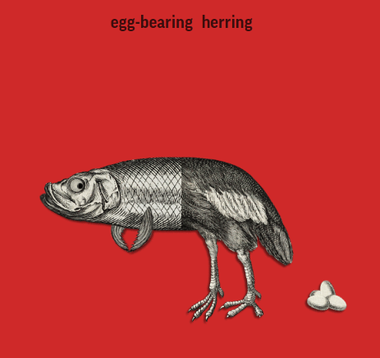
X A descriptive paragraph describes something.
⃝A narrative paragraph tells a story.
⃝ A persuasive paragraph discusses an opinion.
X An explanatory paragraph explains something.

X I planned how out I was going to break my topic into smaller “bites” (paragraphs) that a reader could digest.
THE OVERALL TOPIC IS: Gruesome Monsters
THE FOCUS OF MY PARAGRAPH IS: Egg Bearing Herring

Let me tell you all about a fearsome monster known as the Egg Bearing Herring! First, it is part fish and part chicken. Its front end is covered in fossil grey scales and it has two fins as well. Its back end is covered in white and black feathers. It lays eggs. It is an amphibious creature. It is terrifying because you rarely see a hybrid creature! It spends most of its time living between the thorns of rose bushes in Europe. Lastly, the Egg Bearing Herring’s disgusting breath suffocates you and causes you to throw up blood. If you want to survive, make sure you run into a foggy place. It has bad eyesight and will be unable to see you!

X I indented the paragraph (5 finger spaces)
X I have a topic sentence introducing the focus in a general way.
X I have added 3-5 sentences that support the paragraph’s focus.
X I used transition words (First, Second, Third, Next, Then, Last,)
X I have a closing sentence to finish off my paragraph. This closing sentence restates the focus and might tease the reader to read onto the next paragraph. (Now you know, In conclusion, In Summary,…Read on to learn all about ___________.
X I have utilized my writer’s toolkit for fresh words etc.
X I (or my proofreading partner) edited my work using “O.P.P.”

