LITERACY CIRCLES

Students will decide upon a book as a group.
Students will switch roles after every session.
Roles are as follows:
- Discussion Director
- Vocabulary Enricher
- Literary Luminary
- Checker
Students will decide as a group how many pages should be attempted to be read within a 15 minute reading block. They will set the goal using a post it note in their book. Students will take turns reading in their circle. The final 10 minutes will be used to discuss the book, highlight key sections, identify new vocabulary words and assess group performance.
Discussion Director: The Discussion Director promotes discussion using the Q chart and sample question sheet provided.
Vocabulary Enricher: The Vocabulary Enricher records any challenging words on the sheet provided. They will record the location of the word, the word in context and will use dictionary.com to record the definition.
Literary Luminary: The Literary Luminary’s role is to identify key passages that ought to be brought to the group’s attention. Possible reasons for picking a passage to be shared aloud: good dialogue, surprising, tells about characters, well-written, figurative language, funny, confusing, sets a mood, thought-provoking.
Checker: The Checker will assess individual participation and performance with a + or a – on the chart provided.

DISCUSSION DIRECTOR
The Discussion Director promotes discussion using the Q chart and sample question sheet provided. 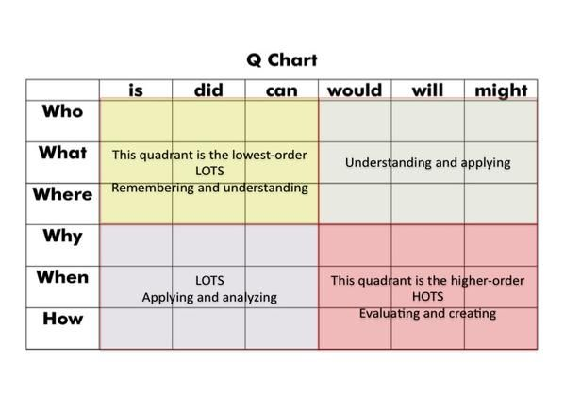
CHARACTERS
Who are the main characters in the story?
Which character do you like best? Why? Support with proof from the text and your own life.
Who is the most important character in the story? Why?
Do any of the characters change in the story? How?
Does a character do things that are good or bad? What kinds of things?
SETTING
Where does the story take place? Describe it!
When did this story take place? How do you know?

PLOT
What is the main problem in the story?
How was the problem solved?
What would you have done differently if you had been one of the characters?

MOOD
How did you feel while reading the story? Why did you feel that way?
What was the most exciting thing that happened? Why?
What was the funniest or saddest or strangest thing that happened? Why?
What do you remember most about the story?
STYLE
What special words does the author use to help you see the story?
What pictures did the author leave in your mind?
What is the best part of the story?
How would you improve the story?
THEME
Why did the author write this book?
Is there a message in this story? What is the message?
ILLUSTRATIONS
Do you like the illustrations? Why or why not? What could be improved?
PREDICTIONS
Before I read the book, I predicted that…
After the book ends, I predict…
QUESTIONING
I wonder how…
I wonder if…
I wonder why…
A question I have for the author is…
A part of the story that confused me was when…
CONNECTIONS
Text to Text
Does this remind you of another book? Which one? Why?
Have you read about a settling like this before?
Do the illustrations remind you of another book? Which one? Why?
Can you think of another book in the same genre? Which one?
Text to Self
How would you solve the problem in the story?
Is the problem like something that has happened to you before?
How does this book make you feel? Why?
Do you agree with what the main character did? Why?
Text to World
Does this remind you of something that happened in the news?
Has this ever happened before? Where? When?
REFLECTIONS
Now I understand that…
Now I understand why…
After reading the book, I want to…
NON FICTION
Did you know something about this topic before reading the book?
What did you learn about?
What are 3 new facts that you’ve learned from this book?
What was the most useful text feature for you? Why? (Italic/bold type, Photographs with captions, Headings and Subheadings, Illustrations/Diagrams, Table of Contents, Index, Glossary, Quiz/Test)

Vocabulary Enricher: The Vocabulary Enricher records any challenging words on the sheet provided. They will record the location of the word, the word in context and will use dictionary.com to record the definition.
Literary Luminary: The Literary Luminary’s role is to identify key passages that ought to be brought to the group’s attention. Possible reasons for picking a passage to be shared aloud: good dialogue, surprising, tells about characters, well-written, figurative language, funny, confusing, sets a mood, thought-provoking.

CHECKER

The Checker will assess individual participation and performance with a + or a – on the chart provided.

BOOK TITLE (Don’t Forget Capitals): _______________________________________________________

DATE: _______________________________________________________________________________
(Day, Month #, Year.)
GROUP MEMBER NAMES | DID THEY SHARE IN THE READING?  (Y OR N) | ROLE | PARTICIPATION  4 Point Scale  (4 for focused contributions and cooperative behaviors all the way down to  1-given for interrupting, washroom breaks, distracting, goofing off)
 |  | Checker | 4 3 2 1
 |  | Discussion Director | 4 3 2 1
 |  | Vocabulary Enricher | 4 3 2 1
 |  | Literary Luminary | 4 3 2 1

LITERARY LUMINARY
NAME: ________________________________________________________________________

BOOK TITLE (Don’t forget Capitals):_________________________________________________
The Literary Luminary locates a section of text to share with the group and states the reasons for choosing the selections.
Possible reasons for picking a passage to be shared aloud:
*Good dialogue
*Surprising
*Tells about characters
*Well-written
*Figurative language (Simile, alliteration, hyperbole, etc.)
*Funny
*Confusing
*Sets a mood
*Thought-provoking
PAGE: _______________________ PARAGRAPH/LINE: _________________________________
WHY DID YOU PICK THIS PASSAGE? ________________________________________________________________________________________________________________________________________________

VOCABULARY ENRICHER
The Vocabulary Enricher clarifies word meanings and pronunciations. In this role, the person writes how the word was used in the story and looks up each word in the dictionary. This person would also find the correct definition of the word.
NAME: ________________________________________________________________________
BOOK TITLE (Don’t forget Capitals): _________________________________________________

PAGE NUMBER
PARAGRAPHOR LINE NUMBER
WORD
SENTENCE FROM BOOK | ________________________________________________________________________________________________________________________
DEFINITION | ________________________________________________________________________________________________________________________

PAGE NUMBER
PARAGRAPHOR LINE NUMBER
WORD
SENTENCE FROM BOOK | __________________________________________________________________________________________
DEFINITION | __________________________________________________________________________________________

SUMMARIZER

The summarizer’s role is to give the gist of the fiction or non-fiction book that has been read.

FICTION RETELLING/SUMMARIZING
Who are the main characters?
Where does the story take place (setting)?
What was the major problem (conflict)?
How was the problem was solved (resolution)?
NON FICTION RETELLING/SUMMARIZING
What was the book/chapter mostly about?
First, I learned…
Then, I learned…
Next, I learned…
Lastly, I learned…
What text features did the author use to help you understand the information?

