THE “MOUNT RUSHMORE” OF OUR LEARNING
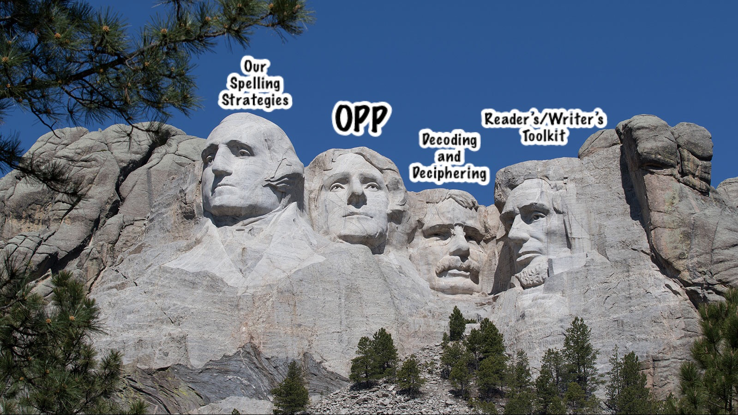

OUR SPELLING STRATEGIES: https://tinyurl.com/spellingstrat
OUR PROOFREADING PLAN: https://tinyurl.com/ourproofreadingplan
DECODING/DECIPHERING: https://tinyurl.com/decodedecipher
WRITER’S TOOLKIT: http://tiny.cc/wtoolkit
READER’S TOOLKIT: http://tiny.cc/rtoolkit

