MULTIPLICATION, DIVISION, ETC.
STUDY GUIDE
https://www.drooker.ca/number.html

WATCH THE FOLLOWING VIDEO
https://www.youtube.com/watch?v=tr2u97LLYg8
PRACTICE YOUR TIMES TABLE TRICKS IN THE SPACE BELOW
3 | 4
6 | 7
8 | 9
11 | 12

MULTIPLICATION

Multiplication is repeated addition (of the same number)
3 + 3 + 3 = 9
VS
3 x 3 = 9

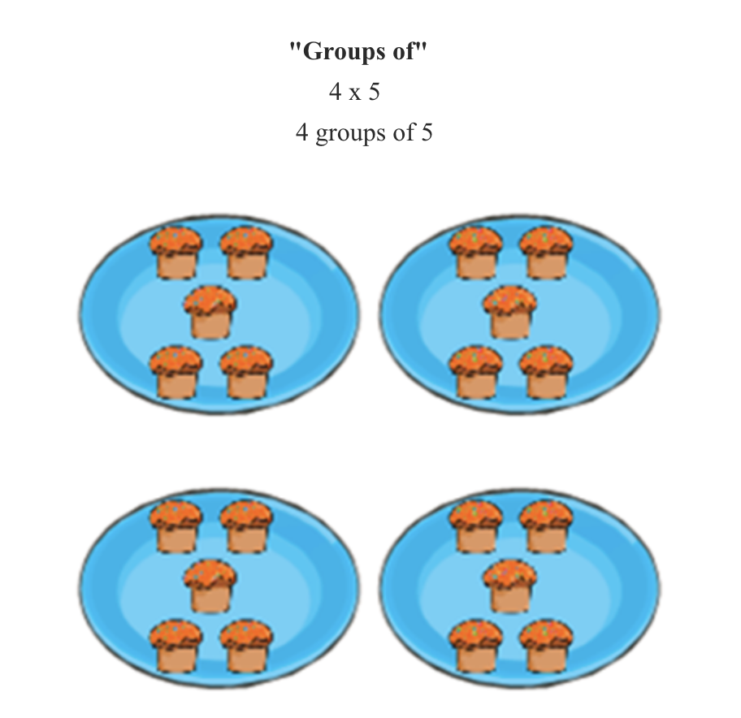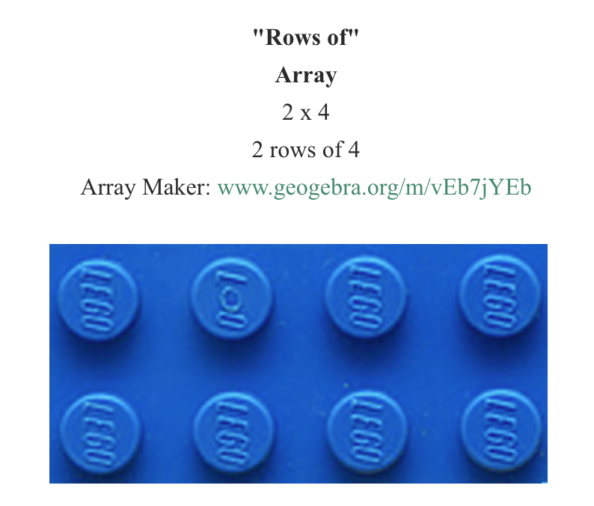
DIVISION

DIVISION IS RELATED TO REPEATED SUBTRACTION
https://www.youtube.com/watch?v=xBlingXK188
45 / 5 =9
45 -5=40
40-5=35
35-5=30
30-5=25
25-5=20
20-5=15
15-5=10
10-5=5
5-5=0
(9 STEPS OF SUBTRACTION!)

CHECK OUT THE FOLLOWING VIDEO THAT RELATES ARRAYS AND MULTIPLICATION TO DIVISION
https://www.youtube.com/watch?v=mwig70aQuHI

DIVISION SOLUTION STRATEGIES
1)Use multiplication to help solve a question
45 / 5 = ? What is the ? x 5 which would equal 45
2) Use manipulatives and divide them into rows
3) Repeatedly subtract and count how many steps until you reach 0

LONG AND SHORT DIVISION
https://www.youtube.com/watch?v=BCqqn2sWUzY
https://www.youtube.com/watch?v=SLze82Zcc4Y

FRACTIONS

Fraction Song
https://player.vimeo.com/video/215758087?app_id=122963

Fraction Manipulatives
toytheater.com/fraction-bars/
toytheater.com/fraction-strips/

RATIOS/RATES

Take note as to how multiplication and division factor into the balance within growing and shrinking ratios!

