GRADE 2/3 NARRATIVE
UNIT PLAN
https://www.drooker.ca/narrative-writing.html
UNIT AT A GLANCE
SUBJECT: | LITERACY (WRITING)
GRADE: | 2/3
TIMELINE: | Approximately 2 Months
APPROXIMATE DATES: | TBD
PURPOSE: | This cross curricular unit will familiarize students with the paragraph structure and voice found within narrative stories. This unit will also provide students an opportunity to explore and utilize their Toolkit Binders to assist with word choice, dialogue tags, word menus, etc. This writing unit will be complemented with narrative guided reading sessions as well as dramatic reading podcast presentations.
LESSON #1: Introduction: What is a Narrative? (Mrs. Buttkiss Read Aloud)
LESSON #2: Script Writing vs. Narratives (“SWBS”)
LESSON #3: Introduction/Co-Creation of Graphic Organizer and Success Criteria Through Reverse Engineering of a Narrative (Mrs. Buttkiss)
LESSON #4: Diagnostic: Rollercoaster
LESSON #5: Partial Language Learning: Drooker’s Daily Drill Mini Lessons: Dialogue and Dialogue Tags (Ant and the Aardvark-Hasty But Tasty/Handout and QR Code Activity), Description (Revisit Telling vs. Showing), Details/Series of Events (Road Runner), Use of Toolkit Binder
LESSON #6/#7: Formative Task #1: Magic Bean (Alongside Co-creation of Level 4 Work Sample/Anchor Chart Through Modelled/Shared Write)
LESSON #8: Formative Task #2: Alphabet Soup: Don’t Look Under Your Bed
LESSON #9/#10: Formative Task #3: Whack a M/hole (Alongside Co-creation of Level 4 Work Sample/Anchor Chart Through Modelled/Shared Write)
LESSON #11: Read aloud of Max and Moritz (Oral story telling vs. Written and the Importance of a Series of Events)
LESSON #12: Formative Task #4: Centipede/Tai Chi Incident (Truth is Stranger Than Fiction: Hyperbole)
LESSON #13: Formative Task #5: Grey Parrot (Truth is Stranger Than Fiction: Humour)
LESSON #14: Quiz #5: Unmagic Schoolbus
LESSON #15: Formative #6: Hen Who Lost Her Eye
LESSON #16: Formative #7: Snowball Soccer Hot Chocolate Challenge
LESSON #17: Summative Test: Digging for Gold
LESSON #18: Publishing/Visit to Starbucks
LESSON #19: Drama/Recording Podcast Using Garage Band
LESSON #20: Hot Chocolate “Fireplace” Celebration/Exit Interview
INTERSPERSED THROUGHOUT UNIT: Guided Reading: Focus on Reverse Engineering Narratives, Voice, Dialogue Tag Alternatives, Oral Fiction Retells, Genres

MINISTRY EXPECTATIONS
OVERALL | SPECIFIC
GRADE 2/3 WRITING  - generate, gather, and organize ideas and information to write for an intended purpose and audience;  - draft and revise their writing, using a variety of informational, literary, and graphic forms and stylistic elements appropriate for the purpose and audience;  - use editing, proofreading, and publishing skills and strategies, and knowledge of language conventions, to correct errors, refine expression, and present their work effectively;  - reflect on and identify their strengths as writers, areas for improvement, and the strategies they found most helpful at different stages in the writing process.  GRADE 2/3 READING  - read and demonstrate an understanding of a variety of literary, graphic, and informational texts, using a range of strategies to construct meaning;  - recognize a variety of text forms, text features, and stylistic elements and demonstrate understanding of how they help communicate meaning  - use knowledge of words and cueing systems to read fluently;  GRADE 2/3 DRAMA  -Creating and Presenting: apply the creative process to dramatic play and process drama, using the elements and conventions of drama to communicate feelings, ideas, and stories;  - Exploring Forms and Cultural Contexts: demonstrate an understanding of a variety of drama and theatre forms and styles from the past and present, and their social and/or community contexts. | GRADE 2 WRITING  -Classifying Ideas 1.4 sort ideas and information for their writing in a variety of ways, with support and direction (e.g., by using simple graphic organizers such as webs or a Venn diagram)  -Organizing Ideas 1.5 identify and order main ideas and supporting details, using graphic organizers (e.g., a story grammar: characters, setting, problem, solution; a sequential chart: first, then, next, finally) and organizational patterns (e.g., problem solution, chronological order)  -Purpose and Audience 1.1 identify the topic, purpose, audience, and form for writing (e.g., a fairy tale to entertain another class; the procedure for fire drills to inform the class; a poster to promote a favourite book or movie). Teacher prompts: "What is your writing about?" "Why are you writing?" "Whom are you writing for?"  -Review 1.6 determine whether the ideas and information they have gathered are suitable for the purpose, and gather new material if necessary (e.g., use a graphic organizer to explain their material to a classmate and ask for feedback to identify gaps)  -Form 2.1 write short texts using several simple forms (e.g., a friendly letter; a factual recount of a scientific or mathematical investigation; a recipe describing the procedure for cooking a favourite food; directions for playing a game; a paragraph describing the physical characteristics of an animal; an original story or an extension of a familiar story, modelled on stories read; their own variation on a patterned poem; an advertisement for a toy)  -Preparing for Revision 2.6 identify elements of their writing that need improvement, using feedback from the teacher and peers, with a focus on content and word choice. Teacher prompts: "Do you have enough information to support your ideas?" "Are there any other words that you could use to create a better word picture for your audience?"  -Producing Drafts 2.8 produce revised, draft pieces of writing to meet criteria identified by the teacher, based on the expectations  -Revision 2.7 make simple revisions to improve the content, clarity, and interest of their written work, using several types of strategies (e.g., reordering sentences to present information in a more logical sequence; adding linking words to connect ideas; replacing general words with concrete, specific words/phrases). Teacher prompt: "What linking words could you use to connect two ideas?" "What words could you add to create a more vivid picture for the reader?"  -Grammar 3.5 use parts of speech appropriately to communicate their meaning clearly, with a focus on the use of: proper nouns for local, provincial, and national place names and for holidays; the personal object pronouns me, you, him, her, us, them; adjectives to describe a noun; verbs in the simple present and past tenses; joining words (e.g., and, but); simple prepositions of place and time (e.g., under, with, before, after)  Producing Finished Works  -3.8 produce pieces of published work to meet criteria identified by the teacher, based on the expectations  -Punctuation 3.4 use punctuation to help communicate their intended meaning, with a focus on the use of: question marks, periods, or exclamation marks at the end of a sentence; commas to mark pauses; and some uses of quotation marks  -Spelling Familiar Words 3.1 spell many high–frequency words correctly (e.g., words from their oral vocabulary, anchor charts, the class word wall, and shared–, guided–, and independent–reading texts)  -Vocabulary 3.3 confirm spellings and word meanings or word choice using a few different types of resources (e.g., locate words in alphabetical order by using first and second letters in a primary dictionary, on a word wall, or in an online picture dictionary)  -Portfolio 4.3 select pieces of writing that they think show their best work and explain the reasons for their selection  GRADE 2 READING  - Analysing Texts 1.7 identify the main idea and some additional elements of texts (e.g., narrative: characters, setting, problem, solution, events/episodes, resolution; procedure: goal, materials, method). Teacher prompts: "What main idea do these two stories share?" "What elements did the author include to make the recipe interesting and still easy to follow?"  - Demonstrating Understanding 1.4 demonstrate understanding of a text by retelling the story or restating information from the text, with the inclusion of a few interesting details (e.g., retell a story or restate facts in proper sequence or correct time order, with a few supporting details; restate the important ideas from a short informational text about the life cycle of a butterfly in the correct sequence)  - Elements of Style 2.4 identify some simple elements of style, including voice, word choice, and different types of sentences, and explain how they help readers understand texts (e.g., descriptive adjectives help the reader visualize a setting; alliteration helps make ideas or characters stand out: red red robin)  - Text Forms 2.1 identify and describe the characteristics of a few simple text forms, with a focus on literary texts such as a fairy tale (e.g., plot, characters, setting), graphic texts such as a primary dictionary (e.g., words listed in alphabetical order, simple definitions accompanied by picture clues or diagrams), and informational texts such as a "How to" book (e.g., materials listed in order of use, numbered steps, labels, diagrams)  - Text Patterns 2.2 recognize simple organizational patterns in texts of different types, and explain, initially with support and direction, how the patterns help readers understand the texts (e.g., numbered steps help the reader follow a procedure or set of instructions correctly)  GRADE 3 READING  -Analysing Texts 1.7 identify specific elements of texts and explain how they contribute to the meaning of the texts (e.g., narrative: setting, characters, plot, theme; explanation of a procedure: procedure to be explained, sequence of steps). Teacher prompts: "In what way does knowing more about the characters help you to understand the text?" "How does identifying the setting in the text help you as a reader?" "Why is it important to have the steps in a specific sequence?"  -Demonstrating Understanding 1.4 demonstrate understanding of a variety of texts by identifying important ideas and some supporting details (e.g., restate important ideas and some related details from an informational text about early settlers; retell a story giving details about specific elements of the text such as setting, characters, and theme)  - Point of View 1.9 identify the point of view presented in a text and suggest some possible alternative perspectives (e.g., retell the story from the point of view of someone other than the author). Teacher prompts: "How does the author show his/her point of view on this poster?" "How might the story have been different if the main character had been a girl instead of a boy or a senior instead of a child?"  - Variety of Texts 1.1 read a variety of literary texts (e.g., fables, traditional Aboriginal stories, poetry, chapter books, adventure stories, letters, diaries), graphic texts (e.g., comic books, posters, charts, tables, maps, graphs), and informational texts (e.g.,"How to" books, print and electronic reference sources, magazine articles)  - Elements of Style 2.4 identify some elements of style, including voice, word choice, and different types of sentences, and explain how they help readers understand texts (e.g., different sentence types make the text more interesting for the reader and help the author express different kinds of ideas – questions express or stimulate curiosity; exclamations convey emotions such as surprise or excitement)  - Text Forms 2.1 identify and describe the characteristics of a variety of text forms, with a focus on literary texts such as a fable or adventure story (e.g., plot development, characters, setting), graphic texts such as a comic book (e.g., speech bubbles, illustrations, captions), and informational texts such as a nature magazine (e.g., table of contents, diagrams, photographs, labels, captions)  GRADE 3 WRITING  -Developing Ideas 1.2 generate ideas about a potential topic, using a variety of strategies and resources (e.g., formulate and ask questions to identify personal experiences, prior knowledge, and information needs and to guide searches for information; brainstorm and record ideas on the topic)  -Organizing Ideas 1.5 identify and order main ideas and supporting details into units that could be used to develop a short, simple paragraph, using graphic organizers (e.g., a story grammar, a T–chart, a paragraph frame) and organizational patterns (e.g., comparison, chronological order)  -Purpose and Audience 1.1 identify the topic, purpose, audience, and form for writing (e.g., an original fable, modelled on the structures and conventions of fables read, to entertain the class; a scientific explanation demonstrating how some common levers make work easier, for a peer group; a labelled map with a legend identifying the key components of an early settlement in Upper Canada, to accompany a small-group project). Teacher prompts: "What is your writing about?" "Why are you writing?" "Whom are you writing for?"  -Preparing for Revision 2.6 identify elements of their writing that need improvement, using feedback from the teacher and peers, with a focus on specific features (e.g., a strong opening or "lead"; the clarity of the main idea). Teacher prompts: "Can you think of another way you might get the attention of your audience at the beginning?" "Have you provided enough detail to support your main idea?"  -Producing Drafts 2.8 produce revised, draft pieces of writing to meet identified criteria based on the expectations related to content, organization, style, and use of conventions  -Revision 2.7 make revisions to improve the content, clarity, and interest of their written work, using several types of strategies (e.g., reordering sentences, removing repetition or unnecessary information, adding material needed to clarify meaning, adding or substituting words to increase interest, adding linking words or phrases to highlight connections between ideas, using gender-neutral language as appropriate). Teacher prompts: "What similar words or phrases could you use instead of…?” "What time order words might help clarify the sequence of events in your story?"  -Sentence Fluency 2.4 vary sentence structures and maintain continuity by using joining words (e.g., and, or) to combine simple sentences and using words that indicate time and sequence to link sentences (e.g., first, then, next, before, finally, later)  -Voice 2.2 establish a personal voice in their writing, with a focus on using concrete words and images to convey their attitude or feeling towards the subject or audience (e.g., words used literally or figuratively to communicate intensity of feeling: a shiver of excitement; hot anger)  -Word Choice 2.3 use words and phrases that will help convey their meaning as specifically as possible (e.g., comparative adjectives such as smaller, smallest; adverbs)  -Producing Finished Works 3.8 produce pieces of published work to meet identified criteria based on the expectations related to content, organization, style, use of conventions, and use of presentation strategies  -Proofreading 3.6 proofread and correct their writing using guidelines developed with peers and the teacher (e.g., a checklist modified in a teacher–student conference to support individual writing strengths and indicate next steps; a posted class writing guideline)  -Punctuation 3.4 use punctuation to help communicate their intended meaning, with a focus on the use of: quotation marks to indicate direct speech; commas to mark grammatical boundaries within sentences; capital letters and final punctuation to mark the beginning and end of sentences  -Spelling Familiar Words 3.1 spell familiar words correctly (e.g., words from their oral vocabulary, anchor charts, the class word wall, and shared–, guided–, and independent–reading texts)  -Spelling Unfamiliar Words 3.2 spell unfamiliar words using a variety of strategies that involve understanding sound–symbol relationships, word structures, word meanings, and generalizations about spelling (e.g., pronounce a word as it is spelled: Wed–nes–day; make analogies to rhyming words; apply knowledge of short–vowel and long–vowel patterns; cluster words by visual similarities; follow rules for changing base words when adding common endings: hope/hoping, slam/slammed; use memory aids such as visualization)  --Vocabulary 3.3 confirm spellings and word meanings or word choice using several different types of resources (e.g., locate words in an alphabetized personal word book or dictionary using first, second, third, and fourth letters, entry words, or pronunciation; use a variety of dictionaries, such as a rhyming dictionary or a dictionary of synonyms and antonyms; use a thesaurus to find alternative words)  -Interconnected Skills 4.2 describe, with prompting by the teacher, how some of their skills in listening, speaking, reading, viewing, and representing help in their development as writers. Teacher prompts: "How does what you know about reading help you when you are writing?" "How does listening to or viewing different kinds of texts help you generate ideas for writing?"  -Portfolio 4.3 select pieces of writing that they think show their best work and explain the reasons for their selection  GRADE 2 DRAMA  -demonstrate an understanding of the element of role by communicating thoughts, feelings, and perspectives appropriate to the role being played (e.g., devise and share a group mime showing how characters respond to the tension in a situation of conflict, departure, or anticipation; use voice expressively to convey an interpretation of a character's attitude)  -express thoughts, feelings, and ideas about drama experiences and performances in a variety of ways (e.g., use a journal response, a think-pair-share activity, visual art work, or  a drama convention such as role on the wall to explore both the inner thoughts and feelings of the character and the perspectives of others who know the character)  GRADE 3 DRAMA  -communicate feelings and ideas to a familiar audience (e.g., classmates) using audio, visual, and/or technological aids to support or enhance their drama work (e.g., use items found in the classroom to create a feeling or a mood suggested by the teacher; use sound effects or music to create an element of surprise or tension)  - identify some distinct stylistic features of a few drama and theatre forms they experience in their home, school, and community, and in the media (e.g., puppet shows and mask plays use easily recognizable character types to tell a story; actors in live theatre productions use exaggerated gestures and reactions designed to project beyond the footlights; street festivals use amplified live and/or recorded music, costumes, emcees, and amplified announcements to celebrate special events; clown acts use mime featuring clumsy gestures and comical accidents)

ACHIEVEMENT CHART
KNOWLEDGE/  UNDERSTANDING: | Demonstrates knowledge of narrative paragraph writing format (4 Sections/Paragraphs: Orientation, Problem/Complication, Series of Events, Resolution)  The “voice” of each paragraph should clearly orient and establish for the reader which part of the story they are in and include ample voice and description building upon students’ previous knowledge of descriptive writing which occurred earlier this year.
THINKING: | The writing demonstrates creative ideas to support their story arc.  The ideas are supported with considerable detail, dialogue, and description
COMMUNICATION: | Able to express and organize organizes ideas  Varies the sentence structure and uses appropriate conventions (C.U.P.S./O.P.P.) to clearly express ideas in a logical way.  Communicates for an audience and purpose (to narrate and entertain) with considerable effectiveness.
APPLICATON: | Able to make connections among topic, personal experiences, and life situations  Transfers knowledge of these connections by including engaging detail, dialogue, and description.

PRIOR LEARNING
6 + 1 WRITING FOCI
(Organization and Conventions taught throughout the year)
SEPTEMBER: Ideas
OCTOBER: Ideas/Word Choice
NOVEMBER: Ideas/Word Choice
DECEMBER: Voice
JANUARY: Voice
PARTIAL LANGUAGE LEARNING FOCI
(Drooker’s Daily Drills/“3D”)
SEPTEMBER: Our Spelling Strategies, CUPS, Our Proofreading Plan (OPP), Use of the Writer’s Toolkit, Intro to Parts of Speech, Types of Sentences, Run Ons, UWQSA,
OCTOBER: Adjectives
NOVEMBER: Nouns
DECEMBER: Vocabulary
JANUARY: Vocabulary
MONTHLY WRITING FOCI
(Poetry and Grammar interspersed throughout the year)
SEPTEMBER:, Diagnostic Testing, One by One Writing (“Give Me 6”), Basics of Descriptive Writing: Telling vs. Showing, Similes
OCTOBER: Intro to paragraphing, Descriptive Writing, Fiction Retells
NOVEMBER: Letter/Email Writing, Non-Fiction Retells
DECEMBER: Letter/Email Writing, Explanatory/Procedural Writing, Writing in Role, Script Writing
JANUARY: Explanatory/Procedural Writing

GUIDING QUESTIONS
(Throughout the Unit)
What is the purpose of storytelling?
Where do we encounter stories in our everyday lives?
What are the basic parts/structure of a story?
What is the role of a narrator?
What makes a good story?
Why do we need a balance between telling and showing?
What does it mean to give voice to a character?
Why does your audience matter when writing a narrative?
How can we emotionally appeal to your target audience?
What do good descriptive writers do?
What is a simile?
What is a metaphor?
What is a dialogue tag?
How do we structure dialogue into a narrative story?
How do writers use details, description and dialogue to support their stories?

LEARNING GOALS
I will write 4 well developed (details, description, dialogue) paragraphs telling a story (Orientation, Problem/Complication, Series of Events, Resolution)

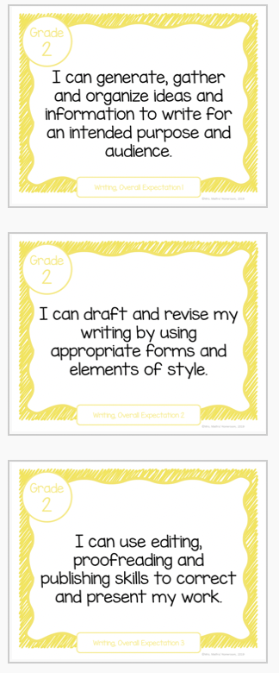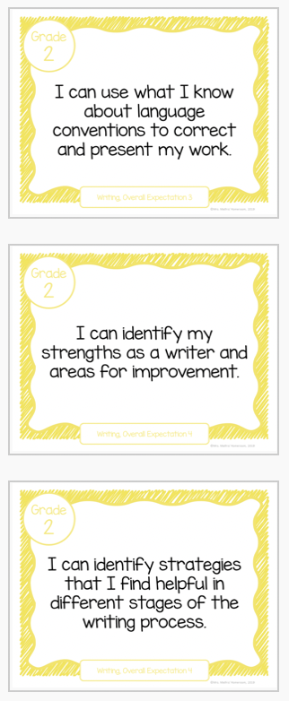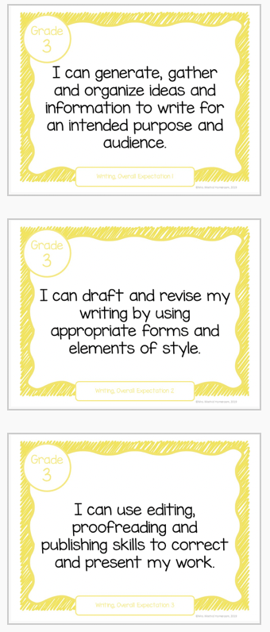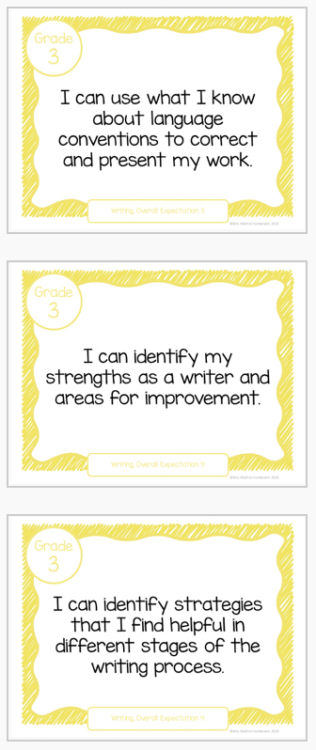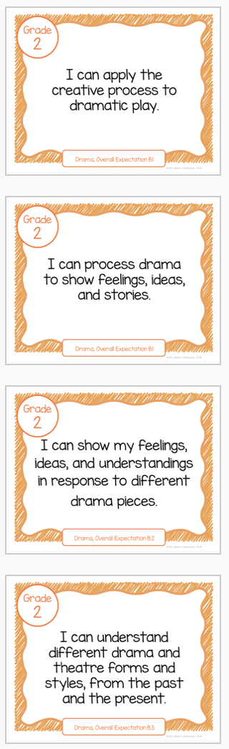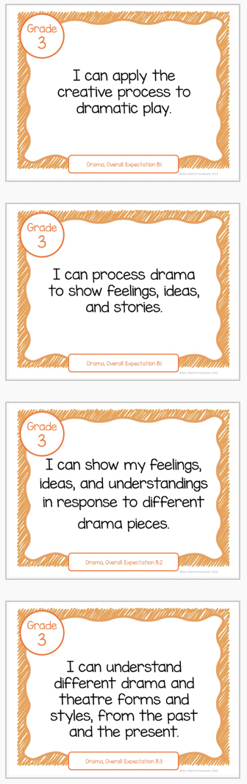

SUCCESS CRITERIA
REASONING/THINKING
(Ideas, Content, Purpose)
□ I worked independently to generate ideas.

□ I have 4 sections
(□ Orientation, □ Complication/Problem, □ Series of Events, □ Resolution)

COMMUNICATION
(Clarity and form)
□ I use my senses (sight, touch, smell, sound, taste) to build up description of the key events

□ I used juicy adjectives (ie. brilliant blue eyes) and adverbs (words ending in “ly”) to paint a picture in the reader’s mind.

□ I use like to compare things (ie. She is fast like a gust of wind)

□ I have a lot of energy/voice in my writing! You can tell that I care and that each character has a unique personality.

□ My sentences start off in different ways.

□ I wrote in past tense (ie. He went, She walked)

□ I used exciting dialogue and dialogue tags in at least 3 spots across the narrative (ie. He screamed: “Watch out!”

ORGANIZATION OF IDEAS
(Logical plan, focus and connected ideas)
□ I have a title that hooks the reader

□ I used transition words like first, next, then, and last between my details. Sentence parts are linked with conjunctions (but, and, or).

APPLICATION OF LANGUAGE CONVENTIONS
(Applies language conventions correctly)
□ I have read my work out loud using “Our Proofreading Plan/OPP” to check for (C.U.P.S.)

ENDURING UNDERSTANDINGS
(What students should know after unit completion)
Students will parlay their refined narrative paragraph writing skills and improved ability to support with dialogue into Newspaper Article writing. Their growing awareness of how to include quotations to develop a story will translate into lede paragraph writing (Inverted factual pyramid/5 Ws and 1H) and second paragraph follow up (Supporting quotes, opinions, etc.).
https://www.drooker.ca/news-article-writing.html

ACCOMODATIONS
Please refer to appendix of accommodations accompanying this unit plan. https://education.alberta.ca/media/525534/ipp6.pdf

Partner/peer helper
Ongoing feedback
Computer/ Internet
Additional time
Technology for organization
Scribe/handout
Alternatives to writing (charts, tables or graphic organizers)
Specialized tools and materials
Alternate assignment
Oral test
IEPs for other modifications
Modified note/handout
Other
Dictionaries
List of important vocabulary
Verbal demonstration
Reword the instructions
Reinforcing effort and providing recognition
Taped material
Anchor activities
Literature circles/Daily 5
Learning contracts
Small-group instruction
Group investigation
Independent study
4MAT
Varied questioning strategies
Compacting
Varied journal prompts

PEDAGOGICAL WEBSITES/RESOURCES
https://www.drooker.ca/paragraphing.html
https://www.drooker.ca/descriptive-writing.html
https://www.drooker.ca/writers-toolkit.html
https://www.drooker.ca/6-trait-writing.html
https://www.drooker.ca/dramawriting-in-role.html
https://www.drooker.ca/narrative-writing.html
https://www.drooker.ca/news-article-writing.html
https://docs.google.com/presentation/d/1IJ5N1XHONMWyivyOqDDwvo2WujjmhpR9NJVlv62ZJxM/edit#slide=id.p
OWA Grade 2/3
Raz Kids Reading Online

ASSESSMENT STRATEGIES | ASSESSMENT DEVICES | TECHNOLOGY
Conference  Classroom Presentation  Interview  Questions/Answers  Exhibition/Demonstration  Learning Log  Observation  Performance Task  Quiz, Test, Examination  Select Response  Self-Assessment  Peer Assessment  Conference  Portfolio  Response Journal | Checklist  Rubric  Rating Scale  Anecdotal Notes  Journal  Pictures  Audio Recording | Laptop/LCD Projector  Document Camera  Classroom Laptops  Classroom Tablets  Laptop/Tablet Cart
MULTIPLE INTELLIGENCES | DIFFERENTIATED INSTRUCTIONS  (INSTRUCTIONAL INTELLIGENCES)  http://goo.gl/11rwT9 | BLOOM’S TAXONOMY VERBS
Visual Spatial  Bodily Kinesthetic  Musical  Interpersonal  Intrapersonal  Linguistic  Logical-mathematical  Natural  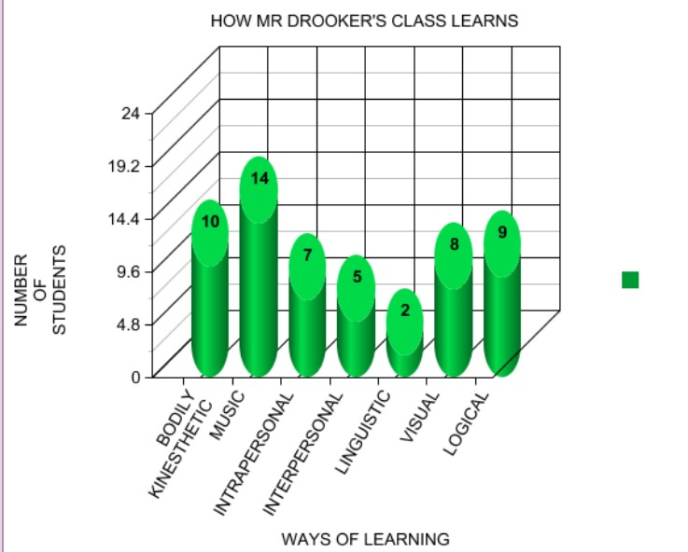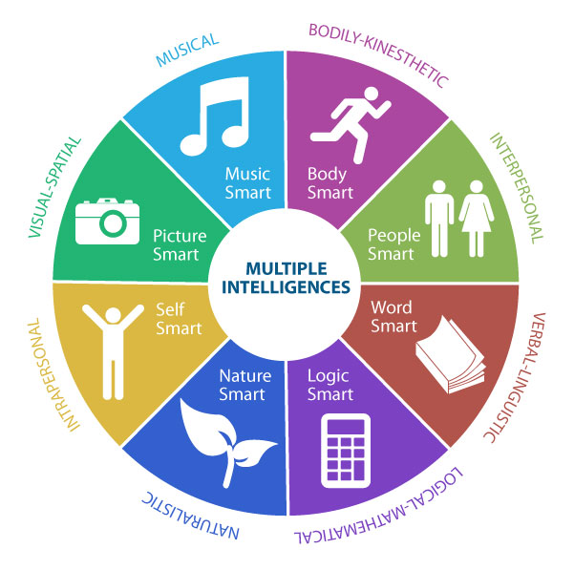 | Think/Pair/Share  Placemat  PMI: Positive/Minus/Interesting  EBS: Examine Both Sides  Fishbone  Venn Diagrams  Numbered Heads  Value Lines/Walkabout  Cooperative Learning  Inside/Outside Circles  Four Corners  Three Step Interview  Graffiti  Team Games Tournament  Concept Attainment  Six Thinking Hats  Discussion  Peer Practice  Cloze  Demonstrations  Flash Cards  Guided Exploration  Guided Reading  Guided Writing  Making Words  Read Along  Shared Read  Independent read  Word wall  Word menu  Work book  Reading Response  Brainstorming  Classifying  Concept Clarification  Estimating  Problem Solving  Writing to learn  Choral reading  Chanting  Games | Knowledge: Count, Define, Describe, Draw, Find, Identify, Label, List, Match, Name, Quote, Recall, Recite, Sequence, Tell, Write  Comprehension: Conclude, Demonstrate, Discuss, Explain, Generalize, Identify, Illustrate, Interpret, Paraphrase, Predict, Report, Restate, Review, Summarize, Tell  Application (Doing after being shown how): Apply, Change, Choose, Compute, Dramatize, Interview, Prepare, Produce, Role-play, Select, Show, Transfer, Use  Analysis (Consider the parts separately): Analyze, Characterize, Classify, Compare, Contrast, Debate, Deduce, Diagram, Differentiate, Discriminate, Distinguish, Examine, Outline, Relate, Research, Separate  Synthesis (Create, Design, Invent): Compose, Construct, Create, Design, Develop, Integrate, Invent, Make, Organize, Perform, Plan, Produce, Propose, Rewrite  Evaluation (Judge, Critically Appraise): Appraise, Argue, Assess, Choose, Conclude, Critic, Decide, Evaluate, Judge, Justify, Predict, Prioritize, Prove, Rank, Rate, Select,

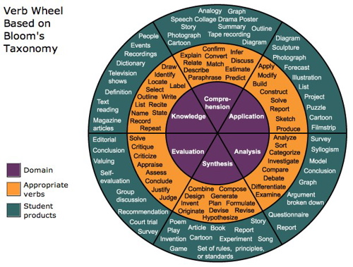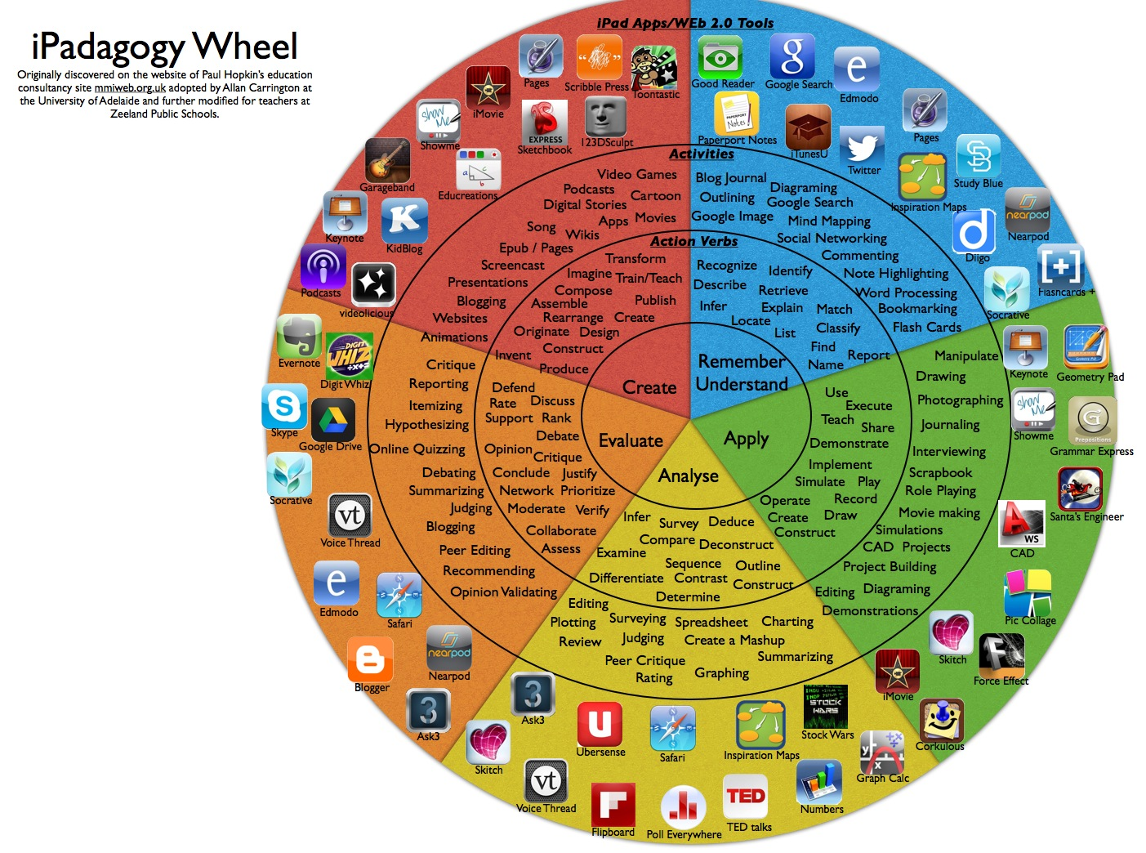

GRADE 2 WRITING OVERALL EXPECTATION RUBRIC
LEVEL 1 | LEVEL 2 | LEVEL 3 | LEVEL 4
With limited effectiveness, you generate, gather, and organize ideas and information to write for an intended purpose and audience | With some effectiveness, you generate, gather, and organize ideas and information to write for an intended purpose and audience | With considerable effectiveness, you generate, gather, and organize ideas and information to write for an intended purpose and audience | With a high degree of effectiveness, you generate, gather, and organize ideas and information to write for an intended purpose and audience
With limited effectiveness, you draft and revise their writing, using a variety of informational, literary, and graphic forms and stylistic elements appropriate for the purpose and audience | With some effectiveness, you draft and revise their writing, using a variety of informational, literary, and graphic forms and stylistic elements appropriate for the purpose and audience | With considerable effectiveness, you draft and revise their writing, using a variety of informational, literary, and graphic forms and stylistic elements appropriate for the purpose and audience | With a high degree of effectiveness, you draft and revise their writing, using a variety of informational, literary, and graphic forms and stylistic elements appropriate for the purpose and audience
With limited effectiveness, you use editing, proofreading, and publishing skills and strategies, and knowledge of language conventions, to correct errors, refine expression, and present their work effectively | With some effectiveness, you use editing, proofreading, and publishing skills and strategies, and knowledge of language conventions, to correct errors, refine expression, and present their work effectively | With considerable effectiveness, you use editing, proofreading, and publishing skills and strategies, and knowledge of language conventions, to correct errors, refine expression, and present their work effectively | With a high degree of effectiveness, you use editing, proofreading, and publishing skills and strategies, and knowledge of language conventions, to correct errors, refine expression, and present their work effectively
With limited effectiveness, you reflect on and identify their strengths as writers, areas for improvement, and the strategies they found most helpful at different stages in the writing process. | With some effectiveness, you reflect on and identify their strengths as writers, areas for improvement, and the strategies they found most helpful at different stages in the writing process. | With considerable effectiveness, you reflect on and identify their strengths as writers, areas for improvement, and the strategies they found most helpful at different stages in the writing process. | With a high degree of effectiveness, you reflect on and identify their strengths as writers, areas for improvement, and the strategies they found most helpful at different stages in the writing process.
STRENGTHS (HIGHLIGHTED):

~ Generates, plans and organizes ideas for writing.
~ Considers target audience when generating and organizing ideas for writing.
~ Writes for a variety of audiences.
~ Writes for a variety of purposes.
~ Brainstorms ideas about a topic of interest in a variety of ways (e.g., formulates and asks questions, talks with a partner).
~ When planning, he/she can determine the appropriate audience, purpose and most engaging form for his/her writing.
~ Uses different ways or resources to find information to support his/her topic (e.g., media texts, interviews).
~ Gathers information about a topic using simple graphic organizers (e.g., webs, interview frame).
~ Includes the main ideas and supporting details from his/her graphic organizer in his/her writing.
~ Sorts and organizes his/her ideas using lists, webs and writing planners.
~ Identifies and orders ideas in his/her writing.
~ Uses different ways or resources to find information to support his/her topic (e.g., talking with a friend, books, magazines and educational websites).
~ Reflects upon and uses personal experiences to decide what to write about and which details to use in his/her writing.
~ Can write a draft and revise his/her work.
~ Writes short texts in a variety of forms.
~ Changes his/her writing to suit the audience and purpose.
~ Makes changes to improve his/her writing.
~ Uses specific words or phrases to add interest to his/her writing.
~ Adds descriptive words to make his/her writing sound more interesting.
~ Identifies ways to make his/her writing more effective (e.g., clear message, interesting voice).
~ Can express his/her feelings and opinions through his/her writing.
~ Uses a variety of sentence lengths and word choice to make his/her writing more convincing.
~ Includes his/her own point of view in his/her writing.
~ Reviews his/her writing using the class revision checklist.
~ Uses proofreading and publishing skills to present his/her work effectively.
~ Edits and proofreads his/her work.
~ Uses strategies and resources to spell unfamiliar words.
~ Correctly spells frequently used words.
~ Uses punctuation to communicate meaning.
~ Uses parts of speech appropriately.
~ Uses the word wall and class charts to spell unfamiliar words.
~ Uses his/her writing checklist when proofreading his/her work.
~ Applies knowledge of short-vowel and long-vowel patterns to spell unfamiliar words.
~ Includes captions for diagrams and photographs in his/her finished work.
~ Uses adjectives and adverbs to write interesting sentences.
~ Uses rhyming patterns to help spell unfamiliar words.
~ Uses his/her knowledge of letter patterns to spell unfamiliar words.
~ Uses punctuation appropriately (e.g., commas, periods, quotation marks).
~ Publishes work that meets established criteria.
~ Uses capital letters and punctuation to mark beginning and end of sentences.
~ Describes what he/she is good at in writing and where he/she needs improvement.
~ Thinks about what he/she does well as a writer.
~ Can tell which strategies help him/her during his/her writing.
~ Knows which strategies are most helpful during different stages of the writing process.
~ Can give reasons why a piece of writing is his/her best work.
~ Uses strategies learned in class to organize his/her thoughts before writing.
~ Explains which graphic organizer suits his/her purpose for writing.
~ Explains how listening to or viewing different texts can help generate ideas for his/her own writing.
~ Uses the descriptive feedback provided in class to help improve his/her work.
~ Talks about how keeping a writer’s notebook helps him/her develop as a writer.
~ Recognizes that graphic organizers are helpful for him/her to plan his/her writing and sort his/her ideas.
~ Uses posted charts to check if his/her writing meets the success criteria.
~ Explains that reading his/her work out loud helps him/her know if his/her writing makes sense.
~ Explains how listening to stories helps him/her when he/she has to write his/her own story.
~ Selects pieces of writing that he/she feels are his/her best work and can explain reasons for his/her choice.

NEXT STEPS (HIGHLIGHTED):

~At home, he/she is encouraged to share the information from his/her organizer (e.g., web) with an adult to review if the ideas are relevant and appropriate for the writing task.
~At home, he/she could write in a journal about things that are interesting to him/her.
~Before writing at home, he/she is encouraged to talk about what he/she is going to write about, who will read it and why he/she is writing it.
~At home, he/she is encouraged to talk about the topic before writing.
~He/She would benefit from everyday opportunities to write (e.g., class blog, party invitations).
~He/She is encouraged to look at the strong samples created in class to help him/her as he/sge gathers and organizes ideas for his/her writing.
~He/She will be encouraged and supported to share his/her ideas with his/her peers to determine if they are suitable for the writing task.
~He/She will be given opportunities to talk to a friend or teacher about his/her topic to further develop his/her ideas before writing.
~To help him/her choose topics for writing, he/she will be supported in reviewing and adding to his/her list of personally significant writing topics in his/her writer’s notebook.
~We will work together to help him/her add more details to his/her graphic organizer when he/she is planning his/her writing.
~He/She will be supported in reviewing the descriptive feedback provided by the teacher to ensure he/she knows what to do next time.
~At home, reading his/her work aloud to an adult will give him/her an audience for writing.
~At home, making grocery lists, and writing cards and notes to family members will provide different purposes for writing.
~He/She is encouraged to review and discuss his/her revision checklist with an adult when making improvements to his/her writing at home.
~Reading his writing aloud will help him/her identify what needs to be improved.
~We will continue to work on making changes to his/her writing based on feedback.
~He/She will be encouraged to use our posted vocabulary charts to help him/her improve his/her writing.
~He/She will further explore the use of voice and word choice in our upcoming Guided Writing sessions.
~He/She will receive teacher support in using class revision checklists during our up-coming writing conferences.
~When writing at home, parents can remind him/her to write so others can read it (e.g., proper paragraph form such as spacing and margins).
~Parents can involve him/her in writing opportunities at home such as an email, a grocery list or a thank-you card.
~When reading magazines or newspapers together, parents can talk with him/her about how the fonts and graphics add to the presentation value.
~He/She will be given a checklist to support him/her in following the publishing process.
~He/She will continue to use his/her “have a go” strategy when spelling new words.
~He/She will be supported during Guided Writing to develop a bank of strategies for spelling.
~He/She is encouraged to make greater use of classroom resources such as personal dictionary or thesaurus.
~He/She will be guided to use the punctuation chart as a support for editing his/her work.
~He/She will be supported in applying teacher and peer feedback to improve the quality of his/her published work.
~When reading together at home, parents can help him/her think about the writing process by asking him/her: “What are some ways you think the author might have come up with the idea for this story/text?”
~When watching TV together, parents can help him/her think about the writing process by asking: “Does this show give you any ideas for things you can write about?”
~He/She is encouraged to keep a home journal to record ideas for writing, and new and interesting words.
~He/She will be supported during writing conferences to help him/her talk about what he/she does well as a writer.
~He/She will be prompted with questions to help him/her explain why a piece of his/her work is good writing.
~He/She will be supported in reviewing feedback to ensure he/she knows what to do differently next time.
~Through the use of exemplars, he/she will work with the teacher to collaboratively create success criteria that needs to be met prior to placing work in his/her portfolio.

OVERALL:

LESSON FOCUS  □ | IDEAS
STRONG | I’ve Got It!  *I know A LOT about this topic.  *My writing is bursting with fascinating details.  *My topic is small enough to handle.
DEVELOPING | On My Way  *I know enough about my topic to get started.  *Some of my details are too general.  *My topic might be a little too big.
BEGINNING | Just Starting  *I haven’t figured out what to say.  *My details aren’t clear.  *I’m still looking for a topic.
LESSON FOCUS  □ | ORGANIZATION
STRONG | I’ve Got It!  *I have a bold beginning, mighty middle, and excellent ending.  *My details are in the right places.  *My ideas are in an order that really works.
DEVELOPING | On My Way  *I’ve made a good attempt at a beginning, middle, and ending.  *Most of my details fit.  *The order of my ideas makes sense
BEGINNING | Just Starting  *My writing doesn’t have a clear beginning, middle, or ending.  *My details are jumbled and confusing.  *I have “stuff” on paper, but it’s not in order.
LESSON FOCUS  □ | VOICE
STRONG | I’ve Got It!  *My writing sounds like me.  *The reader will know I care about this topic.  *I have the right amount of energy in this piece.
DEVELOPING | On My Way  *My writing is safe. You only get a glimpse of me.  *I have only some interest in this topic.  *My energy level is uneven in this piece.
BEGINNING | Just Starting  *I forgot to add what I think and feel in this piece.  *I really don’t care at all about this topic.  *The beginnings all sound the same.  *I’m bored and it shows.
LESSON FOCUS  □ | WORD CHOICE
STRONG | I’ve Got It!  *I’ve picked exactly the right words.  *My words are colorful, fresh, and snappy.  *The words help my reader see my ideas.
DEVELOPING | On My Way  *Some of my words work well, but others don’t.  *I’ve used too many ordinary words.  *My words paint a general picture of the idea.
BEGINNING | Just Starting  *I’m confused about how to use words well.  *I’ve left out key words.  *Many of my words are the same or just wrong.
LESSON FOCUS  □ | SENTENCE FLUENCY
STRONG | I’ve Got It!  *My sentences are well built.  *It is easy to read my sentences aloud.  *The way my sentences begin makes them interesting.  *I’ve varied my sentence lengths.
DEVELOPING | On My Way  *I’ve got sentences!  *There are some places to make smoother when I read aloud.  *I’ve tried a couple of different ways to begin my sentences.  *I might put some sentences together or I could cut a few in two.
BEGINNING | Just Starting  *My sentences aren’t working well.  *I’m having trouble reading my piece aloud.  *The beginnings all sound the same.  *I’ve used “and” too many times.

LESSON FOCUS  □ | CONVENTIONS
STRONG | I’ve Got It!  *My spelling is magnificent  *All my capitals are in the right places  *I used punctuation correctly to make my writing easy to read.  *I used correct grammar and added paragraphs where needed.  *I did a great job of proofreading.
DEVELOPING | On My Way  *Only my simpler words are spelled correctly.  *I used capitals in easy spots.  *I have correct punctuation in some places but not in others  *I proofread quickly and missed some things.
BEGINNING | Just Starting  *My words are hard to read because of the spelling.  *My capitals don’t follow the rules.  *I haven’t used punctuation well at all.  *I forgot to proofread.
LESSON FOCUS  □ | PRESENTATION
STRONG | I’ve Got It!  *My paper is neat—no smudges or cross-outs.  *My letters are printed and written clearly.  *I have margins that make a frame.
DEVELOPING | On My Way  *My paper can be read, but it’s not my best.  *Some of my letters are well done, but some are not.  *My margins work better in some places but not others.
BEGINNING | Just Starting  *My paper is very hard to read.  *My letters are a mess.  *I forgot to use margins.
Writing “Look Fors”
CONTENT  Form of Writing  Imaginative  Persuasion/Exposition  Discussion  Informative  Description  Narrative  Poetry: _______________________  Media  Script  Information Report  Procedure  Recount  Response  Explanation  Letter  Retell/Relate/Reflect  Development of Writing  Beginning/Introduction  Middle/Body of Text  End/Summary/Closure  Appropriate features re: the form selected  Sufficient information  Well-Developed  Unity of Thought  Smooth flow of ideas  Awareness of Audience  Sense of voice  Stylistic devices  Organization  Coherent  Logical  Sequential  Suits the purpose of the writing  Language  Appropriate to the writing  Descriptive words  Conversation/Dialogue  Metaphors  Similes  Analogies | MECHANICS  Grammar and Usage  Sentence fragments  Complete sentences  Run-on sentences  Short sentences  Compound sentences  Complex sentences  Compound-complex sentences  Subject-verb agreement  Conjunctions  Adjectives  Adverbs  Clauses  Adverbial clauses  Other:  Capitalization  Beginning of sentences  Proper name  Places  Titles  Other:  Punctuation  Periods  Question marks  Exclamation marks  Quotation marks  Commas  Colons  Semi-colons  Other:  Spelling  Scribble  Random letters  Initial consonants  Phonetic spelling  Conventional spelling with few errors  Plurals  Endings (-ed, -ing, -tion)  Other:

GRADE 3 WRITING OVERALL EXPECTATION RUBRIC
LEVEL 1 | LEVEL 2 | LEVEL 3 | LEVEL 4
With limited effectiveness, you generate, gather, and organize ideas and information to write for an intended purpose and audience | With some effectiveness, you generate, gather, and organize ideas and information to write for an intended purpose and audience | With considerable effectiveness, you generate, gather, and organize ideas and information to write for an intended purpose and audience | With a high degree of effectiveness, you generate, gather, and organize ideas and information to write for an intended purpose and audience
With limited effectiveness, you draft and revise their writing, using a variety of informational, literary, and graphic forms and stylistic elements appropriate for the purpose and audience | With some effectiveness, you draft and revise their writing, using a variety of informational, literary, and graphic forms and stylistic elements appropriate for the purpose and audience | With considerable effectiveness, you draft and revise their writing, using a variety of informational, literary, and graphic forms and stylistic elements appropriate for the purpose and audience | With a high degree of effectiveness, you draft and revise their writing, using a variety of informational, literary, and graphic forms and stylistic elements appropriate for the purpose and audience
With limited effectiveness, you use editing, proofreading, and publishing skills and strategies, and knowledge of language conventions, to correct errors, refine expression, and present their work effectively | With some effectiveness, you use editing, proofreading, and publishing skills and strategies, and knowledge of language conventions, to correct errors, refine expression, and present their work effectively | With considerable effectiveness, you use editing, proofreading, and publishing skills and strategies, and knowledge of language conventions, to correct errors, refine expression, and present their work effectively | With a high degree of effectiveness, you use editing, proofreading, and publishing skills and strategies, and knowledge of language conventions, to correct errors, refine expression, and present their work effectively
With limited effectiveness, you reflect on and identify their strengths as writers, areas for improvement, and the strategies they found most helpful at different stages in the writing process. | With some effectiveness, you reflect on and identify their strengths as writers, areas for improvement, and the strategies they found most helpful at different stages in the writing process. | With considerable effectiveness, you reflect on and identify their strengths as writers, areas for improvement, and the strategies they found most helpful at different stages in the writing process. | With a high degree of effectiveness, you reflect on and identify their strengths as writers, areas for improvement, and the strategies they found most helpful at different stages in the writing process.
STRENGTHS (HIGHLIGHTED):

~ generates, plans and organizes his ideas for writing.
~ considers his target audience when generating and organizing his ideas for writing.
~ writes for a variety of audiences.
~ writes for a variety of purposes.
~ brainstorms ideas about a topic of interest in a variety of ways (e.g., formulates and asks questions, talks with a partner).
When planning, ~ can determine the appropriate audience, purpose and most engaging form for his writing.
~ uses different ways or resources to find information to support his topic (e.g., media texts, interviews).
~ gathers information about a topic using simple graphic organizers (e.g., webs, interview frame).
~ includes the main ideas and supporting details from his graphic organizer in his writing.
~ sorts and organizes his ideas using lists, webs and writing planners.
~ identifies and orders ideas in his writing.
~ uses different ways or resources to find information to support his topic (e.g., talking with a friend, books, magazines and educational websites).
~ reflects upon and uses personal experiences to decide what to write about and which details to use in his writing.
~ can write a draft and revise his work.
~ writes short texts in a variety of forms.
~ changes his writing to suit the audience and purpose.
~ makes changes to improve his writing.
~ uses specific words or phrases to add interest to his writing.
~ adds descriptive words to make his writing sound more interesting.
~ identifies ways to make his writing more effective (e.g., clear message, interesting voice).
~ can express his feelings and opinions through his writing.
~ uses a variety of sentence lengths and word choice to make his writing more convincing.
~ includes his own point of view in his writing.
~ reviews his writing using the class revision checklist.
~ uses proofreading and publishing skills to present his work effectively.
~ edits and proofreads his work.
~ uses strategies and resources to spell unfamiliar words.
~ correctly spells frequently used words.
~ uses punctuation to communicate meaning.
~ uses parts of speech appropriately.
~ uses the word wall and class charts to spell unfamiliar words.
~ uses his writing checklist when proofreading his work.
~ applies knowledge of short-vowel and long-vowel patterns to spell unfamiliar words.
~ includes captions for diagrams and photographs in his finished work.
~ uses adjectives and adverbs to write interesting sentences.
~ uses rhyming patterns to help spell unfamiliar words.
~ uses his knowledge of letter patterns to spell unfamiliar words.
~ uses punctuation appropriately (e.g., commas, periods, quotation marks).
~ publishes work that meets established criteria.
~ uses capital letters and punctuation to mark beginning and end of sentences.
~ describes what he is good at in writing and where he needs improvement.
~ thinks about what he does well as a writer.
~ can tell which strategies help him during his writing.
~ knows which strategies are most helpful during different stages of the writing process.
~ can give reasons why a piece of writing is his best work.
~ uses strategies learned in class to organize his thoughts before writing.
~ explains which graphic organizer suits his purpose for writing.
~ explains how listening to or viewing different texts can help generate ideas for his own writing.
~ uses the descriptive feedback provided in class to help improve his work.
~ talks about how keeping a writer’s notebook helps him develop as a writer.
~ recognizes that graphic organizers are helpful for him to plan his writing and sort his ideas.
~ uses posted charts to check if his writing meets the success criteria.
~ explains that reading his work out loud helps him know if his writing makes sense.
~ explains how listening to stories helps him when he has to write his own story.
~ selects pieces of writing that he feels are his best work and can explain reasons for his choice.

NEXT STEPS (HIGHLIGHTED):

At home, ~ is encouraged to share the information from his organizer (e.g., web) with an adult to review if the ideas are relevant and appropriate for the writing task.
At home, ~ could write in a journal about things that are interesting to him.
Before writing at home, ~ is encouraged to talk about what he is going to write about, who will read it and why he is writing it.
At home, ~ is encouraged to talk about the topic before writing.
~ would benefit from everyday opportunities to write (e.g., class blog, party invitations).
~ is encouraged to look at the strong samples created in class to help him as he gathers and organizes ideas for his writing.
~ will be encouraged and supported to share his ideas with his peers to determine if they are suitable for the writing task.
~ will be given opportunities to talk to a friend or teacher about his topic to further develop his ideas before writing.
To help him choose topics for writing, ~ will be supported in reviewing and adding to his list of personally significant writing topics in his writer’s notebook.
We will work together to help ~ add more details to his graphic organizer when he is planning his writing.
~ will be supported in reviewing the descriptive feedback provided by the teacher to ensure he knows what to do next time.
At home, reading his work aloud to an adult will give him an audience for writing.
At home, making grocery lists, and writing cards and notes to family members will provide different purposes for writing.
~ is encouraged to review and discuss his revision checklist with an adult when making improvements to his writing at home.
Reading his writing aloud will help him identify what needs to be improved.
We will continue to work on making changes to his writing based on feedback.
~ will be encouraged to use our posted vocabulary charts to help him improve his writing.
~ will further explore the use of voice and word choice in our up-coming Guided Writing sessions.
~ will receive teacher support in using class revision checklists during our up-coming writing conferences.
When writing at home, parents can remind ~ to write so others can read it (e.g., proper paragraph form such as spacing and margins).
Parents can involve ~ in writing opportunities at home such as an email, a grocery list or a thank-you card.
When reading magazines or newspapers together, parents can talk with ~ about how the fonts and graphics add to the presentation value.
~ will be given a checklist to support him in following the publishing process.
~ will continue to use his “have a go” strategy when spelling new words.
~ will be supported during Guided Writing to develop a bank of strategies for spelling.
~ is encouraged to make greater use of classroom resources such as personal dictionary or thesaurus.
~ will be guided to use the punctuation chart as a support for editing his work.
~ will be supported in applying teacher and peer feedback to improve the quality of his published work.
When reading together at home, parents can help ~ think about the writing process by asking him “What are some ways you think the author might have come up with the idea for this story/text?”
When watching TV together, parents can help ~ think about the writing process by asking: “Does this show give you any ideas for things you can write about?”
~ is encouraged to keep a home journal to record ideas for writing, and new and interesting words.
~ will be supported during writing conferences to help him talk about what he does well as a writer.
~ will be prompted with questions to help him explain why a piece of his work is good writing.
~ will be supported in reviewing feedback to ensure he knows what to do differently next time.
Through the use of exemplars, ~ will work with the teacher to collaboratively create success criteria that needs to be met prior to placing work in his portfolio.

OVERALL:

LESSON PLAN #

LESSON #
LESSON TITLE:
TIME ALLOTTED:
LEARNING TARGET:
SUCCESS CRITERIA:
CURRICULUM EXPECTATIONS:
INSTRUCTIONAL APPROACHES: | Modeled  Shared  Guided  Independent
INSTRUCTIONAL STRATEGIES:  http://goo.gl/11rwT9 | Think/Pair/Share  Placemat  PMI: Positive/Minus/Interesting  EBS: Examine Both Sides  Fishbone  Venn Diagrams  Numbered Heads  Value Lines/Walkabout  Cooperative Learning  Inside/Outside Circles  Four Corners  Three Step Interview  Graffiti  Team Games Tournament  Concept Attainment  Six Thinking Hats  Discussion  Peer Practice  Cloze  Demonstrations  Flash Cards  Guided Exploration  Guided Reading  Guided Writing  Making Words  Read Along  Shared Read  Independent read  Word wall  Word menu  Work book  Reading Response  Brainstorming  Classifying  Concept Clarification  Estimating  Problem Solving  Writing to learn  Choral reading  Chanting  Games
GROUPINGS: | Whole Class  Small Groups  Pairs  Individuals
ASSESSMENT CHECKPOINT:  ☐Diagnostic (Assessment of Previous Learning):  ☐Formative (Assessment for/as Learning):  Assessment FOR learning is the use of a task or an activity for the purpose of determining student progress during a unit or block of instruction. Teachers are now afforded the chance to adjust classroom instruction based upon the needs of the students. Similarly, students are provided valuable feedback on their own learning.  Assessment AS learning is the use of a task or an activity to allow students the opportunity to use assessment to further their own learning. Self and peer assessments allow students to reflect on their own learning and identify areas of strength and need. These tasks offer students the chance to set their own personal goals and advocate for their own learning.  ☐Summative (Assessment of Learning):  Assessment OF learning is the use of a task or an activity to measure, record and report on a student's level of achievement in regards to specific learning expectations. These are often known as summative assessments. | Test/quiz  Homework check  Assignment  Project  Presentation  Culminating task  Summative  Rubrics  Self-evaluation  Peer-evaluation  Application  Observation  Participation  Response/Reflection  Critique  Sketchbook/Hournal  Conferencing  Verbal feedback  Other:  Test  Conference  Product  Performance  Other:
 | 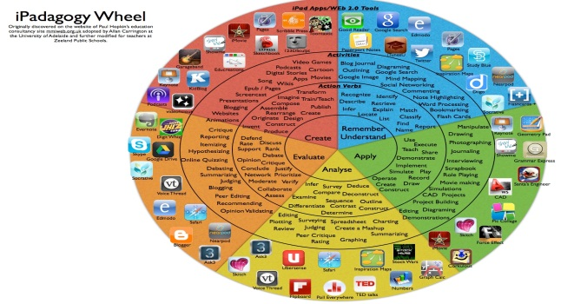
LEARNING SKILLS | Organization  Independent Work  Collaboration  Responsibility  Initiative  Self-Regulation
ACCOMODATIONS/MODIFICATIONS | https://education.alberta.ca/media/525534/ipp6.pdf  Partner/peer helper  Ongoing feedback  Computer/ Internet  Additional time  Technology for organization  Scribe/handout  Alternatives to writing (charts, tables or graphic organizers)  Specialized tools and materials  Alternate assignment  Oral test  IEPs for other modifications  Modified note/handout  Other  Dictionaries  List of important vocabulary  Verbal demonstration  Reword the instructions  Reinforcing effort and providing recognition  Taped material  Anchor activities  Literature circles  Learning contracts  Small-group instruction  Group investigation  Independent study  4MAT  Varied questioning strategies  Compacting  Varied journal prompts
COMPREHENSIVE MATH PROGRAM | MINI LESSONS: Where for a short time, the whole group or small group works together to increase fluency with mental math strategies. They’re building an understanding of connections and relationships between numbers:  Is there something about this concept that I must help students to name?  Are there connections that I need to draw attention to?  PUZZLES: Playing games and solving puzzles is another type of experience that builds understanding and computational skills:  What games and puzzles will build a deeper understanding of the math?  What game and puzzles support connections to other math content?  MEANINGFUL PROBLEMS: Meaningful problems are designed to support students in reaching specific mathematical goals while developing flexibility of ideas and strategies:  What scenarios will engage students in the math?  How can I help students investigate math content?  PURPOSEFUL PRACTICE  What will be meaningful practice?  Problems are often explored using a 3-part lesson structure:  - Setting the Context/Activating Students’ thinking  - Investigation Stage  - Consolidating the Learning
RESOURCES
BEFORE/ACTION:
(Mental Set/”Hook”)
DURING/MINDS ON:  (Model, Demonstrate, Guided Practice, Check for Understanding, Independent Practice) | Re-voice  Paraphrase  Agree or Disagree? Why?  Prompt for Participation  Wait Time
AFTER/CONSOLIDATION:
REFLECTION/NOTES:

