MATH ADDITION NINJA BLACK BELT TEST
963 +874=
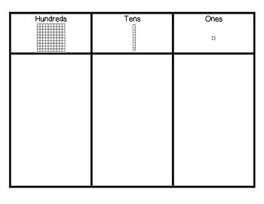
--------------------------------------

MATH SUBTRACTION NINJA BLACK BELT TEST
645-478=
--------------------------------------

