MATH ADDITION NINJA BLACK BELT TEST
963 +874 =
NUMBERS
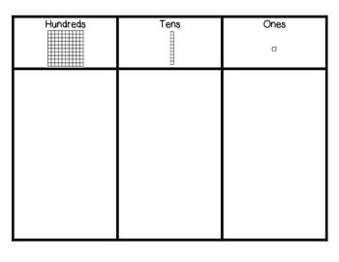
PICTURES

MATH SUBTRACTION NINJA BLACK BELT TEST
645- 478 =
NUMBERS
PICTURES

