NON FICTION RETELL

BOOK TITLE: _____________________________
What was the book/chapter/page mostly about?
________________________________________________________________________
Give 4 (new or otherwise) facts you have learned from the book
First, I learned…
________________________________________________________________________
Then, I learned…
________________________________________________________________________
Next, I learned…
________________________________________________________________________
Lastly, I learned…
________________________________________________________________________

Highlight the text features the author used:
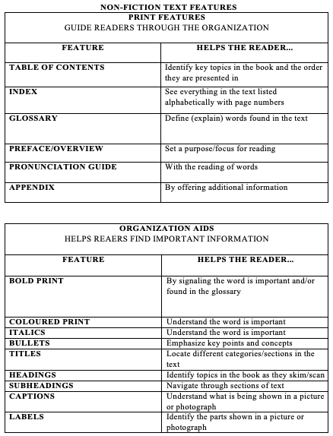
Highlight the text features the author used:
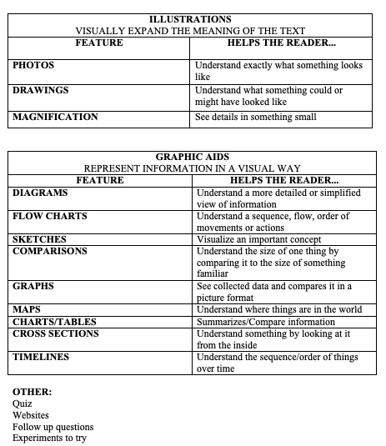

Select one text feature the author chose to include in his book ( _________) and explain how it helped you navigate your way through the information provided. Support with specific proof from the text.

____________________________________________________________________________________________________________________________________________________________________________________________________________________________________________________________________________________________________________________________________________________________________________________________________________________________________________________________________________________

⃝ Did you use “OPP” to edit your work?

