“THE ORIGIN OF ______________”
“Logo-fy” and create a title page⬆ 
YOUR TASK
*Represent the origin of your superhero’s abilities in 6 cells of any shape/size (up to 8 ½ x 11)
Your final cell should show your superhero emerge with appropriate narration (e.g. “From then on, he was known as Swamp Thing!)
*Tip: Pick cell sizes that are appropriate for the action!
SUCCESS CRITERIA
*At least 1 Onomatopoeia word (Boof, Thud, etc.)
*Colours as feelings

*Speech bubbles (Write first, place bubble second): Thought, Screaming, Regular, Narrator/Caption, Whisper, etc.
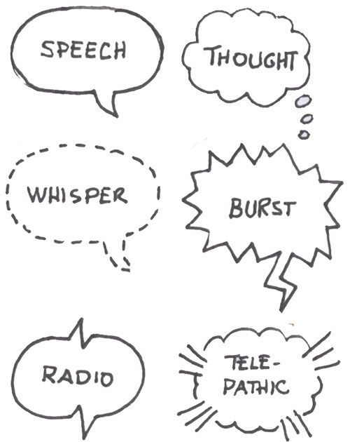
*Background should be detailed but should not interfere with characters
*Contrast colours to draw people’s attention
*Character: Eyes, eyebrows, lips, mouth, arms, legs, etc.
-Spelling/editing/feedback before the good copy
-Logo fonts: www.abstractfonts.com
DRAWING TIPS
1) Pencil first
2) Trace your pencil outline and texture with a black pen to make it pop!
3) Consider and select your colours and values .
(Light values require space between hatch lines. Dark values require hatch lines close to one another)
4) When hatching, use a consistent direction (unless texture is needed)

