PRINT ADVERTISEMENT SUCCESS CRITERIA
LEARNING TARGET:
We are learning to tell and sell our product through print/billboard/poster/website advertisements
PRODUCT NAME: Panera Bread
MESSAGE: When you cook at home, you know what’s going into your food. But we live hectic lives and we eat out a lot. Panera offers healthier choices than other restaurants. Most of their choices have a mixtures of foods from different food groups!
SUCCESS CRITERIA:
○ Is the logo your focal point? (It’s usually centered!)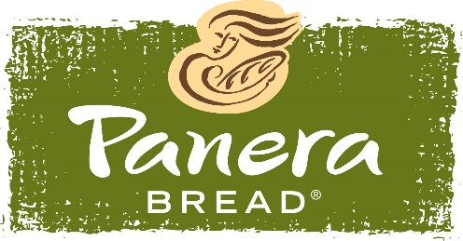
○ Do you have a slogan (sentence, motto, saying) that explains your product quickly and with gusto!? Remember, it’s usually centered as well!
SLOGAN: “Food as it should be!”
○ Do you have the message delivered in a unique, original and memorable way (usually in between your logo and slogan) targeting your audience? Remember, people tend to pass by ads/posters quite quickly. There are so many of them in the world! Try to draw in your audience’s attention with a picture that spells out the target audience and uses something shocking, wacky, humorous, etc.
○ Did you include either a border or background colour to liven up your advertisement?
○ Do you have a website and/or phone number listed?
PHONE NUMBER: (905) 713-0965
WEBSITE: http://delivery.panerabread.com
DID YOU REMEMBER TO DO A ROUGH DRAFT FIRST AND SEEK FEEDBACK/EDITING FROM A TEACHER BEFORE FINALIZING THINGS?!

FINAL POSTER SUCCESS CRITERIA
*Be neat at all times! If things get messy, don’t be afraid to start again!
*Use a pencil first and then use a black pen over parts that need to “pop” such as the outline of letters or areas that show texture.
*Make sure there are no spelling mistakes on your good copy! Make any writing bold with easy to read but unique fonts (See: www.abstractfonts.com for reference)
*Hatch (colour in) beautifully in one consistent direction with pencil crayons (markers tend to “bleed”).

