Dear Parents and Guardians,
I am so very pleased to be teaching your child this year! Research has shown that the greater the parental involvement, the greater the student success. I fully endorse that belief! It is my desire to extend classroom learning and sync it seamlessly with the learning at home. Education is not a unilateral process. I will be in touch with you regularly throughout the year, updating you on your child's progress and communicating ways in which we can work together to ensure your child's success.
I want to let you know that I am a dedicated and passionate educator who is committed to every student. My pedagogical philosophy is straightforward: I "work with" students (honing their skill sets and polishing their talents) rather than simply "teaching to" them. I am a Queen’s University Concurrent Education graduate who has taught on all levels. This is my 18th year teaching, having previously taught at Yorkhill Elementary School, Richmond Rose Public School and Nokiidaa Public School. I am thrilled to be joining Whitchurch Highlands Public School as I start a new chapter in my career!
The Zello App (https://www.zello.com) will serve as our “go to” tool to facilitate parent/teacher communication. As such, enable notifications on the app. I will also provide you access to your child’s Remote Learning Google Drive. I will upload notable work within this drive alongside additional resources, exemplars, passwords, etc. for your perusal! Be aware that my website (www.drooker.ca Password: 4321) has webpages for every subject and unit! Each page contains invaluable links, photos, anchor charts, tutorial videos, work samples, downloadable organizers, games, and extra practice opportunities which bridge our learning between classroom and home. My website even has Learning Blog (https://www.drooker.ca/learning-blog.html) that is updated throughout the day.
Thank you in advance for your continued time, effort, energy and support. I am looking forward to a tremendous year!
Sincerely,
Jonathan Drooker
jonathan.drooker@yrdsb.ca
​
CORE PEDAGOGICAL BELIEFS
“Working with” rather than “Teaching to” students!
“Interesting learning” is the number one classroom management tool!
Research has shown that the greater the parental involvement, the greater the student success. I wholeheartedly endorse that belief!
A balanced literacy program with the gradual release of responsibility serves as the fundamental backbone to my instruction! Not only is it board policy, it is my personal policy!
A successful numeracy program is best accomplished through a comprehensive math program (Mini lessons, Puzzles, Meaningful Problems (delivered through a 3 part lesson structure))
A cross curricular approach is ideal as it models for students the interplay between one subject and another!
Equity vs. Equality: Treating everyone exactly the same actually is not fair. What equal treatment does do is erase our differences and promote privilege. Differentiated instruction is the way to go! everydayfeminism.com/2014/09/equality-is-not-enough/

IMPORTANT: PLEASE READ CAREFULLY

Please complete the highlighted sections of the following document.

Upon completion, please watch the following tutorial video alongside your child:
https://www.youtube.com/watch?v=ErhnfAY0ppc
Thereafter, submit this document within their “Finished Folder” after logging into your child’s username@gapps.yrdsb.ca account. Should you have any questions (e.g. lost your child’s username and password) feel free to reach out!

PARENT/GUARDIAN INFORMATION SURVEY
CHILD NAME:
BIRTH DATE:
BIRTH ORDER (E.G. FIRST BORN):
NUMBER OF CHILDREN IN THE FAMILY:

SIBLING(S)
NAME | AGE | GRADE

MY CHILD’S FIRST LANGUAGE IS:
WHAT LANGUAGE (S) IS/ARE SPOKEN AT HOME?
MY CHILD’S HOUSEHOLD INCLUDES:
MOTHER FATHER GRANDPARENTS OTHERS

PARENT/GUARDIAN INFORMATION
NAME | RELATIONSHIP | HOME/CELL PHONE NUMBER | WORK  NUMBER | “GO TO” EMAIL ADDRESS | BEST TIME TO REACH YOU

DOES YOUR CHILD TAKE THE BUS TO AND FROM SCHOOL? YES NO

THE FOLLOWING PEOPLE ARE AUTHORIZED TO PICK UP MY CHILD AT THE END OF THE DAY
NAME | RELATIONSHIP | PHONE NUMBER

IS THERE ANYTHING I SHOULD BE AWARE OF INVOLVING YOUR CHILD’S HEALTH THAT MAY AFFECT ATTENDANCE OR PARTICIPATION IN SCHOOL ACTIVITES (E.G. VISION, HEARING, ALLERGIES, ETC.)?

DOES YOUR CHILD HAVE ANY FOOD RESTRICTIONS?

DOES YOUR CHILD REQUIRE AN EPIPEN?

IS YOUR CHILD TAKING ANY MEDICATION THAT I SHOULD BE MADE AWARE OF?

DO YOU HAVE ANY CONCERNS ABOUT YOUR CHILD’S SPEECH/LANGUAGE/VISION DEVELOPMENT?

DESCRIBE YOUR CHILD’S BEHAVIOUR WHEN PLAYING WITH OTHER CHILDREN:

WHAT IS YOUR CHILD’S ATTITUDE TOWARDS ATTENDING SCHOOL?

HOW DOES YOUR CHILD COPE WITH SEPARATION FROM YOU?

HOW DO YOU SEE YOUR CHILD’S PERSONALITY?

WHAT KIND OF SITUATIONS EXCITE OR FRIGHTEN YOUR CHILD?

WHAT ARE YOUR CHILD’S SPECIAL TALENTS OR INTERESTS?

WHAT KIND OF TOYS/ACTIVITIES DOES YOUR CHILD PREFER?

WHAT KIND OF OUTDOOR ACTIVITIES DOES YOUR CHILD ENJOY?

DO YOU HAVE ANY SPECIAL HOBBIES OR INTERESTS THAT YOU WOULD LIKE TO SHARE WITH YOUR CHILD’S CLASS?

WHAT ARE YOUR PROFRESSIONS?
(WE OFTEN TRY TO TIE OUR LEARNING WITH REAL WORLD APPLICATIONS AND CLASSROOM VISITS BY PROFESSIONALS!):

ARE THERE ANY RELIGIOUS/CULTURAL PRACTICES OR OBSERVANCES WE SHOULD BE AWARE OF AS WE PROGRAM FOR YOUR CHILD?

MY CHILD RESPONDS BEST TO:

☑ THE PROMISE/FOLLOW THROUGH OF REWARDS
☑ THE PROMISE/FOLLOW THROUGH OF CONSEQUENCES
☑ VERBAL PRAISE/RECOGNITION
☑ INTRINSICALLY MOTIVATED AND ALWAYS DOES HIS/HER BEST

I HAVE REVIEWED AND SIGNED OFF ON YRDSB POLICIES PROVIDED WITHIN THE “STUDENT START UP PACKAGE” (E.G. USE OF TECHNOLOGY, ETC.) | YES NO
I HAVE BOOKMARKED OUR CLASS WEBSITE http://www.drooker.ca (Password: 4321) | YES NO
I HAVE VISITED https://www.drooker.ca/routines.html TO LEARN ABOUT OUR CLASSROOM ROUTINES | YES NO
I HAVE VISITED https://www.drooker.ca/work.html AND UNDERSTAND ITS PURPOSE
I UNDERSTAND THAT THE CLASS LEARNING BLOG https://www.drooker.ca/learning-blog.html IS UPDATED THROUGHOUT THE DAY AND IS WORTH REVIEWING/UNPACKING ALONGSIDE MY CHILD ON A NIGHTLY BASIS | YES NO

ZELLO WALKIE TALK APP COMMUNICATION
Zello is an extremely useful communication app which allows me to offer up real time voice text/note updates! The Zello app works somewhat like a walkie talkie voice/text messenger. Throughout the day, we can communicate through this app. I can drop you a voice note when something typical or atypical occurs (which you can listen to live and replay).
Kindly download the app such that we can use it as our go to means of communication Phone calls and meetings remain in play, but this app saves significant time and energy as it consolidates the entire class into one easy to navigate app for me. I will check the app as often as possible for responses from you and will “walkie-talkie” back as soon as possible.
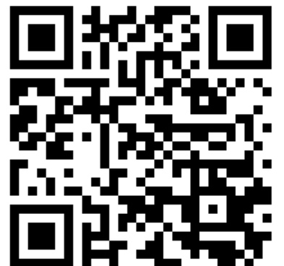
I HAVE DOWNLOADED THE APP FOR COMMUNICATION PURPOSES AND I HAVE ADDED THE USERNAME: “MRDROOKER”: YES NO
I HAVE SET UP THE FOLLOWING USERNAME (S) ENSURING THAT I STATE MY/OUR RELATIONSHIP WITHIN IT FOR EASY ACCESS (E.G. X’s MOM or X’s DAD)
USERNAME:
I RECOGNIZE THAT THIS APP IS WORTH CHECKING ON A DAILY BASIS: YES NO

YRDSB DIGITAL TOOL FORM
Dear Parents/Guardians,
We will be using the following digital tool(s) in an effort to support authentic, relevant, and deep learning experiences in our classroom. I have examined the privacy policy of this tool(s) specifically looking at:
- where the data is being stored,
- who owns the content
- what will be done with the content that is created/stored.
I ask that you review the privacy policy too and indicate whether or not you approve of the inclusion of this tool in your child’s learning and the identifiable information that might be shared.
Teacher: Jonathan Drooker |  | Subject/Course: |  | Date:
Digital Tool | Privacy Policy URL | Identifiable information to be shared | Rationale |  | Initial to indicate approval
Zello  App | https://zello.com/privacy/ | Voice notes | Teacher and Parent access/use  This app will allow for digital voice messages to be sent to parents throughout the course of the day updating them as to their child’s progress. Voice messages can be listened to live and/or listened to later
Flipgrid  App | https://legal.flipgrid.com/privacy.html | Videos | Teacher, Parent and Student access/use  The Flipgrid App will be utilized for students to complete their monthly video/oral presentation task
Raz Kids | http://help.learninga-z.com/customer/portal/articles/1649236-privacy?_ga=2.173961187.1782676746.1568235198-885611271.1568121199 | First name | Teacher, Parent and Student access/use  Students will be assigned a reading level after diagnostic testing is complete. Students will have access to ~20 digital story books per level to read, listen to and respond to before advancing to the next level. This digital reading program will be part of their monthly homework packages.
Code.org | https://code.org/privacy | First name | Teacher, Parent and Student access/use  Students will be given access to grade specific coding work as part of our mathematics learning.

By signing below, I indicate that I understand the information provided, have read the privacy policy for the tool(s) above and give permission for my child or their teacher to access this tool(s) as I have initialled above.
Student Name: | Parent/Guardian Signature: | Date:

“PRINTABLES”
PRINT OFF AND RETAIN THE FOLLOWING ANCHOR CHARTS, TOOLS, ETC. IN A HIGH VISIBILITY AREA (E.G. FRIDGE) FOR REFERENCE!

HOMEWORK CHECKLIST
https://www.drooker.ca/uploads/1/1/0/9/110962203/homework_checklist.pdf

REMOTE LEARNING GOOGLE DRIVE
I have created a “Remote Learning Google Drive” for your child. To access this digital work portfolio, students must login to their YRDSB GAPPS account using their username@gapps.yrdsb.ca and password. Parents/guardians will be provided with an invitation to collaborate via email.
To access the drive, students must click on the “Waffle Icon” () and then select “drive” () followed by clicking on “Starred” (). I invite you to peruse its contents frequently if not daily (ideally alongside your child)!

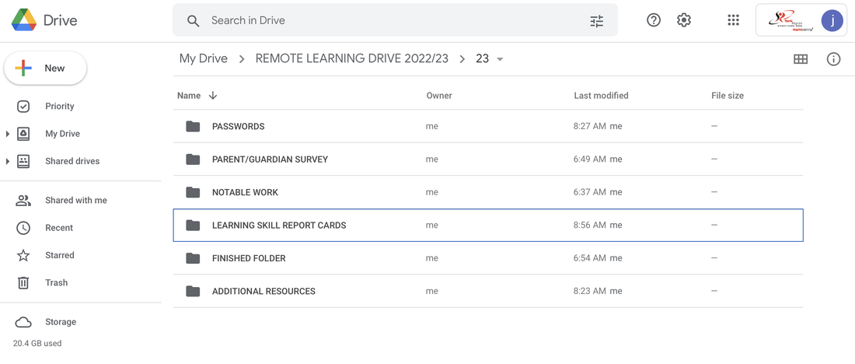

This Google Drive has many subfolders within it that I’d like to familiarize you with:
​
Parent/Guardian Survey: Kindly fill in the document as soon as possible for my perusal at the start of the year.
Passwords: Key passwords will be uploaded within to access various digital tools.
Finished Folder: Work completed remotely is to be uploaded to this folder for assessment and/or evaluation.
Additional Resources: This subfolder contains a variety of supporting materials such as advanced math, Level 4/A+ Writing, Examples, At Home Spelling Program, etc.
Notable Work: I will scan and upload typical and atypical work within this folder for your perusal including quizzes, tests, evaluations, etc. Young students often misplace work requiring your attention and signature and through the use of this folder, I can avoid the loss of any key evidence.
Learning Skills: I file completed “Learning Skill” and “Goal Setting” report cards for your review around the time that you child is "V.I.P."

THE “MOUNT RUSHMORE” OF OUR LEARNING
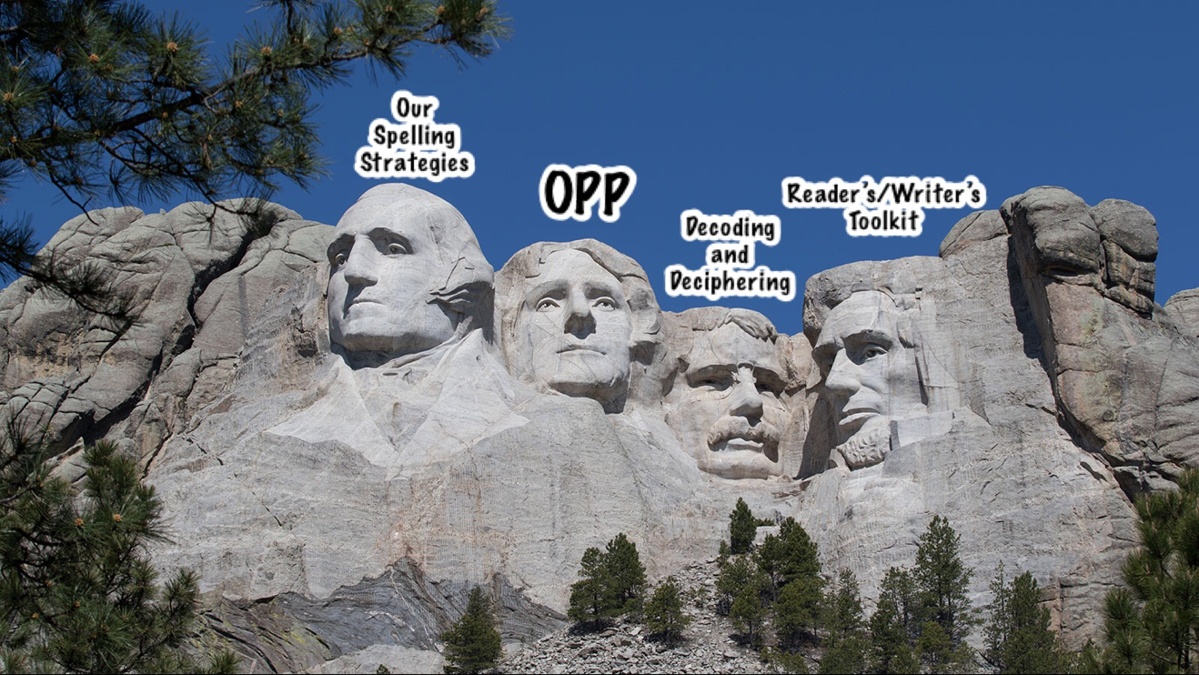

OUR SPELLING STRATEGIES: https://tinyurl.com/spellingstrat
OUR PROOFREADING PLAN: tinyurl.com/ourppplan
DECODING/DECIPHERING: https://tinyurl.com/decodedecipher
WRITER’S TOOLKIT: http://tiny.cc/wtoolkit
READER’S TOOLKIT: http://tiny.cc/rtoolkit

WRITING
Visit http://www.drooker.ca and access our Writer’s Toolkit webpage for a video tutorial
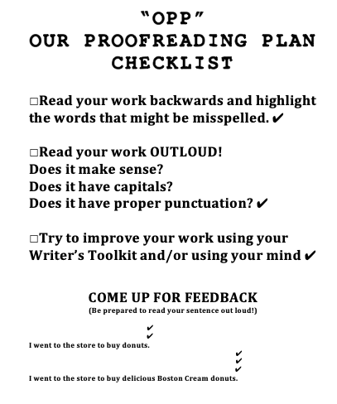

TIMETABLE

 | DAY 1 | DAY 2 | DAY 3 | DAY 4 | DAY 5
PERIOD 1  9:10-9:50 | LITERACY | LITERACY | LITERACY | LITERACY | LITERACY
PERIOD 2  9:50-10:10 | LITERACY | LITERACY | LITERACY | LITERACY | LITERACY
PERIOD 3  10:10-10:50 | LITERACY (MEDIA) | LITERACY | LITERACY | LITERACY | LITERACY
RECESS  10:50-11:20 | DUTY: PLAYGROUND  (INCLEMENT WEATHER: INDOOR HALLWAY) | DUTY: PLAYGROUND  (INCLEMENT WEATHER: NDOOR HALLWAY)
PERIOD 4  11:20-12:00 | GRADE 3 SCIENCE/SOCIAL STUDIES  GRADE 4 FRENCH/SSC | GRADE 3 SCIENCE/SOCIAL STUDIES  GRADE 4 FRENCH/SSC | GRADE 3 SCIENCE/SOCIAL STUDIES  GRADE 4 FRENCH/SSC | MATH | MATH
PERIOD 5  12:00-12:20 | GRADE 3 SCIENCE/SOCIAL STUDIES  GRADE 4 FRENCH/SSC | GRADE 3 SCIENCE/SOCIAL STUDIES  GRADE 4 FRENCH/SSC | MATH | MATH | MATH
PERIOD 6  12:20-1:00 | SCIENCE/SOCIAL STUDIES/DPA | LIBRARY/MATH | SCIENCE/SOCIAL STUDIES/DPA | SCIENCE/SOCIAL STUDIES | MATH/DPA
LUNCH
1:00-2:00
PERIOD 7  2:00-2:40 | TBD | PHYSICAL EDUCATION | MATH | MATH | MATH
PERIOD 8  2:40-3:00 | MUSIC (MITCHELL) | ARTS (MITCHELL) | MATH | MATH | SCIENCE/SOCIAL STUDIES
PERIOD 9  3:00-3:40 | MUSIC MITCHELL) | ARTS (MITCHELL) | HEALTH (MITCHELL) | PHYSICAL EDUCATION | ARTS (MITCHELL)

