Patterning word menu
Attribute, growing, shrinking, addition, subtraction, multiplication, division, pattern rule/core, directions, orientation, north, south, east, west, diagonal , horizontal 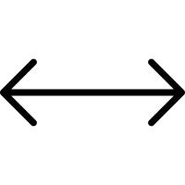, vertical

Growing pattern
Pattern rule + 10
11, 21, 31, 41, 51, 61, 71, 81, 91, 101

Shrinking pattern
Pattern rule -5
24, 19, 14, 9, 4, -1

One attribute pattern
(colour)

two attribute pattern
(colour, Size)

three attribute pattern
(orientation, colour, Size)

four attribute pattern
(orientation, colour, Size, shape)
↑ |  |  |  | ↑ |  |  |  | ↑

Patterning paragraph success criteria
⃝ Indent ⃝ Transition words ⃝ Topic Sentence ⃝ Body: Did you describe the pattern core/rule? ⃝ Clincher

Let me tell you about this pattern that has 4 attributes changing within it. In the pattern core/rule, there is a north pointing, small, black, arrow. Next, there is a large, yellow, smiley pointing west. It is followed by a medium, black, north pointing smiley. Lastly, it is followed by another medium, black, north pointing smiley. Now you know about the 4 attribute pattern!

