PUSHUP/HINDU SQUAT CHALLENGE
https://www.youtube.com/watch?v=LwTGJdnmZWo

https://www.youtube.com/watch?v=IlYi6p7gjV4

MONTH ONE
Use the following calendar to ✓ your progress
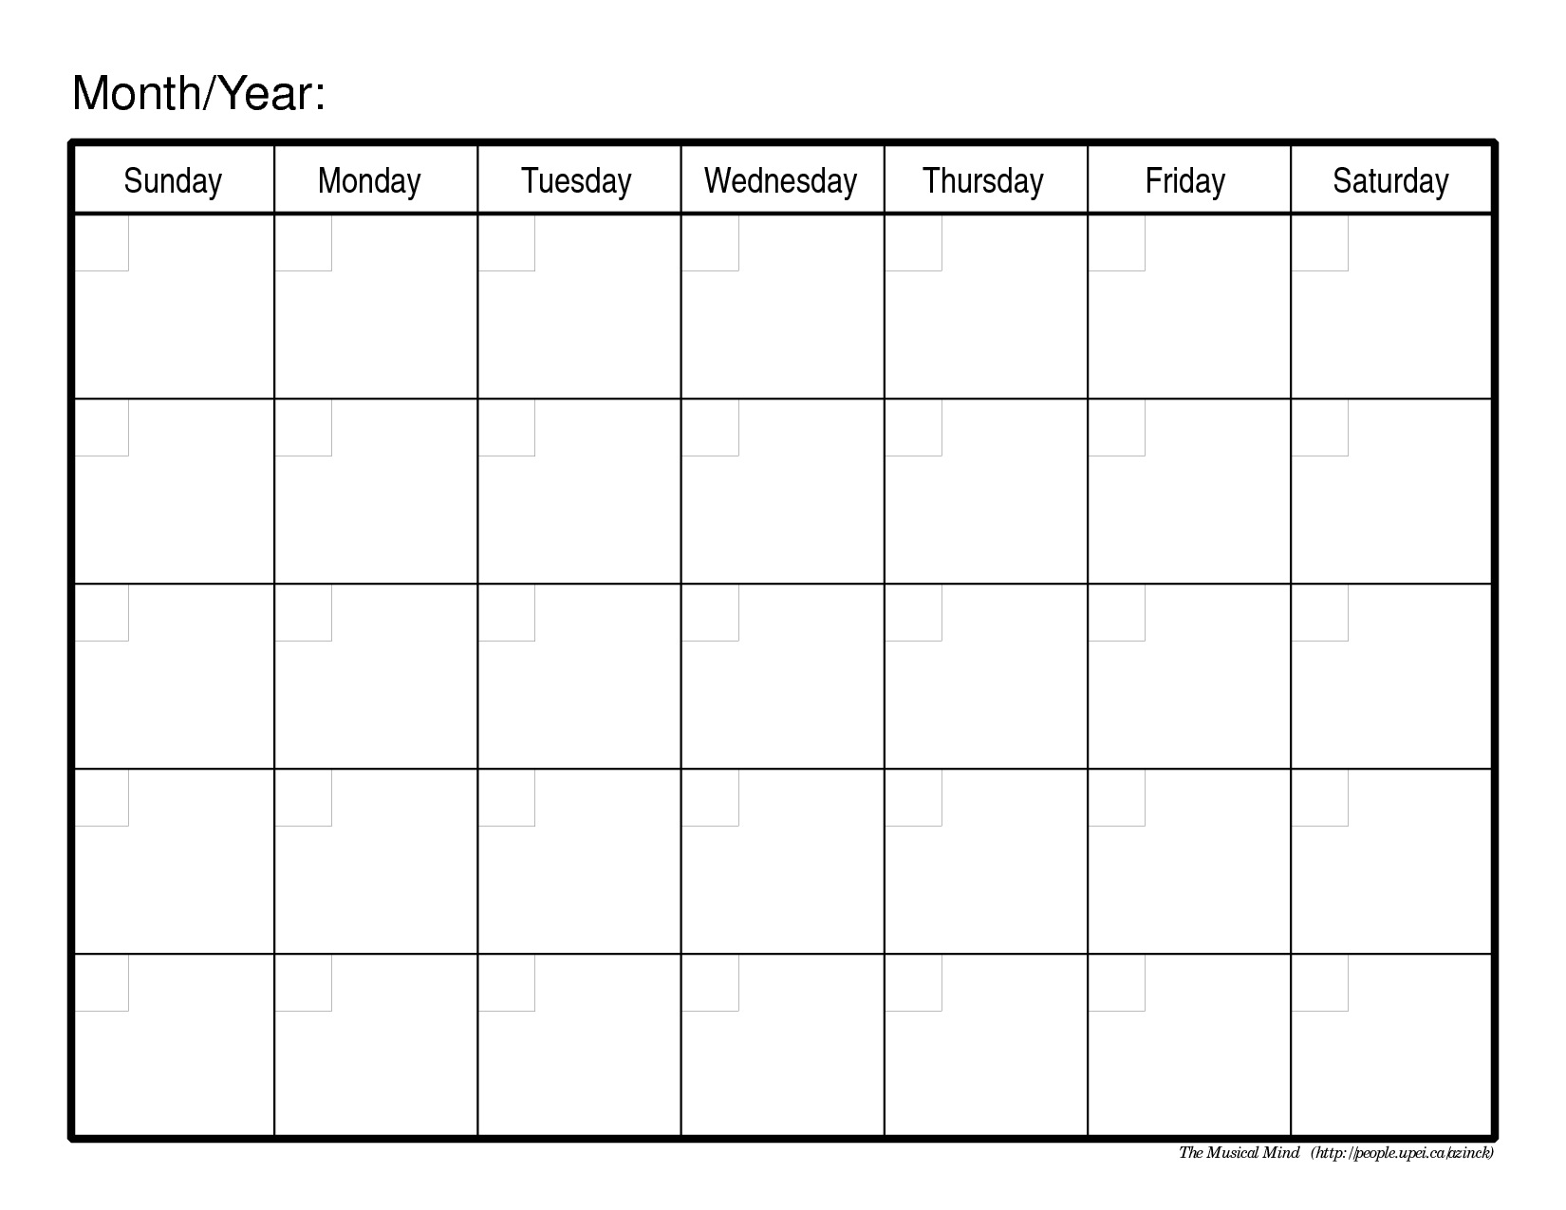
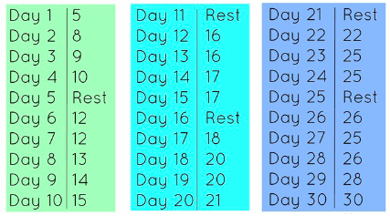
MONTH TWO
Use the following calendar to ✓ your progress

Days 1-10: Do 5 x 10 Push ups followed by 5 x 10 Squats (Total: 50 Push ups/50 Squats)
Day 11: Rest day
Days 12-20: Do 5 x 15 Push ups followed by 5 x 15 Squats (Total: 75 push up/75 Squats a day)
Day 21: Rest day
Days 22-29: Do 5 x 20 Push ups followed by 5 x 20 Squats (Total: 100 push ups/100 Squats a day)
Day 30: Rest day

MONTH THREE
Use the following calendar to ✓ your progress

Days 1-10: Do 5 x 25 Push ups followed by 5 x 25 Squats (Total: 125 push ups/125 Squats a day)
Day 11: Rest day
Days 12-20: Do 5 x 30 Push ups followed by 5 x 30 Squats (Total: 150 push ups/150 Squats a day)
Day 21: Rest day
Days 22-29: Do 5 x 35 Push ups followed by 5 x 35 Squats (Total: 175 push ups a day/175 Squats a day)
Day 30: Rest day

