USA (FEET) | CANADA (METERS)
1 FOOT | ~30 centimeters
OUR ROCKET (USA FEET) | CANADA (CENTIMETERS
1100 FEET | ~? centimeters

ADD 30 + 30 + 30.... 1 100 times! =
~33 000 centimeters (Apogee)

Why do we see highway speed limit signs that state the distance in kilometers per hour?

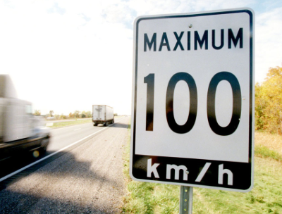

Why not centimeters per hour?

- It isn’t easy to read a sign as you speed along that says
10 000 000 centimeters per hour. Remember, is it easy to quickly count the number of zeroes as place value holders?

- Obviously a car or a rocket travels far greater distances than a “puny” centimeter. It isn’t the appropriate unit of measure!

SO
33000 centimeters should be converted into kilometers.

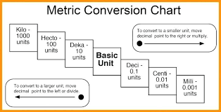
Our rocket will travel 0.33 kilometers to its apogee.

(0.33 is 1/3rd of a kilometer)

It took 4.0 seconds to travel to its apogee of 0.33 kilometers.

If we multiply that by 3, it would take 12 seconds for it to go 1 kilometer.

In one minute (5 groups of 12 seconds), our rocket would travel 5 kilometers!
Since there are 60 minutes in an hour...
5 x 60 or 5 + 5...(60 times)= 300

Therefore our rocket was travelling 300 kilometers an hour! 3 times as fast as our highway speed limit.

The circumference of our wind-measuring device (pinwheel) is 62 centimeters:
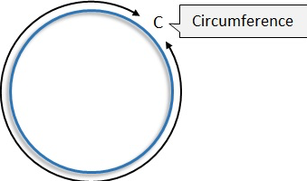

We took 2 wind measurements prior to launch.
1) It took 1.73 seconds to travel 62 centimeters
2) It took 0.93 seconds to travel 62 centimeters

If we round our results to the nearest second...
- It took 2 seconds to travel 62 centimeters
- It took 1 second to travel 62 centimeters