Strong Descriptive Writers…
-Have lots of detail and flesh out their writing instead of giving the reader a skeleton

Paint a picture with words. If one listens to your writing, they can picture most or all of what you're trying to show
Use their basic senses (touch, taste, smell, hearing, sight)
Have a balance between showing and telling
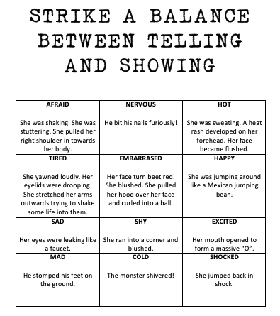
Use similes (like/as) to make comparisons
https://www.englishclub.com/vocabulary/figures-similes-list.htm

