TRANSFORMATIONAL GEOMETRY TREASURE MAP TASK

Our school field is essentially a giant rectangle. I have superimposed a coordinate grid atop our field for you! Bury your “treasure” for another group to find.

SUCCESS CRITERIA
- Use compass rose words (e.g.: North) throughout the paragraph
- Mention a specific starting location (e.g.: A1)
- Include updated locations after every movement (e.g.: You will now be at A5)
- Include at least one instance of a translation
- Include at least one instance of a rotation around an invisible cyclone of wind. State where the cyclone is located and where the group will land.
- Include at least one instance of reflection over a “booby trap” snake pit that you have created. State where the snake pit starts and where it ends.
- A specific ending location (e.g.: B6)
- A specific description of where the treasure can be found within the rectangular end location
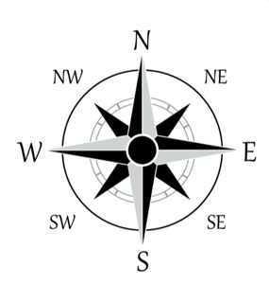
10
9
8
7
6
5
4
3
2
1
 | A | B | C | D | E | F | G | H | I | J

Basketball Hoops

____________________________________________________________________________________________________________________________________________________________________________________
____________________________________________________________________________________________________________________________________________________________________________________
____________________________________________________________________________________________________________________________________________________________________________________
____________________________________________________________________________________________________________ Did you apply the steps of “O.P.P.” to your writing?

