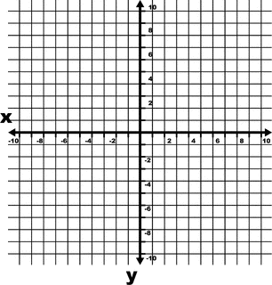

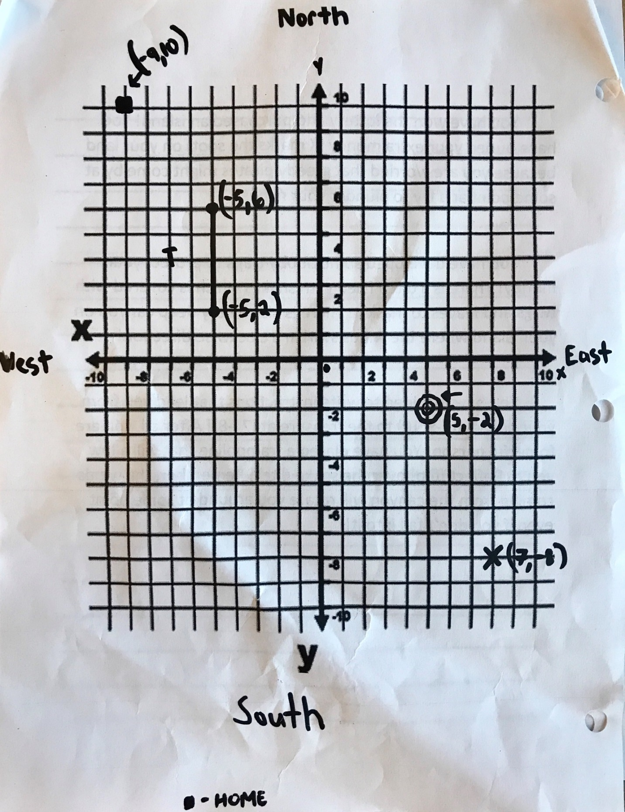

You have won the lottery and purchased an island! You have buried your extra money (X marks the spot) on your land because you are worried that greedy pirates might come by at some point and try to plunder your riches!

You have developed some booby traps to protect your money! There is a ditch filled with snakes which is covered with twigs and leaves to mask it. There is also a very deep canyon on your island where the winds swirl in a clockwise direction!

You have decided to write instructions that lead you from your house at (-9,10) to the treasure at (7, -8)! After all, you are forgetful person! You have placed a trampoline that will allow you to Reflect (flip) over the snake ditch. Remember, the winds coming from the canyon will rotate you around at some point even if you don’t fall into it!

Success Criteria
⃝Did you include a topic sentence?
⃝Write your directions using navigational/mathematical language (north, south, east, west, translation, rotation, reflection, as well as (X,Y) coordinates)
⃝Do you have a clincher?
⃝Did you apply “OPP” once you were finished writing?
________________________________________________________________________________________________________________________________________________________________________________________________________________________________________________________________________________________________________________________________________________________________________________________________________________________________________________________________________________________________________________________________________________________________________________________________________________________________________________________________________________________________________________________________________________________________________________________________________________________________________________________________________________________________________________________________________________________________________________________________________________________________________________________________________________________________________________________

