UNIT PLANNER #1
https://www.drooker.ca

UNIT AT A GLANCE
SUBJECT:
GRADE:
TIMELINE:
APPROXIMATE DATES:
PURPOSE: | This unit will assist students in  This unit will also provide students an opportunity to
LESSON 1:
LESSON 2:
LESSON 3:
LESSON 4:
LESSON 5:
LESSON 6:
LESSON 7:
LESSON 8:
LESSON 9:
LESSON 10:
LESSON 11:
LESSON 12:

MINISTRY EXPECTATIONS
OVERALL | SPECIFIC

ACHIEVEMENT CHART
KNOWLEDGE/  UNDERSTANDING  *Knowledge of the X Format | Demonstrates knowledge of
THINKING
*Creative/critical thinking processes are used to form an answer in their words

COMMUNICATION
*Clear expression and logical organization of an answer
*Use of conventions (spelling, grammar, punctuation)

APPLICATON
*Transfers ideas from text into other texts and/or world outside

PRIOR LEARNING

GUIDING QUESTIONS
(Throughout the Unit)

LEARNING GOALS

SUCCESS CRITERIA

ENDURING UNDERSTANDINGS
(What students should know after unit completion)
Students will parlay their

ACCOMODATIONS
Please refer to appendix of accommodations accompanying this unit plan. https://www.learnalberta.ca/content/kes/pdf/or_ws_tea_ld_b_04_acc.pdf

Partner/peer helper
Ongoing feedback
Computer/ Internet
Additional time
Technology for organization
Scribe/handout
Alternatives to writing (charts, tables or graphic organizers)
Specialized tools and materials
Alternate assignment
Oral test
IEPs for other modifications
Modified note/handout
Other
Dictionaries
List of important vocabulary
Verbal demonstration
Reword the instructions
Reinforcing effort and providing recognition
Taped material
Anchor activities
Literature circles
Learning contracts
Small-group instruction
Group investigation
Independent study
4MAT
Varied questioning strategies
Compacting
Varied journal prompts

PEDAGOGICAL WEBSITES/RESOURCES

ASSESSMENT STRATEGIES | ASSESSMENT DEVICES | TECHNOLOGY
Conference  Classroom Presentation  Interview  Questions/Answers  Exhibition/Demonstration  Learning Log  Observation  Performance Task  Quiz, Test, Examination  Select Response  Self-Assessment  Peer Assessment  Conference  Portfolio  Response Journal | Checklist  Rubric  Rating Scale  Anecdotal Notes  Journal  Pictures  Audio Recording | Laptop/LCD Projector  Document Camera  Classroom Laptops  Classroom Tablets  Laptop/Tablet Cart
MULTIPLE INTELLIGENCES | DIFFERENTIATED INSTRUCTIONS  (INSTRUCTIONAL INTELLIGENCES)  https://www.cvusd.us/uploaded/Ed_Services/Reclassification_Criteria/EL-SDAIE-Strategies.pdf | BLOOM’S TAXONOMY VERBS
Visual Spatial  Bodily Kinesthetic  Musical  Interpersonal  Intrapersonal  Linguistic  Logical-mathematical  Natural  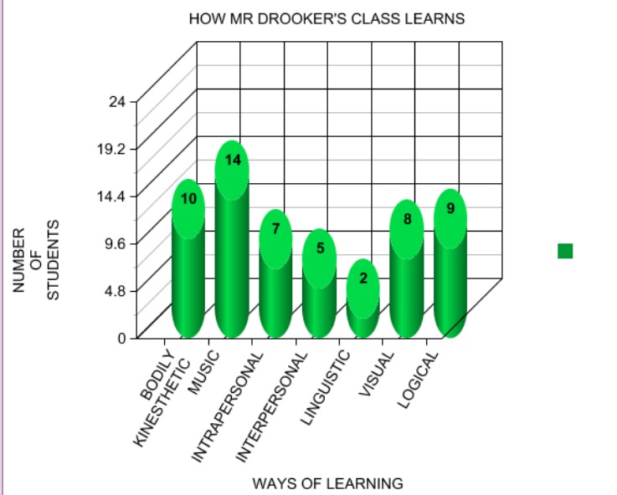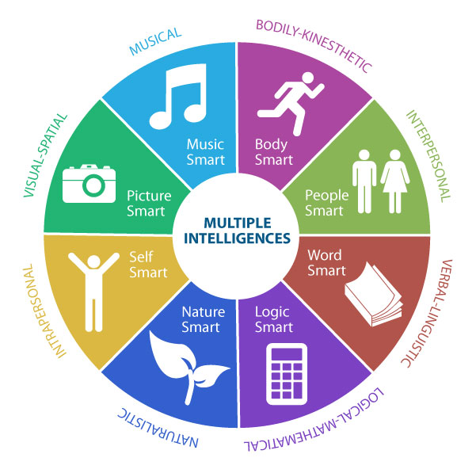 | Think/Pair/Share  Placemat  PMI: Positive/Minus/Interesting  EBS: Examine Both Sides  Fishbone  Venn Diagrams  Numbered Heads  Value Lines/Walkabout  Cooperative Learning  Inside/Outside Circles  Four Corners  Three Step Interview  Graffiti  Team Games Tournament  Concept Attainment  Six Thinking Hats  Discussion  Peer Practice  Cloze  Demonstrations  Flash Cards  Guided Exploration  Guided Reading  Guided Writing  Making Words  Read Along  Shared Read  Independent read  Word wall  Word menu  Work book  Reading Response  Brainstorming  Classifying  Concept Clarification  Estimating  Problem Solving  Writing to learn  Choral reading  Chanting  Games | Knowledge: Count, Define, Describe, Draw, Find, Identify, Label, List, Match, Name, Quote, Recall, Recite, Sequence, Tell, Write  Comprehension: Conclude, Demonstrate, Discuss, Explain, Generalize, Identify, Illustrate, Interpret, Paraphrase, Predict, Report, Restate, Review, Summarize, Tell  Application (Doing after being shown how): Apply, Change, Choose, Compute, Dramatize, Interview, Prepare, Produce, Role-play, Select, Show, Transfer, Use  Analysis (Consider the parts separately): Analyze, Characterize, Classify, Compare, Contrast, Debate, Deduce, Diagram, Differentiate, Discriminate, Distinguish, Examine, Outline, Relate, Research, Separate  Synthesis (Create, Design, Invent): Compose, Construct, Create, Design, Develop, Integrate, Invent, Make, Organize, Perform, Plan, Produce, Propose, Rewrite  Evaluation (Judge, Critically Appraise): Appraise, Argue, Assess, Choose, Conclude, Critic, Decide, Evaluate, Judge, Justify, Predict, Prioritize, Prove, Rank, Rate, Select

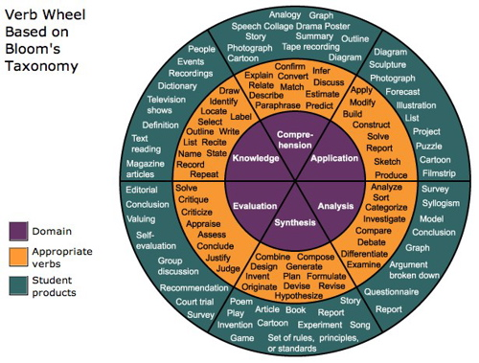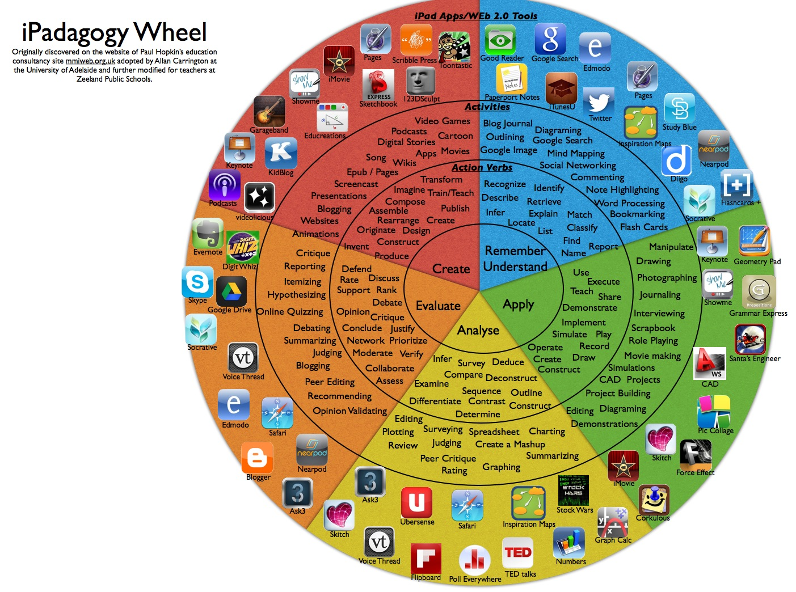

UNIT PLANNER #2
https://www.drooker.ca

UNIT AT A GLANCE

SUBJECT:
GRADE:
TIMELINE:
APPROXIMATE DATES:
PURPOSE:
LESSON 1:
LESSON 2:
LESSON 3:
LESSON 4:
LESSON 5:
LESSON 6:
LESSON 7:
LESSON 8:
LESSON 9:
LESSON 10:
LESSON 11:
LESSON 12:

OVERALL AND SPECIFIC EXPECTATIONS
Previous Grade Expectation  (Overall and Specific) | Current Grade Expectation  (Overall and Specific) | Following Grade Expectation  (Overall and Specific)
ACCOMODATIONS AND MODIFCATIONS
What accommodations or modifications will need to be implemented?
What supports are necessary for students to be successful?
https://www.learnalberta.ca/content/kes/pdf/or_ws_tea_ld_b_04_acc.pdf
Partner/peer helper
Ongoing feedback
Computer/ Internet
Additional time
Technology for organization
Scribe/handout
Alternatives to writing (charts, tables or graphic organizers)
Specialized tools and materials
Alternate assignment
Oral test
IEPs for other modifications
Modified note/handout
Other
Dictionaries
List of important vocabulary
Verbal demonstration
Reword the instructions
Reinforcing effort and providing recognition
Taped material
Anchor activities
Literature circles
Learning contracts
Small-group instruction
Group investigation
Independent study
4MAT
Varied questioning strategies
Compacting
Varied journal prompts

BIG IDEAS
What are the big Ideas that will be addressed in this learning sequence?

CURRICULUM EXPECTATIONS AND THE ACHEIVEMENT CHART
What Students Need to “Know and Do”
Building Understanding of X Concepts | Working towards proficiency with facts, skills, procedures | Creating engagement in the X processes | Providing opportunities for reflecting on, monitoring and working towards goals
Understanding | Application | Thinking | Communication
*Demonstrates knowledge of planning and processing skills to solve X problems with considerable effectiveness | *Applies knowledge and skills effectively to | *Demonstrates understanding of concepts by describing relationships among units of | *Expresses and organizes X thinking with effectiveness when describing strategies and procedures used in  *Uses X conventions, vocabulary, and terminology effectively

DIAGNOSTIC | SUMMATIVE/ASSESSMENT OF LEARNING
What is the most significant information you need to know about your students in relation to this learning BEFORE you begin the unit? | What kind of a task(s) would adequately address all or almost all of the “KNOW and DO” items?  Is the task(s) open enough to address all (or most) of the achievement chart categories?

UNIT LEARNING GOALS AND SUCCESS CRITERIA
What is the most significant information you need to know about your students in relation to this learning BEFORE you begin the unit? | What kind of a task(s) would adequately address all or almost all of the “KNOW and DO” items?  Is the task(s) open enough to address all (or most) of the achievement chart categories?

PEDAGOGICAL WEBSITES/RESOURCES:
*
*
*
*

ASSESSMENT STRATEGIES | ASSESSMENT DEVICES | TECHNOLOGY
Conference  Classroom Presentation  Interview  Questions/Answers  Exhibition/Demonstration  Learning Log  Observation  Performance Task  Quiz, Test, Examination  Select Response  Self-Assessment  Peer Assessment  Conference  Portfolio  Response Journal | Checklist  Rubric  Rating Scale  Anecdotal Notes  Journal  Pictures  Audio Recording | Laptop/LCD Projector  Document Camera  Classroom Laptops  Classroom Tablets  Laptop/Tablet Cart
MULTIPLE INTELLIGENCES | DIFFERENTIATED INSTRUCTIONS  (INSTRUCTIONAL STRATEGIES  https://www.cvusd.us/uploaded/Ed_Services/Reclassification_Criteria/EL-SDAIE-Strategies.pdf | BLOOM’S TAXONOMY VERBS
Visual Spatial  Bodily Kinesthetic  Musical  Interpersonal  Intrapersonal  Linguistic  Logical-mathematical  Natural  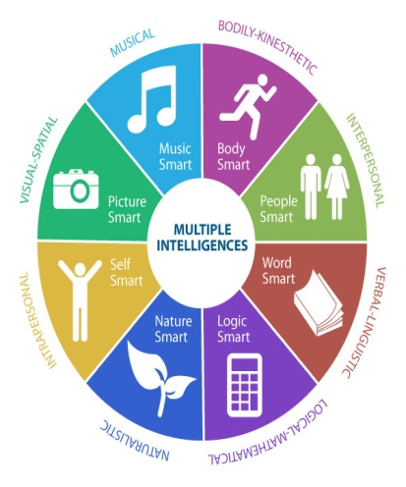 | Think/Pair/Share  Placemat  PMI: Positive/Minus/Interesting  EBS: Examine Both Sides  Fishbone  Venn Diagrams  Numbered Heads  Value Lines/Walkabout  Cooperative Learning  Inside/Outside Circles  Four Corners  Three Step Interview  Graffiti  Team Games Tournament  Concept Attainment  Six Thinking Hats  Discussion  Peer Practice  Cloze  Demonstrations  Flash Cards  Guided Exploration  Guided Reading  Guided Writing  Making Words  Read Along  Shared Read  Independent read  Word wall  Word menu  Work book  Reading Response  Brainstorming  Classifying  Concept Clarification  Estimating  Problem Solving  Writing to learn  Choral reading  Chanting  Games | Knowledge: Count, Define, Describe, Draw, Find, Identify, Label, List, Match, Name, Quote, Recall, Recite, Sequence, Tell, Write  Comprehension: Conclude, Demonstrate, Discuss, Explain, Generalize, Identify, Illustrate, Interpret, Paraphrase, Predict, Report, Restate, Review, Summarize, Tell  Application (Doing after being shown how): Apply, Change, Choose, Compute, Dramatize, Interview, Prepare, Produce, Role-play, Select, Show, Transfer, Use  Analysis (Consider the parts separately): Analyze, Characterize, Classify, Compare, Contrast, Debate, Deduce, Diagram, Differentiate, Discriminate, Distinguish, Examine, Outline, Relate, Research, Separate  Synthesis (Create, Design, Invent): Compose, Construct, Create, Design, Develop, Integrate, Invent, Make, Organize, Perform, Plan, Produce, Propose, Rewrite  Evaluation (Judge, Critically Appraise): Appraise, Argue, Assess, Choose, Conclude, Critic, Decide, Evaluate, Judge, Justify, Predict, Prioritize, Prove, Rank, Rate, Select,

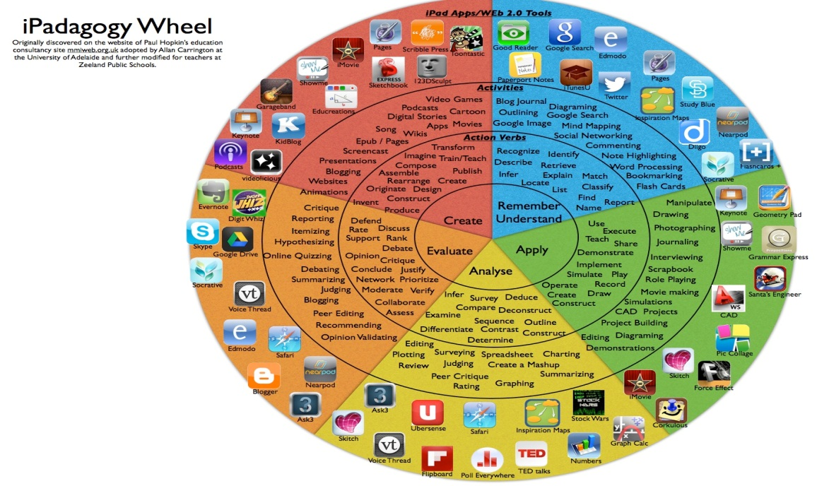

LESSON PLAN #

LESSON #
LESSON TITLE:
TIME ALLOTTED:
LEARNING TARGET:
SUCCESS CRITERIA:
CURRICULUM EXPECTATIONS:
INSTRUCTIONAL APPROACHES: | Modeled  Shared  Guided  Independent
INSTRUCTIONAL STRATEGIES:  http://goo.gl/11rwT9 | Think/Pair/Share  Placemat  PMI: Positive/Minus/Interesting  EBS: Examine Both Sides  Fishbone  Venn Diagrams  Numbered Heads  Value Lines/Walkabout  Cooperative Learning  Inside/Outside Circles  Four Corners  Three Step Interview  Graffiti  Team Games Tournament  Concept Attainment  Six Thinking Hats  Discussion  Peer Practice  Cloze  Demonstrations  Flash Cards  Guided Exploration  Guided Reading  Guided Writing  Making Words  Read Along  Shared Read  Independent read  Word wall  Word menu  Work book  Reading Response  Brainstorming  Classifying  Concept Clarification  Estimating  Problem Solving  Writing to learn  Choral reading  Chanting  Games
GROUPINGS: | Whole Class  Small Groups  Pairs  Individuals
ASSESSMENT CHECKPOINT:  ☐Diagnostic (Assessment of Previous Learning):  ☐Formative (Assessment for/as Learning):  Assessment FOR learning is the use of a task or an activity for the purpose of determining student progress during a unit or block of instruction. Teachers are now afforded the chance to adjust classroom instruction based upon the needs of the students. Similarly, students are provided valuable feedback on their own learning.  Assessment AS learning is the use of a task or an activity to allow students the opportunity to use assessment to further their own learning. Self and peer assessments allow students to reflect on their own learning and identify areas of strength and need. These tasks offer students the chance to set their own personal goals and advocate for their own learning.  ☐Summative (Assessment of Learning):  Assessment OF learning is the use of a task or an activity to measure, record and report on a student's level of achievement in regards to specific learning expectations. These are often known as summative assessments. | Test/quiz  Homework check  Assignment  Project  Presentation  Culminating task  Summative  Rubrics  Self-evaluation  Peer-evaluation  Application  Observation  Participation  Response/Reflection  Critique  Sketchbook/Hournal  Conferencing  Verbal feedback  Other:  Test  Conference  Product  Performance  Other:
 | 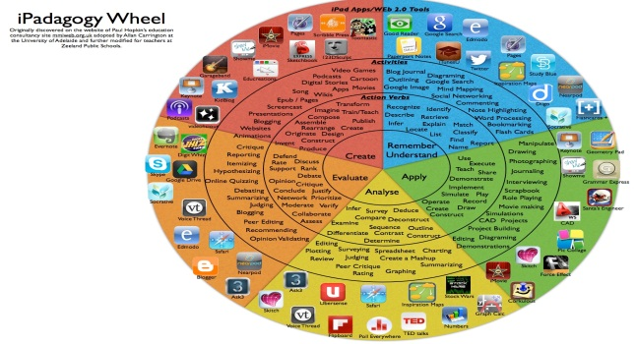
LEARNING SKILLS | Organization  Independent Work  Collaboration  Responsibility  Initiative  Self-Regulation
ACCOMODATIONS/MODIFICATIONS | https://education.alberta.ca/media/525534/ipp6.pdf  Partner/peer helper  Ongoing feedback  Computer/ Internet  Additional time  Technology for organization  Scribe/handout  Alternatives to writing (charts, tables or graphic organizers)  Specialized tools and materials  Alternate assignment  Oral test  IEPs for other modifications  Modified note/handout  Other  Dictionaries  List of important vocabulary  Verbal demonstration  Reword the instructions  Reinforcing effort and providing recognition  Taped material  Anchor activities  Literature circles  Learning contracts  Small-group instruction  Group investigation  Independent study  4MAT  Varied questioning strategies  Compacting  Varied journal prompts
COMPREHENSIVE MATH PROGRAM | MINI LESSONS: Where for a short time, the whole group or small group works together to increase fluency with mental math strategies. They’re building an understanding of connections and relationships between numbers:  Is there something about this concept that I must help students to name?  Are there connections that I need to draw attention to?  PUZZLES: Playing games and solving puzzles is another type of experience that builds understanding and computational skills:  What games and puzzles will build a deeper understanding of the math?  What game and puzzles support connections to other math content?  MEANINGFUL PROBLEMS: Meaningful problems are designed to support students in reaching specific mathematical goals while developing flexibility of ideas and strategies:  What scenarios will engage students in the math?  How can I help students investigate math content?  PURPOSEFUL PRACTICE  What will be meaningful practice?  Problems are often explored using a 3-part lesson structure:  - Setting the Context/Activating Students’ thinking  - Investigation Stage  - Consolidating the Learning
RESOURCES
BEFORE/ACTION:
(Mental Set/”Hook”)
DURING/MINDS ON:  (Model, Demonstrate, Guided Practice, Check for Understanding, Independent Practice) | Re-voice  Paraphrase  Agree or Disagree? Why?  Prompt for Participation  Wait Time
AFTER/CONSOLIDATION:
REFLECTION/NOTES:

