ORIGINAL IMAGE
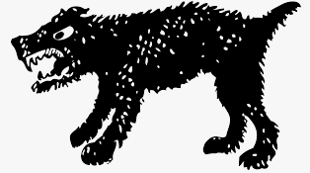
YOUR “FREEHAND” IMAGE COMPOSED OF SYBOLS FROM
“THE VISUAL ALPHABET”
