WEEKLY WORKOUT

BEFORE YOU BEGIN

- Have a parent or older sibling with you to assist as needed or to be your workout buddy.
- Designate a safe area for your workout.
- Be sure to have water handy.
- Be sure to stretch and warm up.
- You can adjust/modify the workout as needed. Aim to complete each exercise within the recommended range. Aim high!
- It's okay to take breaks if you need to. Try and challenge yourself to only take breaks every 3-5 exercises.
- If something is hurting, please adjust the exercise and/or stop. Let an adult know you are sore.
- Play some music to help you through the workout.
- You can repeat the daily workout for an extra challenge or increase the numbers.
BE SMART...BE CAREFUL.

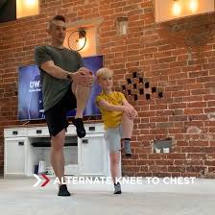

EXERCISE | NUMBER/  TIME | VIDEO
JUMPING JACK |  | https://www.youtube.com/watch?v=nGaXj3kkmrU
CRUNCHES |  | https://www.youtube.com/watch?v=Xyd_fa5zoEU
SQUATS |  | https://www.youtube.com/watch?v=EbOPpWi4L8s
PUSH UPS |  | https://www.youtube.com/watch?v=LwTGJdnmZWo&feature=emb_title
LUNGES |  | https://www.youtube.com/watch?v=QOVaHwm-Q6U
SIDE LUNGES |  | https://www.youtube.com/watch?v=FUX6Pz8vV0s
RUSSIAN TWISTS |  | https://www.youtube.com/watch?v=KJbMeSAAZVI
TRICEP DIP |  | https://www.youtube.com/watch?v=6kALZikXxLc
JOG ON SPOT |  | https://www.youtube.com/watch?v=GkS_SEgHzsg
CALF RAISES |  | https://www.youtube.com/watch?v=gwLzBJYoWlI
HAND PLANK |  | 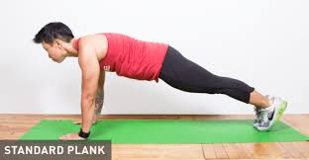
ELBOW PLANK
BIRDDOG PLANK |  | 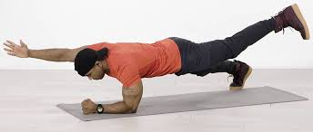
WALL SIT |  | https://www.youtube.com/watch?v=XULOKw4E4P4

