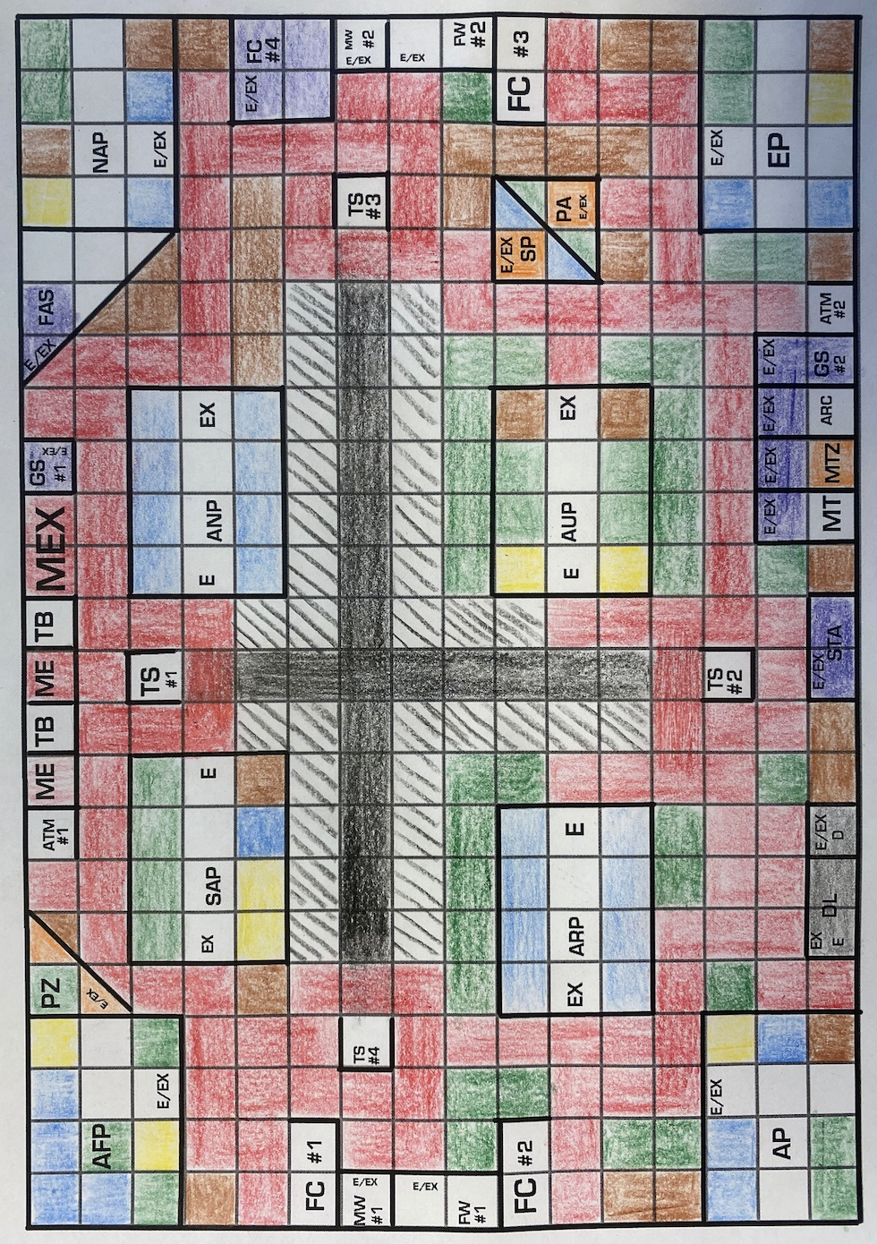
LEGEND
STRUCTURE | SYMBOL
Food Court | FC
North America Pavilion | NAP
South America Pavilion | SAP
Asia Pavilion | AP
Europe Pavilion | EP
Australia Pavilion | AUP
Arctic Pavilion | ARP
Antarctica Pavilion | ANP
Africa Pavilion | AFP
Gift Shop | GS
Ticket Booth | TB
ATM $ | ATM
Trolley Stop | TS
Entrance Door | E
Exit Door | EX
Main Entrance | ME
Main Exit | MEX
Splash Pad | SP
Petting Zoo | PZ
First Aid Station | FAS
Picnic Area | PA
Movie Theatre | MT
Meet the Zookeeper Area | MTZ
Arcade/Carousel | ARC
Park | P
Female Washroom | FW
Male Washroom | MW
Dumpster | D
Deliveries | DL
Staff Area/Vet Clinic | STA

TOTAL PERIMETER COSTS
ZOO PERIMETER FENCE
78 Centimeters X $5.00 = $390.00
ATM #1, MAIN ENTRANCE, MAIN EXIT, TICKET BOOTH, GIFT SHOP #1
13 X $5.00 = $65.00
STAFF AREA
____ X $5.00 = $_____________
FOOD COURT #1, MALE WASHROOM #1, FEMALE WASHROOM #1, FOOD COURT #2
____ X $5.00 = $_____________
AFRICA PAVILION, PETTING ZOO
____ X $5.00 = $_____________
NORTH AMERICA PAVILION, FIRST AID STATION
____ X $5.00 = $_____________
SOUTH AMERICA PAVILION:
____ X $5.00 = $_____________
EUROPE PAVILION:
____ X $5.00 = $_____________
ASIA PAVILION:
____ X $5.00 = $_____________
AUSTRALIA PAVILION:
____ X $5.00 = $_____________
ARCTIC PAVILION:
____ X $5.00 = $_____________

ANTARCTICA PAVILION:
____ X $5.00 = $_____________
FOOD COURT #4, MALE WASHOORM #2, FEMALE WASHROOM #2, FOOD COURT #3
____ X $5.00 = $_____________
MOVIE THEATRE, MEET THE ZOOKEEPER, ARCADE/CAROUSEL, GIFT SHOP #2, ATM #2
____ X $5.00 = $_____________
TROLLEY STOP #1:
____ X $5.00 = $_____________
TROLLEY STOP #2:
____ X $5.00 = $_____________
TROLLEY STOP #3:
____ X $5.00 = $_____________
TROLLEY STOP #4:
____ X $5.00 = $_____________
SPLASH PAD, PICNIC AREA
____ X $5.00 = $_____________
DELIVERIES, DUMPSTER
____ X $5.00 = $_____________
TOTAL SPENT ON PERIMETER WALLS: $_______

TOTAL AREA COSTS (cm²)
Grass (Green): _____ X $0.50 = _____
Gravel (Black Stripes): _____ X $0.75 = _____
Sand (Yellow): _____ X $0.55 = _____
Soil (Brown): _____ X $0.55 = _____
Ice/Water/Snow (Blue): ____ X $1.00 = _____
Asphalt (Black): _____ X $0.50 = _____
Interlocking brick (Red): ____ X $2.00 = _____
Tile (White): _____ X $0.25 = _____
Marble (Purple): _____ X $2.00 = _____
Wood (Orange): _____ X $0.75 = _____
AREA TOTAL: ____________________________

ADD PERIMETER TOTALS
+ | 390.00  65.00  20.00  50.00  45.00  50.00  70.00  35.00  35.00  70.00  70.00  70.00  65.00  75.00  15.00  15.00  15.00  15.00  50.00  30.00
TOTAL | $

ADD AREA TOTALS
+ | 25.00  24.00  4.95  16.50  28.00  11.50  234.00  14.75  27.00  3.00
TOTAL | $
ADD PERIMETER TOTAL AND AREA TOTAL
+ | P: __________________  A:___________________
TOTAL | $

$10 000 -
_________ (Perimeter)
_________ (Area)
_________ (A $100.00 penalty will be incurred per extra centimeter +/-)
_________ (A $100.00 penalty will be incurred per cm² +/-)
_________ (Time Penalty: A $5.00 per minute penalty will be incurred)
= ____________________

